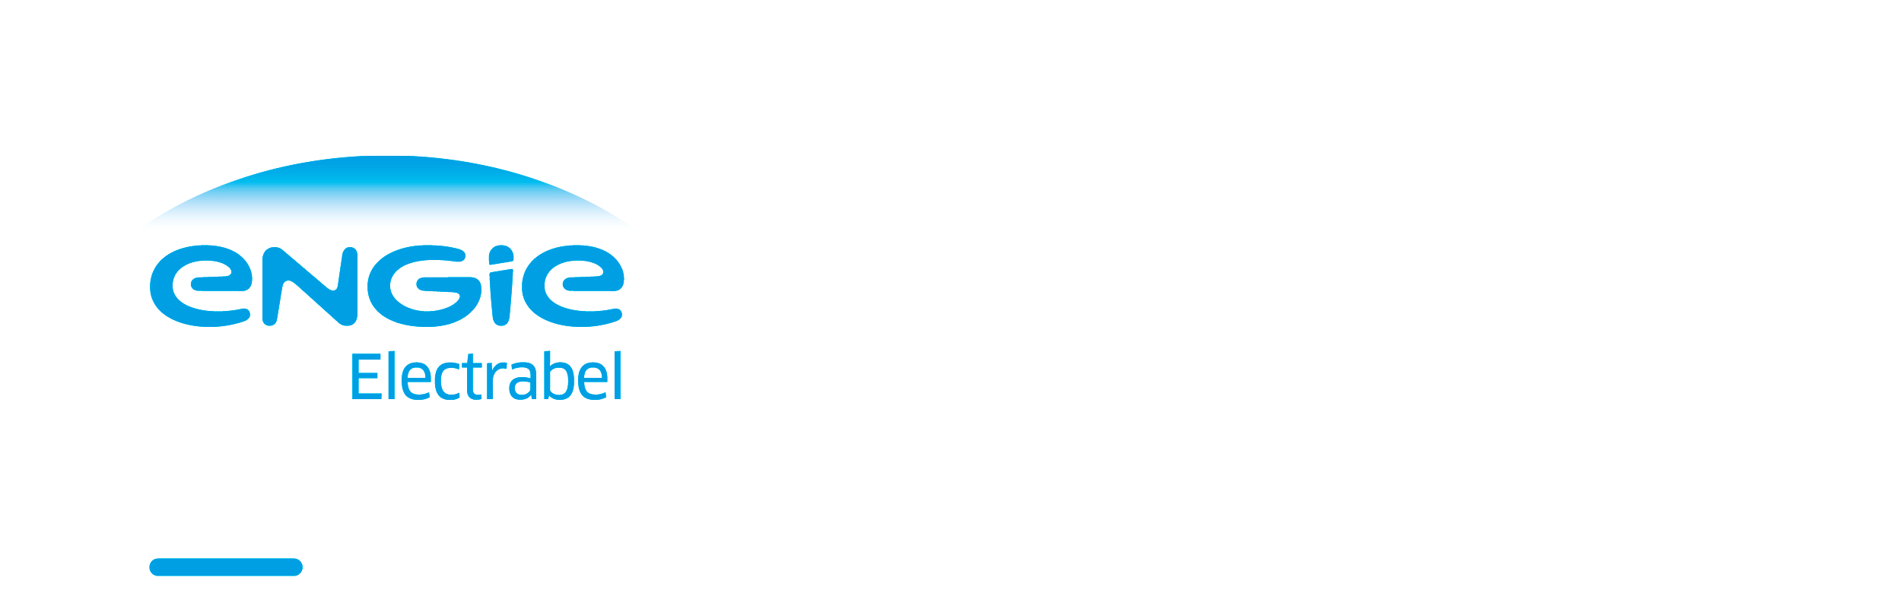

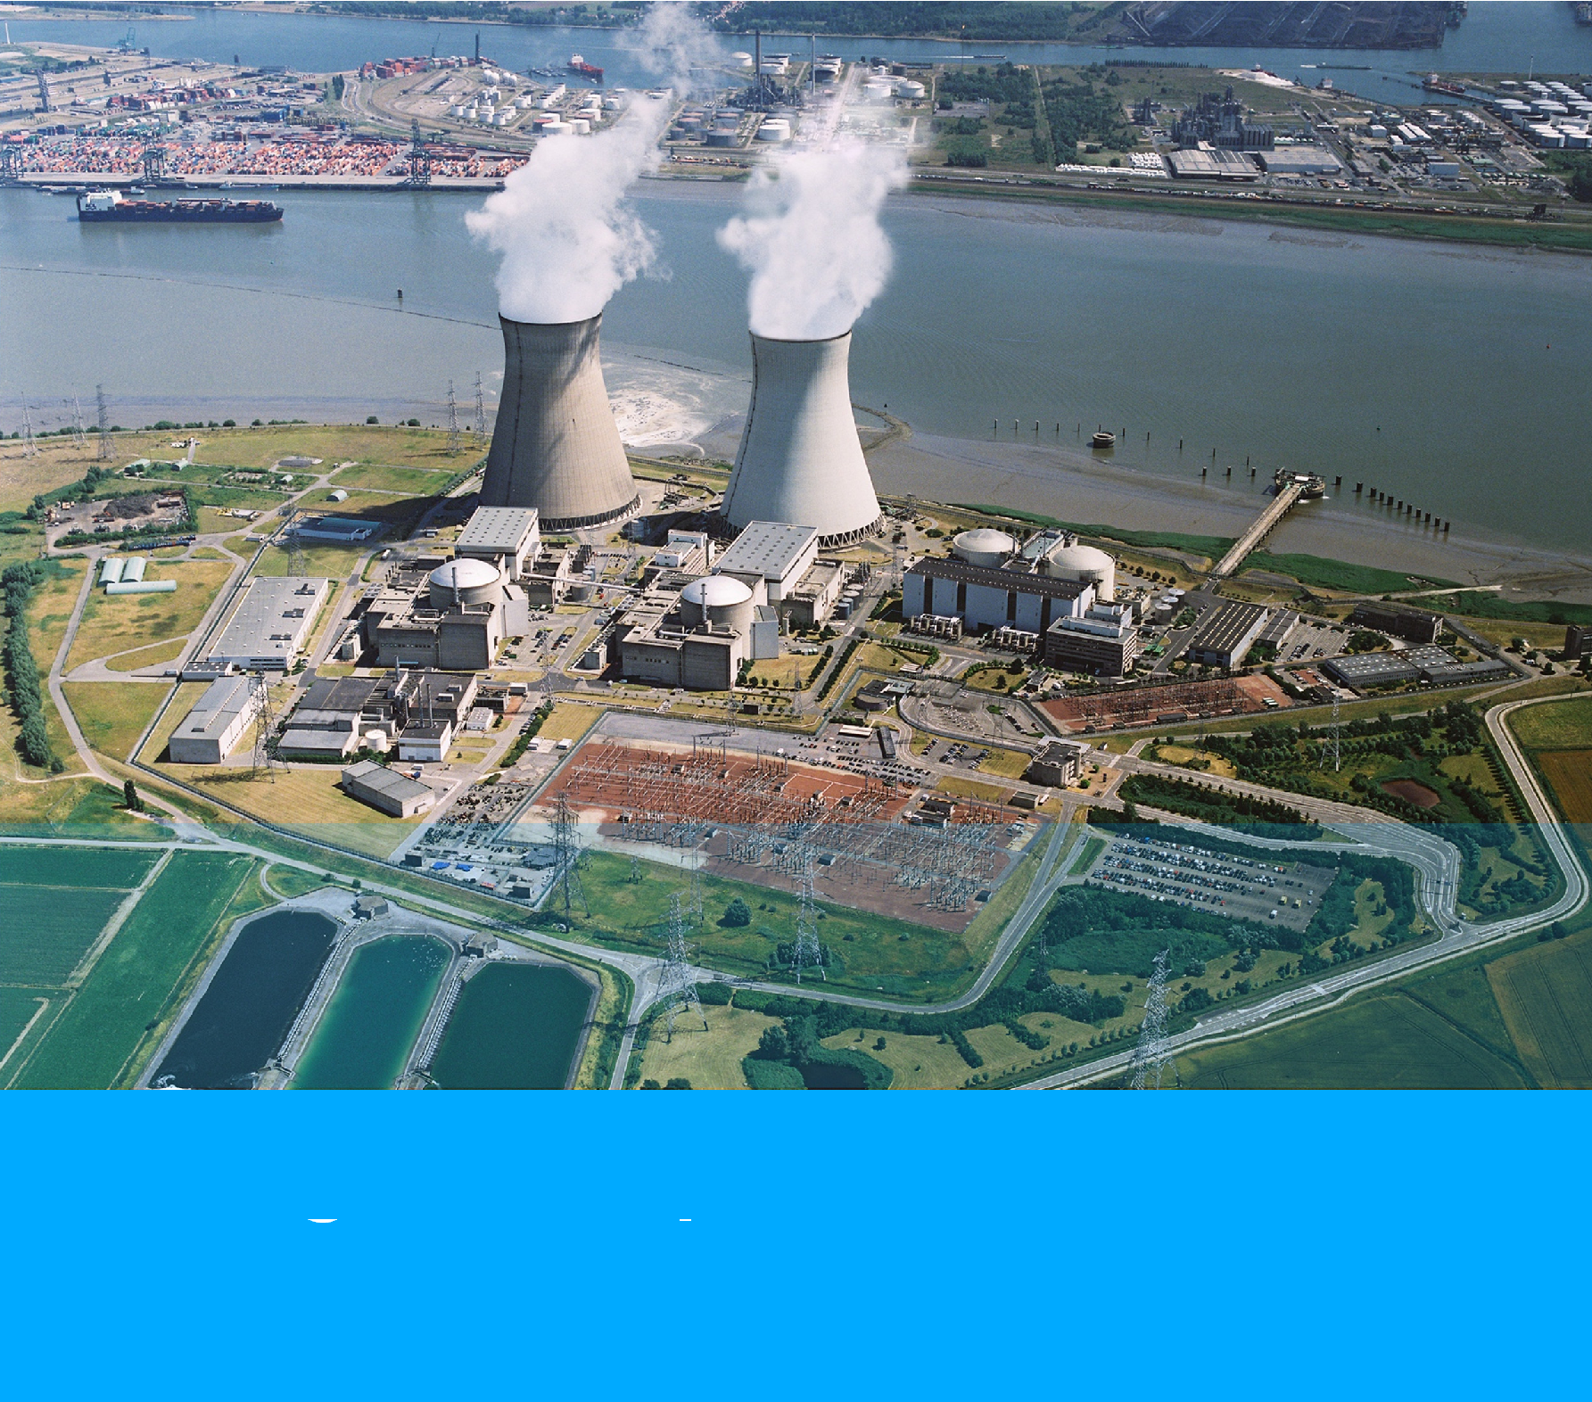

Justified safe continued operation

2015 – 2025

Long-Term Operation

Synthesis report – Doel 1 & Doel 2

Table of contents

Executive Summary |  |  |  | 3
0 | Reason and structure |  |  | 5
1 | Basis and context |  |  | 6
2 | Status Integrated Action Plan |  |  | 8
 | 2.1 | Review LTO-dossier 2012 |  | 9
 |  | 2.1.1 | LTO Ageing Mechanical | 9
 |  | 2.1.2 | LTO Ageing Electrical and I&C | 10
 |  | 2.1.3 | LTO Ageing Engineering | 12
 |  | 2.1.4 | LTO Design | 13
 |  | 2.1.5 | LTO Preconditions and Management of Competencies, Knowledge and Behaviour | 14
 | 2.2 | Re-evaluation BEST-project |  | 15
 | 2.3 | Ten-year Revisions |  | 15
 | 2.4 | Extra inspections in terms of LTO |  | 16
 | 2.5 | Other projects |  | 16
 |  | 2.5.1 | Installation changes | 16
 |  | 2.5.2 | Doel Nuclear Power Plant Projects | 16
 |  | 2.5.3 | Electrabel Corporate Projects | 17
 |  | 2.5.4 | Non-conformity reports (NCR) | 18
 |  | 2.5.5 | Delta 2012-2015 | 18
3 | SALTO-audit programme Doel 1 and Doel 2 |  |  | 19
4 | Planning Integrated Action Plan |  |  | 21
5 | Human Resources |  |  | 22
 | 5.1 | Basic Organisation Nuclear Power Plant Doel and LTO-organisation |  | 22
 | 5.2 | Tractebel ENGIE |  | 23
6 | General decision |  |  | 24
7 | Abbreviations |  |  | 25
8 | References |  |  | 27

Executive Summary

In accordance with the FANC-note of 12 September 2014 [REF 1], ENGIE Electrabel presented the LTO Synthesis Report [REF 2] to the safety authorities on 17 April 2015. This was followed up on 18 December 2015 by the LTO Status Report Doel 1 and Doel 2 [REF 5] for the priority actions. Since then, a status report has been drawn up and submitted to the FANC before the start of every new cycle.

This LTO Synthesis Report consolidates the state of affairs of the execution of the initially agreed upon Integrated Action Plan for Doel 1 and Doel 2.

Framework and Integrated Action Plan

The legislative amendment of 28 June 2015 [REF 3] within the framework of the gradual phasing out of nuclear energy, the agreement with the Belgian government of 30 November 2015 and the legislative amendments of 12 June 2016 and 25 December 2016 concerning the nuclear contributions created a legal and economic framework within which ENGIE Electrabel can carry out the necessary yet significant investments in a justified manner to extend the lifespan of Doel 1 and Doel 2 by ten years (until 2025). The efforts are entirely focused on a safe operation by a team of well-trained and competent employees.

In accordance with the FANC-note of 2014, ENGIE Electrabel drew up an Integrated Action Plan. The safety authorities performed a final evaluation on this action plan. The Scientific Council delivered favourable advice about the evaluation process and about the content of the Integrated Action Plan in its session of 11 September 2015. The proposal to amend the permit of the FANC to ensure strict adherence to the LTO-programme, also received favourable advice and was carried over into a Royal Decree in 2015 [REF 4].

The Integrated Action Plan differentiates between the actions to be implemented before the restart (the ‘priority’ actions) and the actions to be implemented within three or, exceptionally, within five years after the restart (continuous improvement of the safety).

Priority actions: safe from day one

The LTO Status Report of 18 December 2015 demonstrated that all priority actions, which are necessary to guarantee the proper functioning of the safety-related systems, structures and components from day one, have been implemented. Upon approval by the FANC, Doel 1 and Doel 2 were restarted.

Actions to be implemented after the restart: continuous improvement of the safety

All actions that did not fall under the heading ‘priority’ had to be implemented in the period 2016-2019 (end of revision). ENGIE Electrabel has also remitted an LTO Status Report to the FANC before the start of every new cycle with a summary of the actions previously implemented or were being implemented.

Conclusion of the Integrated Action Plan

All actions from the Integrated Action Plan and summarised in “Long-Term Operation - Synthesis Report - Doel 1 and Doel 2 - April 2015 - Version” have been implemented.

A number of remaining actions, which appeared during the implementation of the initial action plan and which are mostly a result of studies, are still being implemented in accordance with agreements with the FANC. Therefore, this synthesis report is a consolidation of the implemented actions of the initially agreed upon Integrated Action Plan.

- Reason and structure

The LTO Status Reports must comply with the first and second requirement in the adjusted licensing conditions for Doel 1 and Doel 2. The LTO Synthesis Report must comply with the third requirement. These conditions are included in the Royal Decree ANPP-0011847 [REF 4]:

- Art. 2.26.1. “Any delay in the planning of the action plan, or deviation of the content from the action plan needs to be justified and the adjusted action plan needs to be presented to the Federal Agency for Nuclear Control for approval.”

- Art. 2.26.2. “Until the complete action plan has been implemented, the operator needs to submit a status report of the implemented actions to the Federal Agency for Nuclear Control for approval and needs to have received approval on this prior to starting any new cycle (in other words: before leaving cold downtime).”

- Art. 2.26.3. “The operator submits a synthesis report about the complete implementation to the Federal Agency for Nuclear Control for approval by no later than 30 April 2020 to conclude the action plan.”

The structure of this LTO Synthesis Report Doel 1 and Doel 2 looks as follows:

- Chapter 1 describes the basis and the context for the lifespan extension of Doel 1 and Doel 2.

- Chapter 2 gives the status of the initial Integrated Action Plan and the most important additional actions.

- Chapter 3 relates to the implemented SALTO audit programme for Doel 1 and Doel 2.

- Chapter 4 explains the followed planning concept for the revisions of 2018 and 2019.

- Chapter 5 shows the evolution of the employees of the basic organisation of the Nuclear Power Plant of Doel, the LTO-organisation and Tractebel ENGIE during the implementation of the action plan.

- Chapter 6 formulates the general conclusion of this LTO Synthesis Report.

- Basis and context

A few essential conditions are linked to the lifespan extension of Doel 1 and Doel 2.

Approval of the action plan

The LTO Synthesis Report of April 2015 [REF 2] demonstrated that the Integrated Action Plan complies with all technical requirements for the long-term operation of Doel 1 and Doel 2. The FANC approved the action plan following favourable advice from the Scientific Council.

Adjustment of the operating licence

The FANC took the initiative to adjust the operating licence for Doel 1 and Doel 2 for strict adherence to the LTO-programme as defined in the LTO Synthesis Report. According to these adjusted licensing conditions, ENGIE Electrabel must implement the Integrated Action Plan in accordance with the programme and the planning as described in the LTO Synthesis Report (see article 2.26). All priority actions must be finished before the restart (see article 2.27). ENGIE Electrabel must also submit a synthesis report about the fourth and Ten-Year Revision (TJH) of Doel 1 and Doel 2 to the FANC before the restart (see article 2.9).

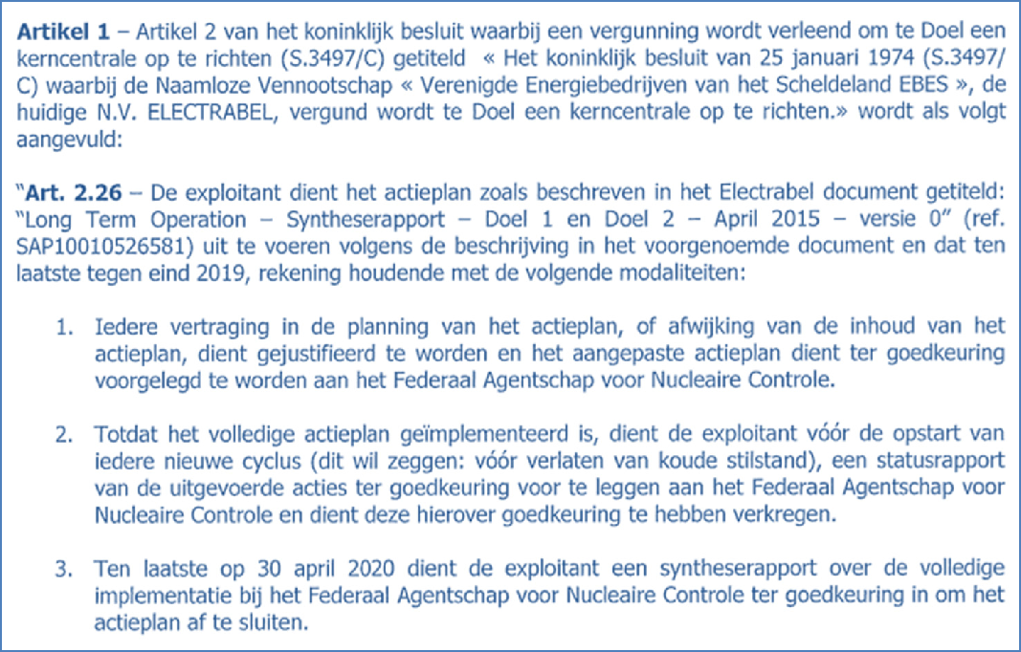

Royal Decree ANPP-0011847 [REF 4]: article 2 of the operating licence was supplemented with article 2.26

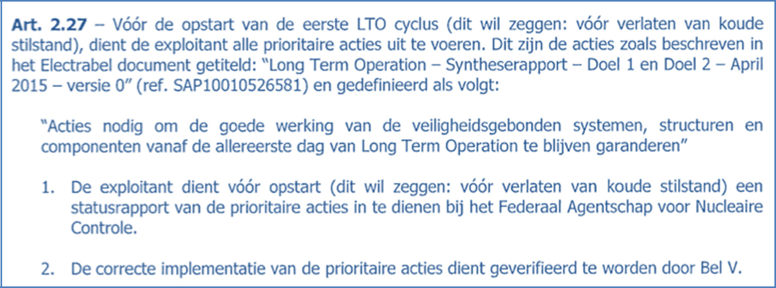

Royal Decree ANPP-0011847 [REF 4]: article 2 of the operating licence was supplemented with article 2.27
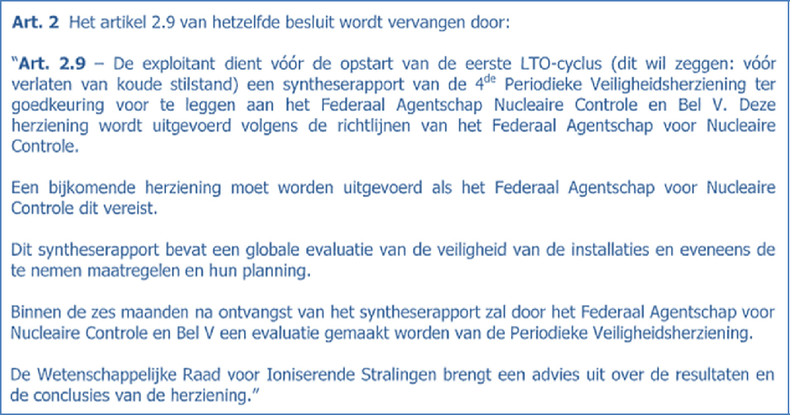

Royal Decree ANPP-0011847 [REF 4]: article 2.9 of the operating licence was replaced by a new article 2.9

Legal and economic framework

The legislative amendment of 28 June 2015 [REF 3] within the framework of the gradual phasing out of nuclear energy, the agreement with the Belgian government of 30 November 2015 and the legislative amendments of 12 June 2016 and 25 December 2016 concerning the nuclear contributions created a judicial and economic framework for the lifespan extension of Doel 1 and Doel 2. The new end data for the two nuclear units was established on 15 February 2025 for Doel 1 and on 1 December 2025 for Doel 2.

- Status Integrated Action Plan

In accordance with the requirements in the operating licence, Electrabel must regularly report to the FANC about the status of the Integrated Action Plan. For this purpose, Electrabel remitted the following LTO Status Reports to the FANC:

Date | Report | Reference
20 April 2020 | LTO Status Report Doel 1 | [REF 13]
27 March 2020 | LTO Status Report Doel 2 | [REF 12]
08 February 2019 | LTO Status Report Doel 1 | [REF 11]
07 January 2019 | LTO Status Report Doel 2 | [REF 10]
07 July 2017 | LTO Status Report Doel 1 | [REF 9]
14 June 2017 | LTO Status Report Doel 2 | [REF 8]
10 October 2016 | LTO Status Report Doel 1 | [REF 7]
07 June 2016 | LTO Status Report Doel 2 | [REF 6]
18 December 2015 | LTO Status Report Doel 1 and Doel 2 | [REF 5]

Each of these status reports followed the structure of the project portfolio as indicated in the initial LTO Synthesis Report, being five components with a total of thirteen packets:

Content and summary of packets
2.1 | Review LTO-dossier 2012
 | 2.1.1 | LTO Ageing Mechanical
 | 2.1.2 | LTO Ageing Electrical and I&C
 | 2.1.3 | LTO Ageing Engineering
 | 2.1.4 | LTO Design
 | 2.1.5 | LTO Preconditions and Management of Competencies, Knowledge and Behaviour
2.2 | Re-evaluation BEST-project
2.3 | Ten-year Revisions
2.4 | Extra inspections in terms of LTO
2.5 | Other projects
 | 2.5.1 | Installation changes
 | 2.5.2 | Doel Nuclear Power Plant Projects
 | 2.5.3 | Electrabel Corporate Projects
 | 2.5.4 | Non-conformity reports (NCR)
 | 2.5.5 | Delta 2012-2015 as a result of operating from the DSZ-vision instead of LTO-vision

Please find below the last status summary per packet that was drawn up of the most important actions.

2.1 Review LTO-dossier 2012

2.1.1 LTO Ageing Mechanical

All priority actions were implemented and checked by Bel V in the domain LTO Ageing Mechanical. These actions guarantee correct management of the ageing effects on the SSC in this specific domain. The most important actions that could be realised after the restart have also been implemented in the meantime.

Inspection actions | Priority | After Restart
Inspection of all parts of the reactors:  reactor lids, baffle bolts, split pins, instrument transits (BMI) at the bottom of the reactor of Doel 1.waD | Implemented
Further periodic follow-up of the reactor lid penetrations and the CRDMs and the actions resulting from it |  | Implemented
Replacement of the split pins |  | Implemented
Inspection of FW baffle boxes, small bore piping, bolts for the presence of material 17-4PH and other small | Implemented
Ultrasonic density measurements and boroscopic inspections on components | Implemented
Inspection of mechanical structures (baseline inspection) | Implemented
Inspection of fire-resistant barriers (doors, penetrations, fire dampers) | Implemented

Fatigue analyses (TLAA) | Priority | After Restart
Number of zones of the pressure control vessels | Implemented
Regenerative heat exchanger of the CV-circuit (Chemical and Volume control system) | Implemented
nozzles and baffle boxes in the feed water lines to the steam generators | Implemented

Improvement actions | Priority | After Restart
Optimisation of the maintenance programmes on mechanical active components (RCM or Reliability Centred Maintenance) | Implemented
Drafting a check-list for visual inspection of structures for the systems in buildings RGB, TUR and GNH | Implemented
Expansion of the inspection programme on pressurised bimetallic welds on penetrations | Implemented

2.1.2 LTO Ageing Electrical and I&C

All priority actions were implemented and checked by Bel V in the domain LTO Ageing Electrical and I&C. The most important actions that could be realised after the restart have also been implemented in the meantime.

Inspection actions | Priority | After Restart
Inspection of the electrical power supply boards and  power switches (AC and DC) | Implemented
Inspection of the cabinets with control and steering circuits in the relay rooms (including the balance of the dampers on which the cabinets are mounted) | Implemented
Inspection of a representative number of smaller electrical cabinets that do not contain active components | Implemented
Inspection of other components that are necessary to demonstrate that they comply with the qualification requirements. | Implemented

Changes and/or replacements | Priority | After Restart
Qualified 380 V-motors of pumps, valves and ventilators and 6 kV-motors of pumps (replacement and/or upgrade) | Implemented
Accessories (positioning, boosters, membranes, etc.) of  pneumatic and hydraulic drives | Implemented
Transmitters | Implemented
Takeover machines 6 kV and fire detection system (previously implemented in the period 2012-2015) | Implemented
Reactor security system (CPR) |  | Implemented
Process controls (Teleperm, SIP) |  | Implemented
Instruments of reactor measurement chains (SIN) |  | Implemented
Operation, alarm signalling and control systems in the  control room (KZ) |  | Implemented
Electrical feeds and switches |  | Implemented
Scram breakers |  | Implemented
Non-safety-related 380 V-boards and switches  (replacement, retrofit or major maintenance) |  | Implemented

Qualification, documentation and maintenance 1EA, 1EB and 1EC | Priority | After Restart
Components with formal RSQ: every non-conformity is  eliminated | Implemented
Components 1EA and 1EB exposed to radiation: based on technical analyses and/or qualification tests, a sufficient qualified lifespan has been demonstrated or they have been replaced by a new component with formal RSQ- components  1EB without exposure to radiation and components  1EC; a justification has been drawn up on the basis of technical analyses, inspections and maintenance work.  These components get a formal RSQ implemented after the restart on the basis of technical analyses and/or qualification tests or are replaced by a new component with formal RSQ | Implemented

2.1.3 LTO Ageing Engineering

The expansion and/or adjustment of the existing inspection programmes was essential in this domain.

Expansion of the ISI-programme for engineering structures | Priority
Inspection procedures adjusted | Implemented
Maintenance plans supplemented | Implemented
Existing ISI-inspection programme upgraded with an inspection periodicity per group of engineering structures | Implemented
New inspection of various structures analogously with these that have been implemented in the preparation of the LTO-report in 2011 | Implemented

It is evident from the results of all inspections, also those from the period between 2012 and 2015, that all buildings are in good condition. The maintenance of the expanded inspection programmes by the O&M-organisation shall continue to guarantee the good condition in the future.

Inspection actions and actions ensuing from it | Priority | After Restart
Implementation of the inspections and the actions resulting from it according to the expanded programme | - | Implemented
Placement and/or repair of measuring points and instruments | Implemented

Curative actions | Priority | After Restart
Investigation to determine the impairment profile and the necessary curative actions (core drill holes in concrete walls, inspections and measurements for chimneys, etc.) in collaboration with specialised labs | - | Implemented

Renovation work | Priority | After Restart
Concrete renovation work on the water intake | - | Implemented
Renovation of the chimneys of the Nuclear Emergency Services Building |  | Implemented
Outer walls of the Nuclear Emergency Services Building: façade renovation |  | Implemented

2.1.4 LTO Design

The Agreed Design Upgrade (ADU) contains design improvements originating from the LTO-project and the BEST-project (see 2.2 ‘Re-evaluation BEST-project’).

Design actions | Priority | After Restart
Targeted improvement of the air density of the control room (KZ) |  | Implemented
New, submersible pumps to fill the raw water cooling tower with water from the river Scheldt |  | Implemented
New, seismic fire brigade pump station with larger fire brigade pumps and larger fire brigade tank |  | Implemented
Containment Filtered Venting System (CFVS) |  | Implemented
Automatism in the Emergency Systems Building to fill the steam generators |  | Implemented
In the Emergency Systems Building: 2 emergency cooling system pumps per unit instead of one |  | Implemented
Deduplicate the valves on the suction of the Sc-circuit from the RC-circuit |  | Implemented
Improve automatic fire extinguishing in the machine room (MAZ) |  | Implemented
Improve fire barriers and automatic fire extinguishing in Nuclear Emergency Services Building |  | Implemented
Improve fire barriers and automatic fire extinguishing in the Reactor Building |  | Implemented

2.1.5 LTO Preconditions and Management of Competencies, Knowledge and Behaviour

All actions in the domain of Preconditions have been implemented.

Precondition actions | Priority | After Restart
The current reliability centred maintenance project is completed and integrated in the existing maintenance process | Implemented
The current qualification synthesis report project is executed in accordance with what is described in 2.1.2 ‘LTO Ageing Electrical and I&C’ | Implemented
The strategy regarding OPTIMOV-tests has been elaborated and a programme is established (including the execution of a number of tests in consultation with the Physical Control  Department) taking into account the pilot project at  Tihange 1 | Implemented
The system health report process is applied to the most important systems, structures and components in scope for LTO Ageing. There is a more strict and more goal-oriented follow-up of the on the corrective actions resulting from the system health report.  The key performance indicators that are connected to the system health reporting process are  elaborated further. | Implemented

The improvement actions planned in 2012 in the domain of Management of Competencies, Knowledge and Behaviour were mostly implemented within the framework of other action plans. The remaining points are executed further as part of the continuous improvement. It concerns more specifically the further refining of the management of Design Basis competencies for the different roles within the processes Design Authority & Configuration Management. This unfolds in collaboration with Corporate, Tihange and Tractebel ENGIE. Where necessary, the tools Nuclear Skills Analysis and Competency Matrices will be adjusted. The reason for this is reinforced governance in this regard.

All of this is also reviewed by the experts during the SALTO-mission (see chapter 3 SALTO audit programme Doel 1 and Doel 2), with a positive result.

2.2 Re-evaluation of the BEST-project

A number of improvement actions in terms of organisation, hardware, procedures, etc. originated from the Resistance Tests (BEST). The implementation of these actions started nearly immediately and have all been completed in the meantime.

Improvement actions (BEST) | Priority | After Restart
Completion of the fixed riser pipes to the docks in the Nuclear Emergency Services Building |  | Implemented
New mobile pumps and diesel generators (currently rented material) |  | Implemented
Additional hydraulic connection points |  | Implemented
Additional electrical cabling |  | Implemented
Additional valves in the SP spray pipes |  | Implemented
Seismic reinforcement of the refueling water storage tanks and the addition of a seismic riser pipe for filling purposes |  | Implemented

2.3 Ten-Year Revisions

The timely submission of a synthesis report about the fourth Ten-Year Revision has been adopted in the adjust licensing conditions [REF 4] as a priority action. This report was submitted on 30 November 2015. The improvement actions that resulted from this fourth Ten-Year Revision were planned for the period 2016-2020, as validated by the FANC, and are being executed or have been implemented in the meantime.

Below is the status of the most important actions in the action plan

Improvement actions (TJH) | Priority | After Restart
Deduplication of component cooling supply of coolers in the shut-down cooling basement |  | Implemented
Separation of electrical polarities |  | Implemented
Installation of new toxic gas measurements |  | Implemented
Upgrade of polar bridges Doel 1 and Doel 2 |  | Implemented
Deduplication of FW-return valves |  | Implemented
Plant-specific steam general pipe rupture |  | In progress 2020
Compilation of an inventory of safety studies |  | Implemented
Drafting of qualification reports for active safety-related pumps and ventilators |  | In progress 2020

2.4 Extra inspections on the basis of LTO

Due to the later execution of the previous LTO-action plan, the domain Ageing received more attention in the form of extra inspections. These inspections produced positive results and were discussed during the different consultations with Bel V.

Inspection actions | Priority | After Restart
Inspection of reactor vessels for the absence of hydrogen inclusions | Implemented
Inspection of the penetrations of the reactor lids | Implemented
Inspection of turbines | Implemented
Inspection of vital electrical signs (alternating current and direct current) | Implemented
Inspection of preselected rooms by fire experts | Implemented
Inspection of a number of control bars (ring gauging) | Implemented

2.5 Other projects

2.5.1 Installation changes

Out of all installation changes that were activated again after the LTO-decision, one was implemented as a priority:

Installation changes | Priority | After Restart
Change of fire detection on the primary pumps | Implemented

All other changes fit within the framework of the continuous improvement and were implemented in accordance with the normal processes.

2.5.2 Doel Nuclear Power Plant Projects
These were the most important projects in this package

Projects | Priority | After Restart
Retrofit of the turbine and the turbine control system |  | Implemented
Replacement of the head and house transformers |  | Implemented
Improvement of the fire extinguishing system in the machine room (MAZ) |  | Implemented

2.5.3 Electrabel Corporate Projects

Within the framework of the new WENRA-legislation, a number of studies had to be conducted at the end of 2015. This did not appear to be feasible for Doel 1 and Doel 2 since not all data was available and the average term for conducting the studies is more than one year.

All studies have been conducted in the meantime, but have given rise to a number of additional actions.

Electrabel Corporate Projects | Priority | After Restart
OPTIMOV: within the framework of the LTO Preconditions, a test campaign was prepared and performed as a priority. The accompanying programme is implemented further. |  | Implemented
Barsebäck: to stay in line with the hypothesis for  qualification of the previously installed recirculation filters, the aluminium hydroxide powder will be removed from the so-called powder holes |  | Implemented
Data collect and cable routing: serves as input for fire hazard analysis and Fire PSA Level 1. Status: partially implemented in the period 2012-2015 and incorporated again in the LTO-vision. |  | Implemented
Flooding PSA Level 1: realisation of the first iteration of the study according to the existing methodology. Experience shows that this first iteration mostly suffices (first analysis already conducted as part of the LTO Design). |  | Study in 2011
FHA (Fire Hazard Analysis): realisation of the study in accordance with the IAEA-methodology (first analysis already conducted as part of the LTO Design) |  | Study in 2011
Fire PSA Level 1: realisation of the study of both iterations in accordance with the existing methodology |  | Study in 2011
All additional actions as a result of the FHA and Fire PSA studies are bundled in an integrated action plan (new since the end of 2017). |  | 2020 Partial revision are implemented

WENRA Safety Reference Levels (SRL) of 2014 concerning earthquakes were recently implemented in binding Belgian regulations. Electrabel has provided for an additional action plan during this period of transition. The FANC agrees that the following projects are defined and integrated proactively in the LTO-programme for Doel 1 and Doel 2

Additional projects (WENRA SARL) | Priority | After Restart
Execute Seismic Margin Assessment for Doel 1 and Doel 2 |  | Study are Implemented
Realisation of agreed upon changes as a result of a combination of earthquake recirculation phase |  | Implemented
Action plan as a result of the Seismic Margin Assessment (new Partial revision since the end of 2018) are implemented |  | Partial revision  since the end of 2018)  are implemented

2.5.4 Non-conformity reports (NCR)

All existing NCRs have been analysed within the LTO-framework to verify whether there are situations or actions that can prevent a restart of Doel 1 and Doel 2 after forty years, and whether there are situations or actions that can potentially impact the nuclear safety. The analysis demonstrated that there is not a single NCR that prevents the restart. The normal processes continue.

2.5.5 Delta 2012-2015

In preparation for the restart, all decisions from the period 2012-2015 that have been reviewed by the Plant Operations Review Committee (PORC) have been re-evaluated. The most important additional actions were:

Delta 2012-2015 | Priority | After Restart
Replacement of the pneumatic insulation valves on the Implemented thermal barriers of the primary pumps |  | Implemented
Placement of redundant insulation valves on the Implemented water excess heat exchangers |  | Implemented

- SALTO-audit programme Doel 1 and Doel 2

The lifespan extension of Doel 1 and Doel 2 was linked to a number of important conditions. One of which was the execution of a SALTO-audit (Safety Aspects of Long-Term Operation), and the correct implementation of the recommendations resulting from it.

That is why, upon request of the Ministry of Internal Affairs and the Federal Agency for Nuclear Control (FANC), the International Atomic Energy Agency of the United Nations (IAEA) launched a SALTO-audit of the LTO-programme of Doel 1 and Doel 2.

- This means that independent nuclear expects checked the management of physical and non-physical ageing during the entire LTO-period in Doel 1 and Doel 2 against the IAEA-standards and international good practices.

As part of this audit, an initial expert mission took place in February 2016 in preparation of the expanded SALTO-mission of February 2017. During this mission, twelve international experts examined the LTO-approach of Doel 1 and Doel 2 under the leadership of the IAEA. The expert panel examined the following domains:

- Organisation, licensing, configuration and change management

- Scoping, screening and plant programmes that are relevant for LTO

- Ageing Management and programmes in the domain of mechanical components

- Ageing Management and programmes in the domain of Electrical and I&C

- Ageing Management and programmes in the domain of engineering structures

- Human Resources, competency and knowledge management for the full LTO-period

The SALTO-experts concluded during the final meeting and in their report that the installations of Doel 1 and Doel 2 are in good condition, that the recommendations of the expert mission in 2016 are adequately incorporated and that the current approach is in line with the safety standards of the IAEA and the international good practices. The experts also identified a number of good practices.

Additionally, the SALTO-experts formulated some additional recommendations and suggestions to further improve the ageing management over the entire LTO-period:

- The plant must continue to comply with all systems, structures and components that are necessary in the long term via the ageing management during the entire LTO-period.

- The plant must continue to guarantee the uniformity and completeness of databases about structures and components over the entire LTO-period.

- The plant must further review the existing ageing management for engineering structures as provided for, and adjust where necessary.

In order to correctly implement the recommendations of this SALTO-mission, Doel 1 and Doel 2 drafted a new action plan and implemented it. The results of this action plan are assessed in June 2019 by international SALTO-experts during a SALTO Follow-Up mission.

According to the experts, the nuclear power plant of Doel has made sufficient progress since the audit of 2017. The operator has, among other things, ensured an improved competency and knowledge transfer in the staff that is involved in the ageing management process. The started programmes are further completed. Further steps must also be taken to guarantee that all necessary infrastructures and components are incorporated in the ageing management programme.

- Planning Integrated Action Plan

Significant efforts were made to elaborate a planning concept for the joint revisions of Doel 1 and Doel 2 in 2018 and 2019.

The LTO Synthesis Report [REF 1] of 17 April 2015 provided a description of the overall time frame, the general marginal conditions and the specific marginal conditions in the Integrated Action Plan in chapter 5 (page 33 to 35). In addition to these conditions, there are three more important parameters that have influenced the establishment of the planning:

- The work on the electrical polarities

- The disposal of subsequent heat as a result of the simultaneous discharging of the cores of Doel 1 and Doel 2 in the summer months.

- The ventilation of the reactor building as a result of the necessity to make openings in the containment.

Multiple scenarios were studied and evaluated. Based on that evaluation, the scenario below was eventually chosen.

Joint revision of Doel 1 and Doel 2 in 2018

- Perform maximum work on Doel 2 according to electrical polarities 22 and 24

- Perform all work that requires a complete discharge of Doel 2

- Perform work that makes an opening in the containment of Doel 2

Joint revision of Doel 1 and Doel 2 in 2019

- Perform maximum work on Doel 1 according to electrical polarities 12 and 14

- Perform all work that requires a complete discharge of Doel 1

- Perform work that makes an opening in the containment of Doel 1

All projects with an expected realisation in the period 2018-2019 were completely aligned with this planning concept.

As a result of the UPI-problems, the planning concept was slightly adjusted for the revision of 2018. It was opted to fully discharge the core of both Doel 1 and Doel 2. As a result of this longer stop, the work that falls under “perform work that makes an opening in the containment of Doel 1” and was expected for 2019 has already been performed in 2018. This approach was repeated in 2019 due to the positive experience in 2018 with the complete discharge of the cores of Doel 1 and Doel 2. This is how the additional UPI-inspections were also simply integrated in the planning. A thorough After Action Review was also performed on the 2018 revision to successfully integrate the experience gained in the preparation and implementation of the 2019 revision.

ENGIE Electrabel has each time reported the state of affairs and adjustments of the project via periodic consultation with the FANC, Bel V and the Physical Control Department.

- Human Resources

The long-term operation of Doel 1 and Doel 2 created an obvious need for additional personnel. The extra recruitments that were announced in the LTO Synthesis Report have been realised in the meantime: a total of 140 employees were contracted for the basic organisation of the Doel Nuclear Power Plant and 60 employees for the LTO-organisation. Meanwhile, ENGIE Electrabel continues to recruit extra employees to absorb any movement of personnel in a timely manner.

Basic Organisation Nuclear Power Plant Doel and LTO-organisation

In the beginning of 2015, more than half of the vacancies were launched, followed by a second wave in the beginning of 2016. Since then, ENGIE Electrabel continues to open vacancies. A state of affairs:

- Fourteen young engineers started the Nuclear Traineeship of ENGIE Electrabel in the autumn of 2015. Eight young engineers entered this programme in 2016, twelve in 2017, five in 2018 and seven in 2019.

- A lot of employees at Operations have commenced the training in 2015 to obtain a nuclear licence. In response to the decision to further expand the staffing of the control rooms, people were recruited and additional training cycles were started. The recruitments continued until 2019, and the accompanying training cycles continue. Eleven employees took their licence exam with a favourable evaluation (in collaboration with Bel V) in 2017, eighteen did in 2018 and eleven in 2019. Seventeen colleagues are currently in training, of whom according to the current expectations eight will take their licence exam in the spring of 2020. Furthermore, other profiles such as electricians, supervisors and chemists were attracted within Operations.

- All crucial technical positions were filled at Maintenance and Engineering: experts, project managers, work planners, etc. Vacancies were opened for more than one hundred additional technical profiles, including a lot of engineers in the different domains (mechanical, electrical, I&C, etc.) for the entire site in the past few years. The vacancies that are currently still open rather have the goal of ensuring the further continuity.

Remark: the most difficult to attract profiles appear to be the professional technical bachelors given the scarcity on the job market, the proximity of the other industries in the port of Antwerp and the mobility challenges in this region. The recruitment action plan takes into account this specific situation in its branding, sourcing and remuneration actions. The operational collaboration with external parties constantly gets our attention.

In the meantime, the most extra employees have been recruited at Care in for instance the domains of radiation protection, safety and the environment.
- The LTO-organisation was composed with employees from the DSZ-team, Engineering, Maintenance and Tractebel ENGIE. These shifts, in turn, paved the way for new vacancies in the basic organisation of the Doel Nuclear Power Plant.

Currently, a total of more than 250 new employees are under contract. The appropriate integration, as well as the efficient filling of the training nodes of the new employees is specifically ensured.

5.2 Tractebel ENGIE

In order to determine the required engineering resources and competencies, the Integrated Action Plan for Doel 1 and Doel 2 has been used as basis. This has shown that the focus is mostly in the domains of Electrical and I&C and that the total workload for engineering is comparable to the LTO Tihange 1 project. Since the summer of 2015, an average of sixty full-time equivalents are involved in LTO Doel 1 and Doel 2. This number increased to eighty in 2016 and even to more than one hundred in 2017. As for the years 2018 and 2019, this number stabilised around eighty full-time equivalents. The current actions described in the initial LTO Synthesis Report to realise the filling of these resources remain applicable in full force and effect.

6 General decision

ENGIE Electrabel uses this LTO Synthesis Report to consolidate its intention to further operate Doel 1 and Doel 2 in a justifiable safe manner. The report demonstrates that all actions of the initial Integrated Action Plan have been implemented.

All actions after the restart fit within the framework of the continuous improvement of the safety. The planning was to realise these within three to five years with the focus on the revisions of 2018 and 2019. Both plants are simultaneously put into a standstill during these revisions, as a result of which these are shut down for a number of months. Both large revisions for Doel 1 and Doel 2 have been completed in the meantime.

A limited number of actions - which developed after the determination of the initial action plan “Long-Term Operation - Synthesis Report - Doel 1 and Doel 2 - April 2015 - Version 0” - are still in progress and will be terminated before 31 December 2020 as proposed and approved by the FANC. In essence, these actions are the result of studies conducted between 2015 and 2018.

Just like in the past, constant periodic consultation with Bel V remains provided for. The claims are discussed transparently during that consultation and the correct implementation is verified, which is completely in line with the additional conditions in the operating licence.

Sending this Synthesis Report is a requirement to conclude the action plan. However, this is not yet possible since a number of actions that were added later on still need to be worked on. Once these have been implemented in accordance with the agreements, ENGIE Electrabel will make a new version of this Synthesis Report to finalise the completely implemented action plan.

The amendment of law of 28 June 2015 as part of the gradual phasing out from nuclear energy, the agreement with the Belgian government dated 30 November 2015 and the amendments of law of

12 June 2016 and 25 December 2016 regarding the nuclear contributions created a legal and economic framework within which ENGIE Electrabel can make the necessary but significant investments in a justified manner to extend the lifespan of Doel 1 and Doel 2 by ten years. As operator, ENGIE Electrabel will also continue to invest in its human resources. It is clear that ENGIE Electrabel will have properly trained and competent people at its disposal for the future operation and further realisation of the action plan.

The important investments in employees, technical systems, methods and continuous improvement are the best guarantee for a high level of nuclear safety, reliability and availability of the nuclear power plants in Doel.

- Abbreviations

Abbreviation |  | Meaning
AC |  | Alternating Current
ADU |  | Agreed Design Upgrade
Bel V |  | Body for the control of nuclear systems (branch of FANC)
BEST |  | Belgian Stress Tests (= in response to events in Fukushima)
BMI |  | Bottom Mounted Instrumentation (of reactor)
CC |  | Component Cooling – interim cooling circuit
CFVS |  | Containment Filtered Venting System
CRDM |  | Control Rod Drive Mechanism
CPR |  | Reactor Protection Circuit
CV |  | Chemical and Volume control system (CV-circuit)
DC |  | Direct Current
DSZ |  | Final stop of electricity production
FANC |  | Federal Nuclear Control Agency
FE |  | Fire Extinction
FHA |  | Fire Hazard Analysis
FW |  | Feed Water
GNH |  | Nuclear Emergency Services Building
GNS |  | Emergency Systems Building
I&C |  | Instrumentation and Control
IAEA |  | International Atomic Energy Agency
ISI |  | In-Service Inspection
KPI |  | Key Performance Indicator
KZ |  | Control room
LTO |  | Long-Term Operation
MAZ |  | Machine room
NCR |  | Non-conformity Report
O&M |  | Operation & Maintenance
OPTIMOV |  | Optimisation Motor Operated Valve (replaces previous MOVATS)
PORC |  | Plant Operations Review Committee
PSA |  | Probabilistic Safety Analysis
RC |  | Reactor Coolant – primary cooling circuit
RCM |  | Reliability Centred Maintenance
RGB |  | Reactor Building
RJ |  | Emergency injection system at seals no. 1 of the primary pumps
RSQ |  | Synthesis Report of the Qualification
RW |  | Raw water circuit (safety-related cold source)
RWST |  | Refuelling Water Storage Tank
SALTO |  | Safety Aspects of Long-Term Operation

Abbreviation |  | Meaning
SC |  | Shut-down Cooling
SHR |  | System Health Reporting
SIN |  | Nuclear Instrumentation System
SIP |  | Protection Instrumentation System
SP |  | Containment Spray – spray system in the primary containment
SRL |  | Safety Reference Level
SSC |  | Systems, Structures and Components
TJH |  | Ten-Year Revision of the safety status
TLAA |  | Time-Limited Ageing Analyses
TUR |  | Gap - space between primary and secondary containment
UPI |  | Upper Plenum Injection
WENRA |  | Western European Nuclear Regulators’ Association

- References

No | Title
1 | Long-Term Operation Doel 1 and Doel 2: Reminder of safety requirements to approve the long-term operation of the reactors of Doel 1 and Doel 2 in case of the nuclear gradual phase-out act of 2003 (Note AFCN 2014-09-12-FH-5-4-2-FR)
2 | Long-Term Operation – Synthesis Report – Doel 1 and Doel 2 – Version 0 – 17 April 2015 (ENGIE Electrabel report SAP 10010526581)
3 | Belgian Law Gazette Numac 201511262 - Royal Decree of 28 June 2015 - law to amend the law of 31 January 2003 relating to the gradual phase-out from nuclear energy for industrial electricity production in view of ensuring the certainty of supply in terms of energy.
4 | KB ANPP-0011847 - Royal Decree where the licensing conditions of the nuclear reactors Doel 1 and Doel 2 are supplemented within the framework of the long-term operation
5 | Long-Term Operation – Status Report – Doel 1 and Doel 2 – Version 0 – 18 December 2015 (ENGIE Electrabel report SAP 10010581957)
6 | Long-Term Operation – Status Report – Doel 2 – Version 0 – 7 June 2016 (ENGIE Electrabel report SAP 10010608686)
7 | Long-Term Operation – Status Report – Doel 1 – Version 0 – 10 October 2016 (ENGIE Electrabel report SAP 10010642560)
8 | Long-Term Operation – Status Report – Doel 2 – Version 0 – 14 June 2017 (ENGIE Electrabel report SAP 10010692634)
9 | Long-Term Operation – Status Report – Doel 1 – Version 0 – 07 July 2017 (ENGIE Electrabel report SAP 10010700148)
10 | Long-Term Operation – Status Report – Doel 2 – Version 1 – 07 January 2019 (ENGIE Electrabel report SAP 10010806920)
11 | Long-Term Operation – Status Report – Doel 1 – Version 0 – 08 February 2019 (ENGIE Electrabel report SAP 10010806919)
12 | Long-Term Operation – Status Report – Doel 2 – Version 0 – 27 March 2020 (ENGIE Electrabel report SAP 10010949311)
13 | Long-Term Operation – Status Report – Doel 1 – Version 0 – 20 April 2020 (ENGIE Electrabel report SAP 10010949310)

