

Appropriate Assessment Screening for proposed improvements on cycle and pedestrian facilities around Wellington Lane, Templeogue, Co. Dublin.
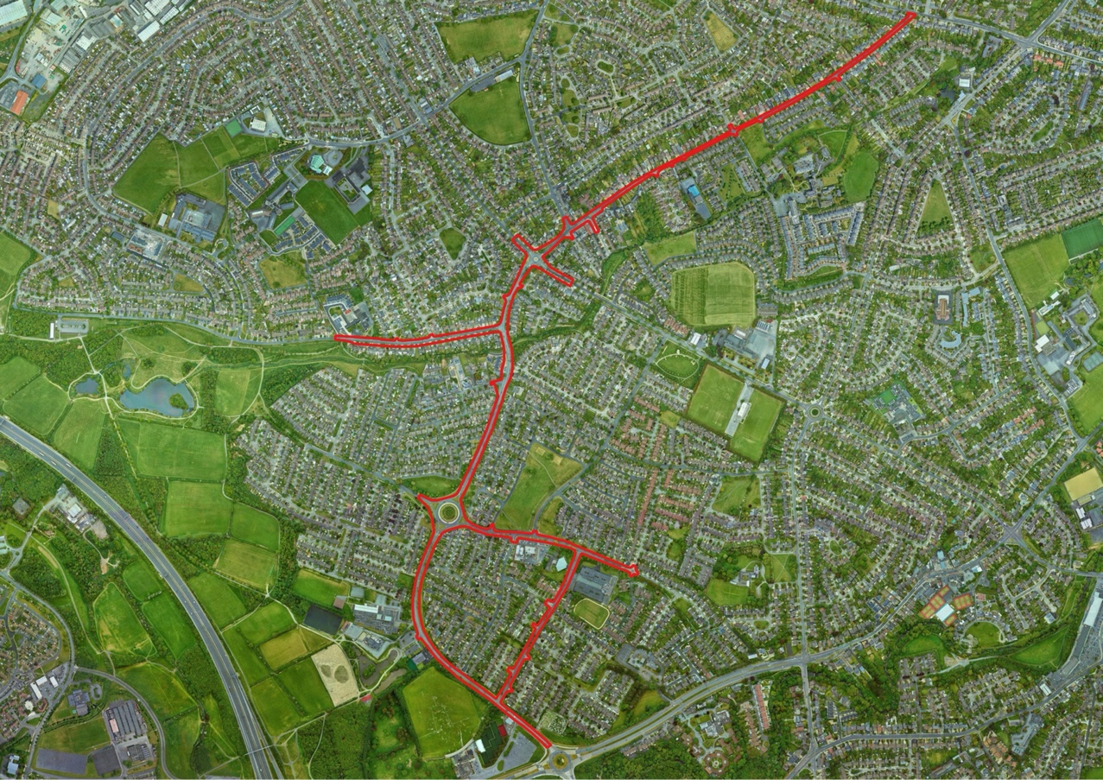
9th August 2022

Prepared by: Bryan Deegan (MCIEEM) of Altemar Ltd.
On behalf of: South Dublin County Council

Altemar Ltd., 50 Templecarrig Upper, Delgany, Co. Wicklow. 00-353-1-2010713. info@altemar.ie
Directors: Bryan Deegan and Sara Corcoran
Company No.427560 VAT No. 9649832U
www.altemar.ie

Document Control Sheet
Project | Appropriate Assessment Screening for proposed improvements on cycle and pedestrian facilities around Wellington Lane, Templeogue, Co. Dublin.
Report | Appropriate Assessment Screening
Date | 5th August 2022
Project No: |  | Document Reference:
Version | Author | Reviewed | Date
A | Bryan Deegan |  | 5th August 2022
Planning | Bryan Deegan |  | 9th August 2022

Contents
Introduction 1
Altemar Ltd. 1
Background to the Appropriate Assessment 2
Methodology 4
Stage 1 Screening Assessment 5
Management of the Site 5
Description of the Proposed Project 5
Identification of Relevant Natura 2000 Sites 3
Construction and Operational Impacts 17
In-Combination Effects 17
Conclusions 18
Findings of No Significant Effects Report 19
Data Used for AA Screening 20
References 20

Introduction
The following Appropriate Assessment (AA) (Screening Stage) has been prepared by Altemar Ltd. at the request of South Dublin County Council (SDCC) for the development of the Wellington Lane Walking & Cycle Scheme..
An Appropriate Assessment is an assessment of the potential effects of a proposed project or plan, on its own, or in combination with other plans or projects, on one or more NATURA 2000 sites. Natura 2000 sites are those sites designated as Special Areas of Conservation (SAC) or Special Protection Areas (SPA).
The AA (screening stage) examines the likely significant effects of a plan or project, either on its own, or in combination with other plans and projects, upon a Natura 2000 site and considers whether, on the basis of objective scientific evidence, it can be concluded that there are not likely to be significant effects on any European site, in view of best scientific knowledge and the conservation objectives of the relevant European sites.

Altemar Ltd.
Since its inception in 2001, Altemar has been delivering ecological and environmental services to a broad range of clients. Operational areas include: residential; infrastructural; renewable; oil & gas; private industry; Local Authorities; EC projects; and, State/semi-State Departments. Bryan Deegan, the managing director of Altemar, is an Environmental Scientist and Marine Biologist with 27 years’ experience working in Irish terrestrial and aquatic environments, providing services to the State, Semi-State and industry. He is currently contracted to Inland Fisheries Ireland as the sole “External Expert” to environmentally assess internal and external projects. He is also chair of an internal IFI working group on environmental assessment. Bryan Deegan (MCIEEM) holds a MSc in Environmental Science, BSc (Hons.) in Applied Marine Biology, NCEA National Diploma in Applied Aquatic Science and a NCEA National Certificate in Science (Aquaculture). Bryan Deegan carried out all elements of this Appropriate Assessment Screening.

Background to the Appropriate Assessment
The Habitats Directive (92/43/EEC), together with the Birds Directive (2009/1477/EC), forms the cornerstone of European nature conservation policy. The Directive protects over 1000 animals and plant species and over 200 "habitat types" which are of European importance. In the Directive, Articles 3 to 9 provide the legislative means to protect habitats and species of European Community interest through the establishment and conservation of an EU-wide network of conservation sites (NATURA 2000).
These are Special Areas of Conservation (SACs) designated under the Habitats Directive and Special Protection Areas (SPAs) designated under the Birds Directive. Article 6(3) and 6(4) of the Habitats Directive set out the decision-making tests for plans and projects likely to affect NATURA 2000 sites (Annex 1.1). Article 6(3) establishes the requirement for Appropriate Assessment:
"Any plan or project not directly connected with or necessary to the management of the [NATURA 2000] site but likely to have a significant effect thereon, either individually or in combination with other plans and projects, shall be subjected to appropriate assessment of its implications for the site in view of the site's conservation objectives. In light of the conclusions of the assessment of the implication for the site and subject to the provisions of paragraph 4, the component national authorities shall agree to the plan or project only after having ascertained that it will not adversely affect the integrity of the site concerned and, if appropriate, after having obtained the opinion of the general public."

Furthermore, as outlined in the EC guidance document on Article 6(4) (January 2007):
“Appropriate assessments of the implications of the plan or project for the site concerned must precede its approval and take into account the cumulative effects which result from the combination of that plan or project with other plans or projects in view of the site's conservation objectives. This implies that all aspects of the plan or project which can, either individually or in combination with other plans or projects, affect those objectives must be identified in the light of the best scientific knowledge in the field.
Assessment procedures of plans or projects likely to affect NATURA 2000 sites should guarantee full consideration of all elements contributing to the site integrity and to the overall coherence of the network, both in the definition of the baseline conditions and in the stages leading to identification of potential impacts, mitigation measures and residual impacts. These determine what has to be compensated, both in quality and quantity. Regardless of whether the provisions of Article 6(3) are delivered following existing environmental impact assessment procedures or other specific methods, it must be ensured that:
- Article 6(3) assessment results allow full traceability of the decisions eventually made, including the selection of alternatives and any imperative reasons of overriding public interest.
- The assessment should include all elements contributing to the site’s integrity and to the overall coherence of the network as defined in the site’s conservation objectives and Standard Data Form, and be based on best available scientific knowledge in the field. The information required should be updated and could include the following issues:
  - Structure and function, and the respective role of the site’s ecological assets;
  - Area, representativity and conservation status of the priority and nonpriority habitats in the site;
  - Population size, degree of isolation, ecotype, genetic pool, age class structure, and conservation status of species under Annex II of the Habitats Directive or Annex I of the Birds Directive present in the site;
  - Role of the site within the biographical region and in the coherence of the NATURA 2000 network; and,
  - Any other ecological assets and functions identified in the site.
- It should include a comprehensive identification of all the potential impacts of the plan or project likely to be significant on the site, taking into account cumulative impacts and other impacts likely to arise as a result of the combined action of the plan or project under assessment and other plans or projects.
- The assessment under Article 6(3) applies the best available techniques and methods, to estimate the extent of the effects of the plan or project on the biological integrity of the site(s) likely to be damaged.
- The assessment provides for the incorporation of the most effective mitigation measures into the plan or project concerned, in order to avoid, reduce or even cancel the negative impacts on the site.
- The characterisation of the biological integrity and the impact assessment should be based on the best possible indicators specific to the NATURA 2000 assets which must also be useful to monitor the plan or project implementation.”

Methodology
This Appropriate Assessment screening was undertaken in accordance with the European Commission Methodological Guidance on the provision of Article 6(3) and 6(4) of the 'Habitats' Directive 92/43/EEC (EC, 2001), Part XAB of the Planning and Development Act 2000, as amended, in addition to the December 2009 publication from the Department of Environment, Heritage and Local Government; ‘Appropriate Assessment of Plans and Projects in Ireland: Guidance for Planning Authorities’ and the European Communities (Birds and Natural Habitats) Regulations 2011 and the provision of Article 6 of the Habitats Directive 92/43/EEC (European Commission, 21 November 2018).
In order to comply with the above Guidelines and legislation, the Appropriate Assessment Screening process must be structured as follows:
- Description of the proposed project or plan;
- Identification of NATURA 2000 sites potentially affected;
- Identification and description of individual in combination effects likely to result from the proposed project;
- Assessment of the likely significance of the effects identified above. Exclusion of sites where it can be objectively concluded that there will be no likely significant effects; and,
- Conclusions.

Stage 1 Screening Assessment

Management of the Site
The proposed project is not necessary to the management of a Natura 2000 site.
Description of the Proposed Project
South Dublin County Council (SDCC) are proposing the development of the of the Wellington Lane Walking & Cycle Scheme. The main scheme route, which aims to provide improved cycle and pedestrian facilities, extends from west of the Spawell Roundabout and runs along Wellington Lane, Wellington Road and Whitehall Road, terminating at the Whitehall Road / Kimmage Road West signalised junction. The main scheme route has also been extended to include Rossmore Road, Orwell Road, Templeogue Wood and Limekiln Road. These routes have been included within the scheme in order to provide key links for pedestrians and cyclists to the primary schools located along Rossmore Road (Bishop Galvin & Bishop Shanahan National School) and Limekiln Road (Riverview Educate Together National School). The scheme, over its majority, provides off road protected cycle track facilities. Pedestrian footpaths and crossings are proposed to be upgraded with crossings located on desire lines. Bus stops are proposed to be upgraded along the scheme route where feasible. A landscaping plan has been proposed over the main routes within the scheme that proposes improved urban realm and additional trees along the route.
Drainage
Surface Water Drainage
Gullies located along the majority of the route will be required to be relocated as part of the scheme proposals to locate off road cycle track facilities. Gullies will also be required to be relocated at the Orwell Road and Templeville Road roundabouts as part of the scheme design. Additional hardstanding may be required in some areas of the scheme route. Appropriate attenuation will be specified at detailed design stage if required.

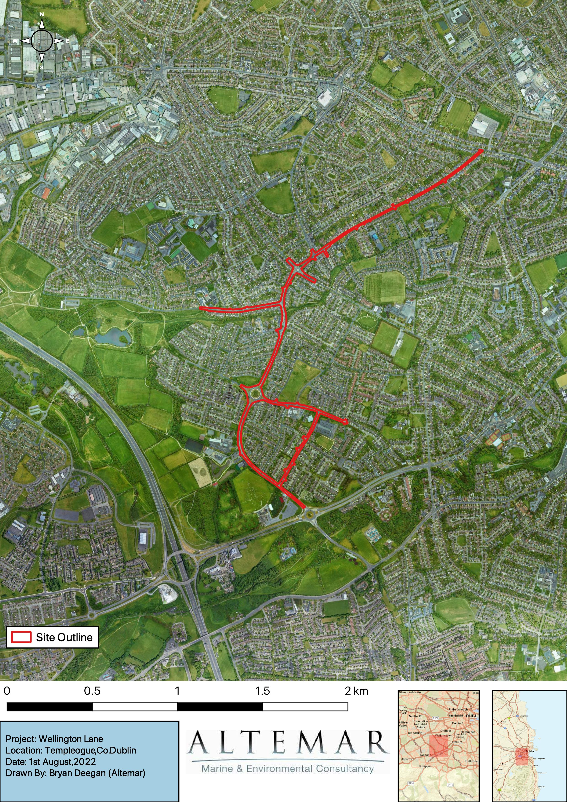
Figure 1. Site Outline.
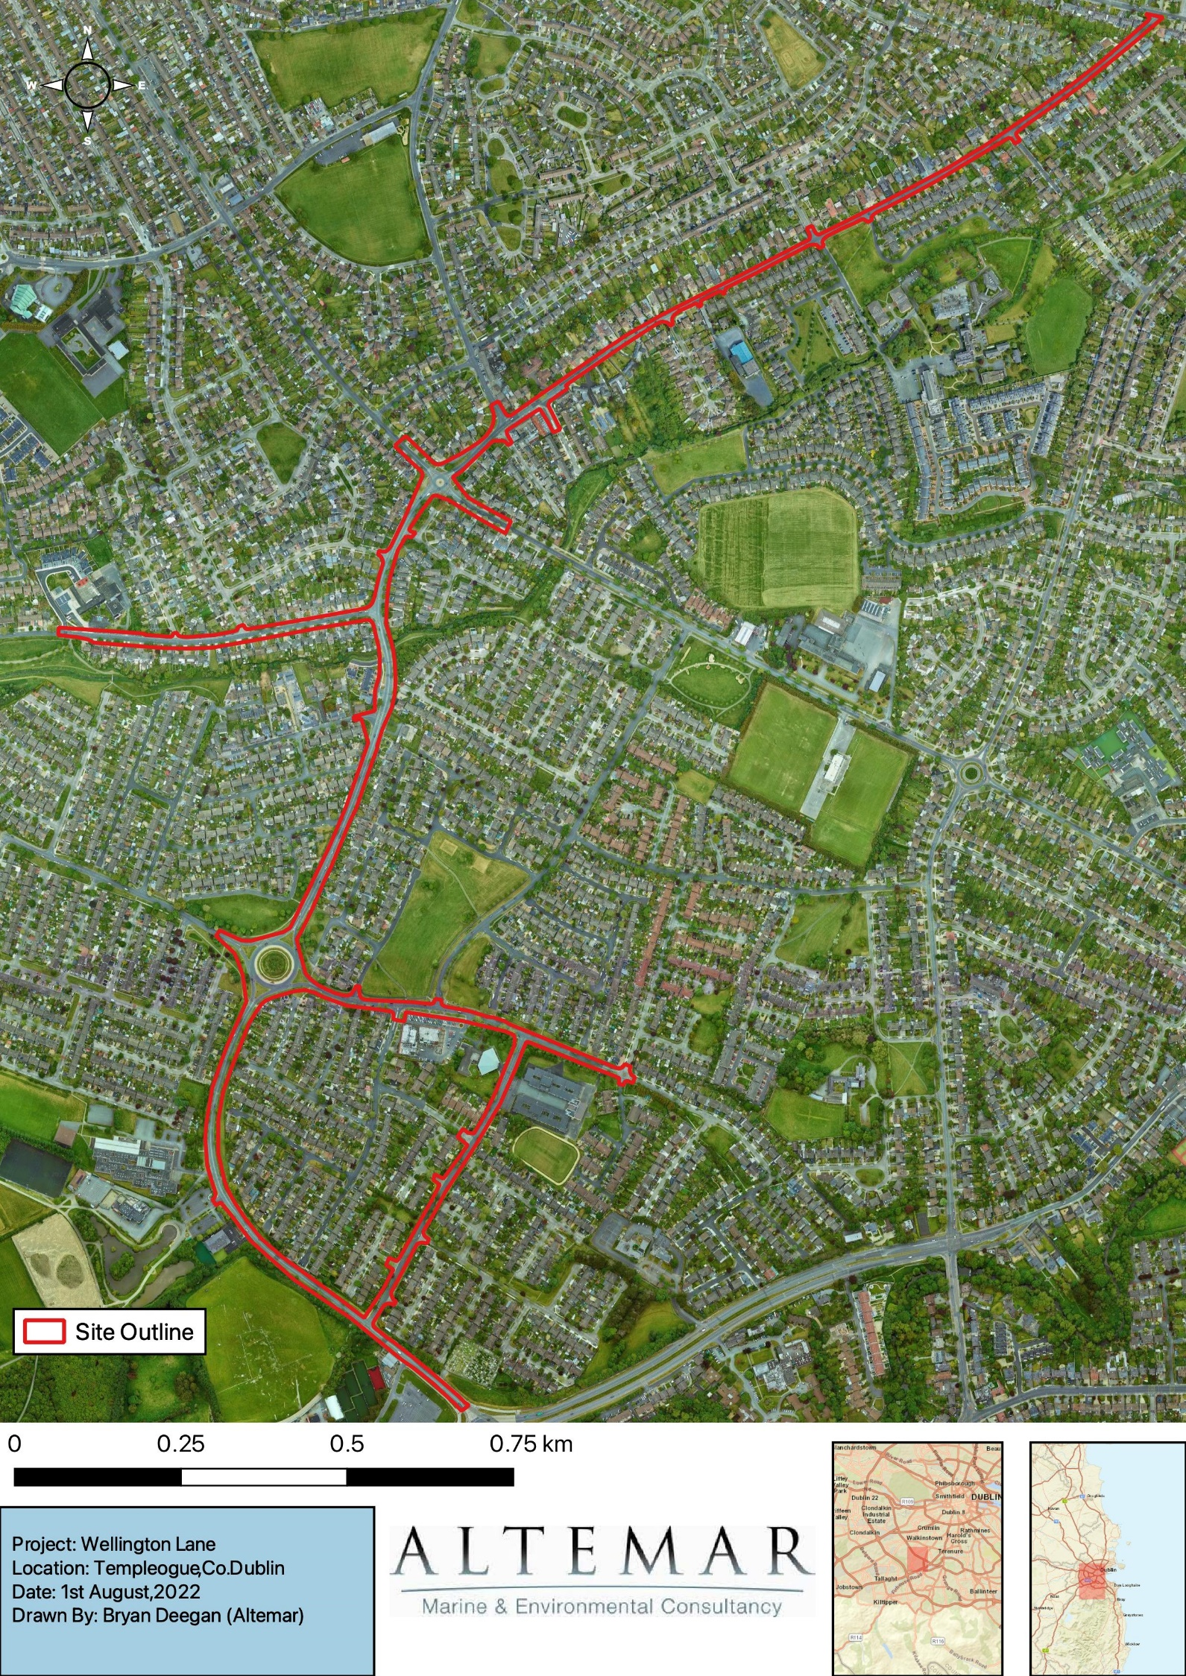
Figure 2. Satellite image of the proposed development site.

Identification of Relevant Natura 2000 Sites
The proposed works are not located within a NATURA 2000 site. The NATURA 2000 sites within 15 kilometres of the subject site are detailed in Table 1 and Figures 6 to 11. Their features of interest and the potential impact of the works on these features of interest are showcased in Table 2.
No Natura 2000 sites are deemed to be in the potential Zone of Influence (ZoI). However, following the precautionary principle, screening of all Natura 2000 sites within 15km and those with a direct/indirect pathway beyond 15km is carried out. It is found there are no Natura 2000 sites with a direct/indirect pathway beyond 15km.
NATURA 2000 Site | Distance | Direct Hydrological / Biodiversity Connection
Special Areas of Conservation
Glenasmole Valley SAC | 5km | No
Wicklow Mountains SAC | 6.5km | No
South Dublin Bay SAC | 6.5km | No
North Dublin Bay SAC | 9.7km | No
Knocksink Wood SAC | 11.5km | No
Rye Water Valley/ Carton SAC | 12.4m | No
Ballyman Glen SAC | 14km | No
Rockabill to Dalkey Island SAC | 14.3km | No
Special Protection Area
Wicklow Mountains SPA | 6.3km | No
South Dublin Bay and River Tolka Estuary SPA | 6.5km | No
North Bull Island SPA | 7.2km | No
Dalkey Islands SPA | 14.5km | No

The initial screening of NATURA 2000 sites within 15km, their features of interest and the Source/Pathway/Receptor links between the works and the Natura 2000 site, with the potential to result in adverse effects (without mitigation measures) on each NATURA 2000 site and features of interest, are seen in Table 2.
The distance of 10km was selected as there is no direct or indirect hydrological pathway from the proposed development site to the Natura 2000 sites beyond 10km and no impact is foreseen on these sites.

NATURA Code | Name | Screened IN/OUT | Details/Reason
Special Protection Areas
IE 004040 | Wicklow Mountains SPA | Out | Conservation Objective:  To maintain or restore the favourable conservation condition of the bird species listed as Special Conservation Interests for this SPA:  Qualifying Interests  Merlin (Falco columbarius) [A098]  Peregrine (Falco peregrinus) [A103]  Source/Pathway/Receptor links between the works and the Natura 2000 site, with the potential to result in significant adverse effects.  The proposed development site is located in an urban environment 6.3km from this SPA. There is no direct pathway from the proposed development to the SPA.  The development is within an urban area with residential housing and as a result will need to comply with standard health and safety requirements in relation to dust and noise.  No specific mitigation measures are deemed necessary to limit the effects of the proposed development on Natura 2000 sites.  No potential impact is foreseen. The construction and operation of the proposed development will not impact on the conservation interests of the site.  No significant effects likely
IE004024 | South Dublin Bay and River Tolka Estuary SPA | Out | Conservation Objective:  The maintenance of habitats and species within Natura 2000 sites at favourable conservation condition will contribute to the overall maintenance of favourable conservation status of those habitats and species at a national level.  Qualifying Interests  Light-bellied Brent Goose (Branta bernicla hrota) [A046]  Oystercatcher (Haematopus ostralegus) [A130]  Ringed Plover (Charadrius hiaticula) [A137]  Grey Plover (Pluvialis squatarola) [A141]  Knot (Calidris canutus) [A143]  Sanderling (Calidris alba) [A144]  Dunlin (Calidris alpina) [A149]  Bar-tailed Godwit (Limosa lapponica) [A157]  Redshank (Tringa totanus) [A162]  Black-headed Gull (Chroicocephalus ridibundus) [A179]  Roseate Tern (Sterna dougallii) [A192]  Common Tern (Sterna hirundo) [A193]  Arctic Tern (Sterna paradisaea) [A194]  Wetland and Waterbirds [A999]  Source/Pathway/Receptor links between the works and the Natura 2000 site, with the potential to result in significant adverse effects.  The proposed development site is located 6.5km from this SPA. There is no direct pathway from the proposed development to the SPA. Drainage from the site drain to the public surface network which discharge into the River Poddle and River Dodder. As a result, there is no direct pathway from the proposed project to Natura 2000 sites.  Given the minimum distance to this SPA (6.5 km) along this indirect pathway, any silt or pollutants will settle, be dispersed, or diluted to negligible levels and will not significantly impact on the conservation objectives of this SPA In the absence of mitigation, no significant effects on this SPA are likely.  The construction and operation of the proposed development will have no significant effect on the conservation interests of the site. No specific mitigation measures are deemed necessary to limit the effects of the proposed development on European sites.  No significant effects likely
IE004006 | North Bull Island SPA | Out | Conservation Objective:  The maintenance of habitats and species within Natura 2000 sites at favourable conservation condition will contribute to the overall maintenance of favourable conservation status of those habitats and species at a national level.  Qualifying Interests  Light-bellied Brent Goose (Branta bernicla hrota) [A046]  Shelduck (Tadorna tadorna) [A048]  Teal (Anas crecca) [A052]  Pintail (Anas acuta) [A054]  Shoveler (Anas clypeata) [A056]  Oystercatcher (Haematopus ostralegus) [A130]  Golden Plover (Pluvialis apricaria) [A140]  Grey Plover (Pluvialis squatarola) [A141]  Knot (Calidris canutus) [A143]  Sanderling (Calidris alba) [A144]  Dunlin (Calidris alpina) [A149]  Black-tailed Godwit (Limosa limosa) [A156]  Bar-tailed Godwit (Limosa lapponica) [A157]  Curlew (Numenius arquata) [A160]  Redshank (Tringa totanus) [A162]  Turnstone (Arenaria interpres) [A169]  Black-headed Gull (Chroicocephalus ridibundus) [A179]  Wetland and Waterbirds [A999]  Source/Pathway/Receptor links between the works and the Natura 2000 site, with the potential to result in significant adverse effects.  The proposed development site is located 7.2km from this SPA. There is no direct pathway from the proposed development to the SPA. Drainage from the site drain to the public surface network which discharge into the River Poddle and River Dodder. As a result, there is no direct pathway from the proposed project to Natura 2000 sites.  Given the minimum distance to this SPA (7.2 km) along this indirect pathway, any silt or pollutants will settle, be dispersed, or diluted to negligible levels and will not significantly impact on the conservation objectives of this SPA. In the absence of mitigation, no significant effects on this SPA are likely.  The construction and operation of the proposed development will have no significant effect on the conservation interests of the site. No specific mitigation measures are deemed necessary to limit the effects of the proposed development on European sites.  No significant effects likely
IE004172 | Dalkey Islands SPA | Out | Conservation Objective:  To maintain or restore the favourable conservation condition of the bird species listed as Special Conservation Interests for this SPA:  Qualifying Interests  Roseate Tern (Sterna dougallii) [A192]  Common Tern (Sterna hirundo) [A193]  Arctic Tern (Sterna paradisaea) [A194]  Source/Pathway/Receptor links between the works and the Natura 2000 site, with the potential to result in significant adverse effects.  The proposed development site is located 14.5km from this SPA. There is no direct pathway from the proposed development to the SPA. Drainage from the site drain to the public surface network which discharge into the River Poddle and River Dodder. As a result, there is no direct pathway from the proposed project to Natura 2000 sites.  Given the minimum distance to this SPA (14.5 km) along this indirect pathway, any silt or pollutants will settle, be dispersed, or diluted to negligible levels and will not significantly impact on the conservation objectives of this SPA. In the absence of mitigation, no significant effects on this SPA are likely.  The construction and operation of the proposed development will have no significant effect on the conservation interests of the site. No specific mitigation measures are deemed necessary to limit the effects of the proposed development on European sites.  No significant effects likely
Special Areas of Conservation
IE001209 | Glenasmole Valley SAC | Out | Conservation Objective:  The maintenance of habitats and species within Natura 2000 sites at favourable conservation condition will contribute to the overall maintenance of favourable conservation status of those habitats and species at a national level.  Qualifying Interests  Semi-natural dry grasslands and scrubland facies on calcareous substrates (Festuco-Brometalia) (* important orchid sites) [6210]  Molinia meadows on calcareous, peaty or clayey-silt-laden soils (Molinion caeruleae) [6410]  Petrifying springs with tufa formation (Cratoneurion) [7220]  Source/Pathway/Receptor links between the works and the Natura 2000 site, with the potential to result in significant adverse effects.  The proposed development site is located 5km from this SAC. There is no direct or indirect hydrological connection between the subject site and this SAC.  No potential impact is foreseen. There is no direct or indirect pathway from this site to the SAC. The construction and operation of the proposed development will not impact on the conservation interests of the site.  No significant effects likely
IE 002122 | Wicklow Mountains SAC | Out | Conservation Objectives:  The maintenance of habitats and species within Natura 2000 sites at favourable conservation condition will contribute to the overall maintenance of favourable conservation status of those habitats and species at a national level.  Features of Interest  Active raised bogs [7110]  Degraded raised bogs still capable of natural regeneration [7120]  Depressions on peat substrates of the Rhynchosporion [7150]  Source/Pathway/Receptor links between the works and the Natura 2000 site, with the potential to result in significant adverse effects.  The proposed development site is located 6.5km from this SAC. There is no direct or indirect hydrological connection between the subject site and this SAC.  No potential impact is foreseen. There is no direct or indirect pathway from this site to the SAC. The construction and operation of the proposed development will not impact on the conservation interests of the site.  No significant effects likely
IE000210 | South Dublin Bay SAC | Out | Conservation Objectives:  The maintenance of habitats and species within Natura 2000 sites at favourable conservation condition will contribute to the overall maintenance of favourable conservation status of those habitats and species at a national level.  Features of Interest  Active raised bogs [7110]  Degraded raised bogs still capable of natural regeneration [7120]  Depressions on peat substrates of the Rhynchosporion [7150]  Source/Pathway/Receptor links between the works and the Natura 2000 site, with the potential to result in significant adverse effects.  The proposed development site is located 6.5km from this SAC. There is no direct pathway from the proposed development to the SAC. Drainage from the site drain to the public surface network which discharge into the River Poddle and River Dodder. As a result, there is no direct pathway from the proposed project to Natura 2000 sites.  Given the minimum distance to this SAC (6.5 km) along this indirect pathway, any silt or pollutants will settle, be dispersed, or diluted to negligible levels and will not significantly impact on the conservation objectives of this SAC. In the absence of mitigation, no significant effects on this SAC are likely.  The construction and operation of the proposed development will have no significant effect on the conservation interests of the site. No specific mitigation measures are deemed necessary to limit the effects of the proposed development on European sites.  No significant effects are likely
IE000206 | North Dublin Bay SAC | Out | Conservation Objectives:  The maintenance of habitats and species within Natura 2000 sites at favourable conservation condition will contribute to the overall maintenance of favourable conservation status of those habitats and species at a national level.  Features of Interest  Calcareous fens with Cladium mariscus and species of the Caricion davallianae [7210]  Petrifying springs with tufa formation (Cratoneurion) [7220]  Alkaline fens [7230]  Vertigo geyeri (Geyer's Whorl Snail) [1013]  Vertigo angustior (Narrow-mouthed Whorl Snail) [1014]  Vertigo moulinsiana (Desmoulin's Whorl Snail) [1016]  Source/Pathway/Receptor links between the works and the Natura 2000 site, with the potential to result in significant adverse effects.  The proposed development site is located 9.7km from this SAC. There is no direct pathway from the proposed development to the SAC. Drainage from the site drain to the public surface network which discharge into the River Poddle and River Dodder. As a result, there is no direct pathway from the proposed project to Natura 2000 sites.  Given the minimum distance to this SAC (9.7 km) along this indirect pathway, any silt or pollutants will settle, be dispersed, or diluted to negligible levels and will not significantly impact on the conservation objectives of this SAC. In the absence of mitigation, no significant effects on this SAC are likely.  The construction and operation of the proposed development will have no significant effect on the conservation interests of the site. No specific mitigation measures are deemed necessary to limit the effects of the proposed development on European sites.  No significant effects are likely
IE000725 | Knocksink Wood SAC | Out | Conservation Objectives:  The maintenance of habitats and species within Natura 2000 sites at favourable conservation condition will contribute to the overall maintenance of favourable conservation status of those habitats and species at a national level.  Features of Interest  Petrifying springs with tufa formation (Cratoneurion) [7220]  Old sessile oak woods with Ilex and Blechnum in the British Isles [91A0]  Alluvial forests with Alnus glutinosa and Fraxinus excelsior (Alno-Padion, Alnion incanae, Salicion albae) [91E0]  Source/Pathway/Receptor links between the works and the Natura 2000 site, with the potential to result in significant adverse effects.  The proposed development site is located 11.5km from this SAC. There is no direct or indirect hydrological connection between the subject site and this SAC.  No potential impact is foreseen. There is no direct or indirect pathway from this site to the SAC. The construction and operation of the proposed development will not impact on the conservation interests of the site.  No significant effects are likely
IE001398 | Rye Water Valley/ Carton SAC | Out | Conservation Objectives:  The maintenance of habitats and species within Natura 2000 sites at favourable conservation condition will contribute to the overall maintenance of favourable conservation status of those habitats and species at a national level.  Features of Interest  Petrifying springs with tufa formation (Cratoneurion) [7220]  Vertigo angustior (Narrow-mouthed Whorl Snail) [1014]  Vertigo moulinsiana (Desmoulin's Whorl Snail) [1016]  Source/Pathway/Receptor links between the works and the Natura 2000 site, with the potential to result in significant adverse effects.  The proposed development site is located 12.4km from this SAC. There is no direct or indirect hydrological connection between the subject site and this SAC.  No potential impact is foreseen. There is no direct or indirect pathway from this site to the SAC. The construction and operation of the proposed development will not impact on the conservation interests of the site.  No significant effects are likely
IE000713 | Ballyman Glen SAC | Out | Conservation Objectives:  The maintenance of habitats and species within Natura 2000 sites at favourable conservation condition will contribute to the overall maintenance of favourable conservation status of those habitats and species at a national level.  Features of Interest  Petrifying springs with tufa formation (Cratoneurion) [7220]  Alkaline fens [7230]  Source/Pathway/Receptor links between the works and the Natura 2000 site, with the potential to result in significant adverse effects.  The proposed development site is located 14km from this SAC.  There is no direct or indirect hydrological connection between the subject site and this SAC.  No potential impact is foreseen. There is no direct or indirect pathway from this site to the SAC. The construction and operation of the proposed development will not impact on the conservation interests of the site.  No significant effects are likely
IE003000 | Rockabill to Dalkey Island SAC | Out | Conservation Objectives:  The maintenance of habitats and species within Natura 2000 sites at favourable conservation condition will contribute to the overall maintenance of favourable conservation status of those habitats and species at a national level.  Features of Interest  Reefs [1170]  Phocoena phocoena (Harbour Porpoise) [1351]  Source/Pathway/Receptor links between the works and the Natura 2000 site, with the potential to result in significant adverse effects.  The proposed development site is located 14.3km from this SAC. There is no direct pathway from the proposed development to the SAC. Drainage from the site drain to the public surface network which discharge into the River Poddle and River Dodder. As a result, there is no direct pathway from the proposed project to Natura 2000 sites.  Given the minimum distance to this SAC (14.5 km) along this indirect pathway, any silt or pollutants will settle, be dispersed, or diluted to negligible levels and will not significantly impact on the conservation objectives of this SAC. In the absence of mitigation, no significant effects on this SAC are likely.  The construction and operation of the proposed development will have no significant effect on the conservation interests of the site. No specific mitigation measures are deemed necessary to limit the effects of the proposed development on European sites.  No significant effects are likely
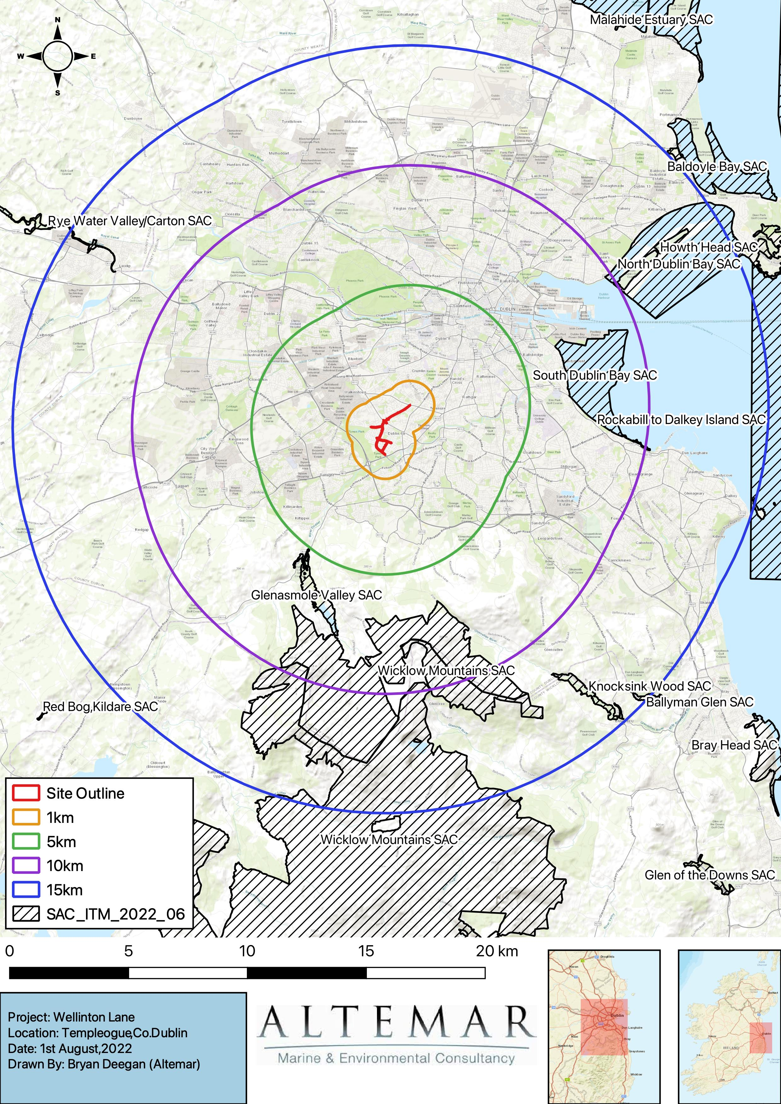
Figure 6. Special Areas of Conservation within 15km.
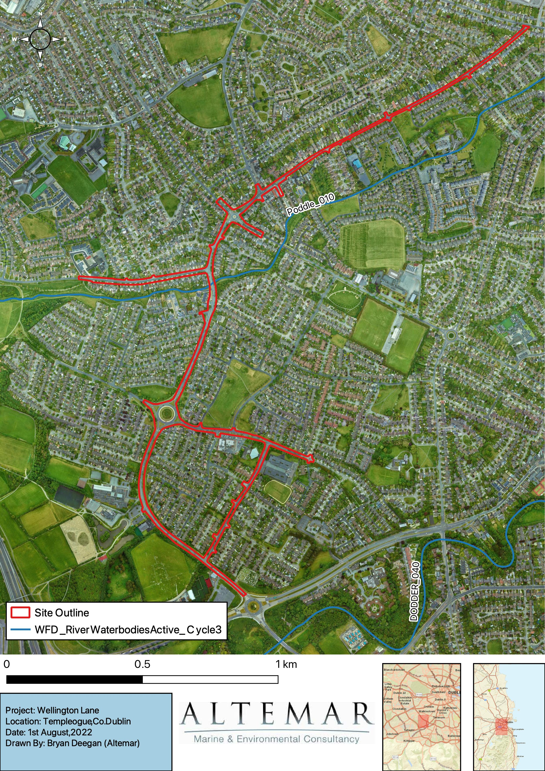
Figure 8. Satellite imagery of waterbodies within close proximity to the site.
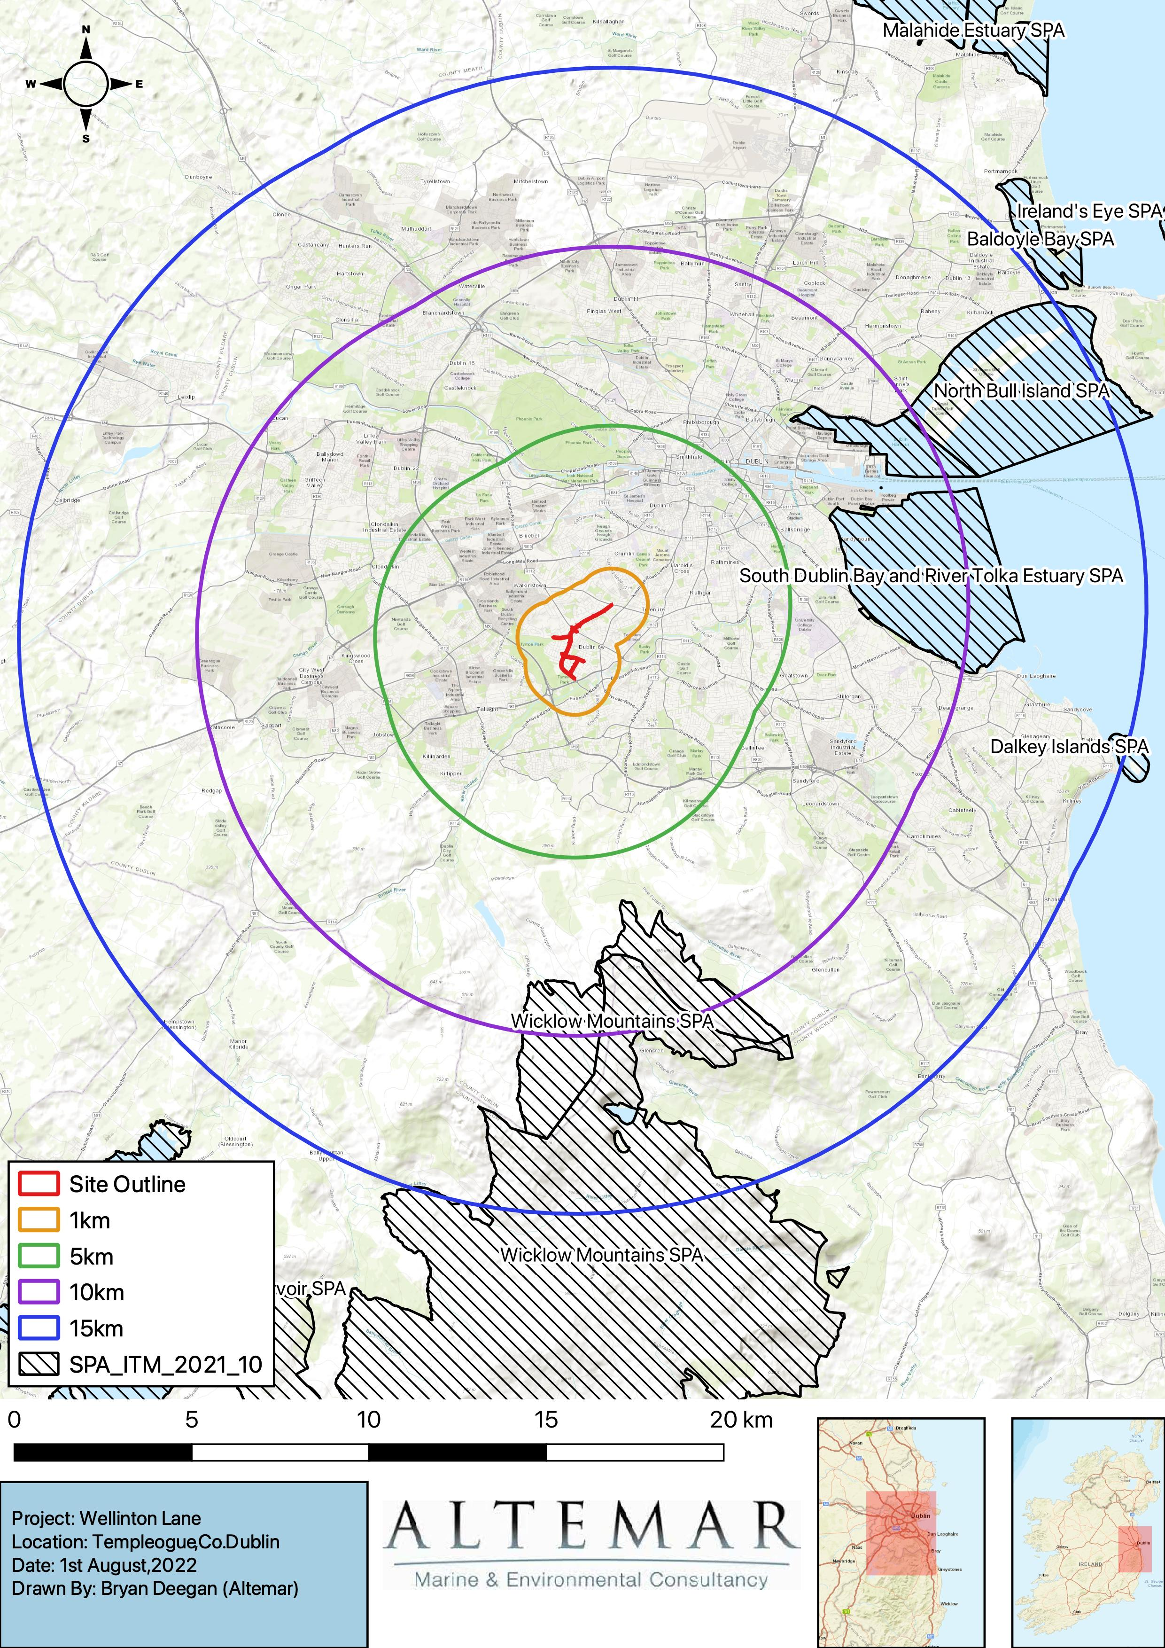
Figure 9. Special Protection Areas within 15km.
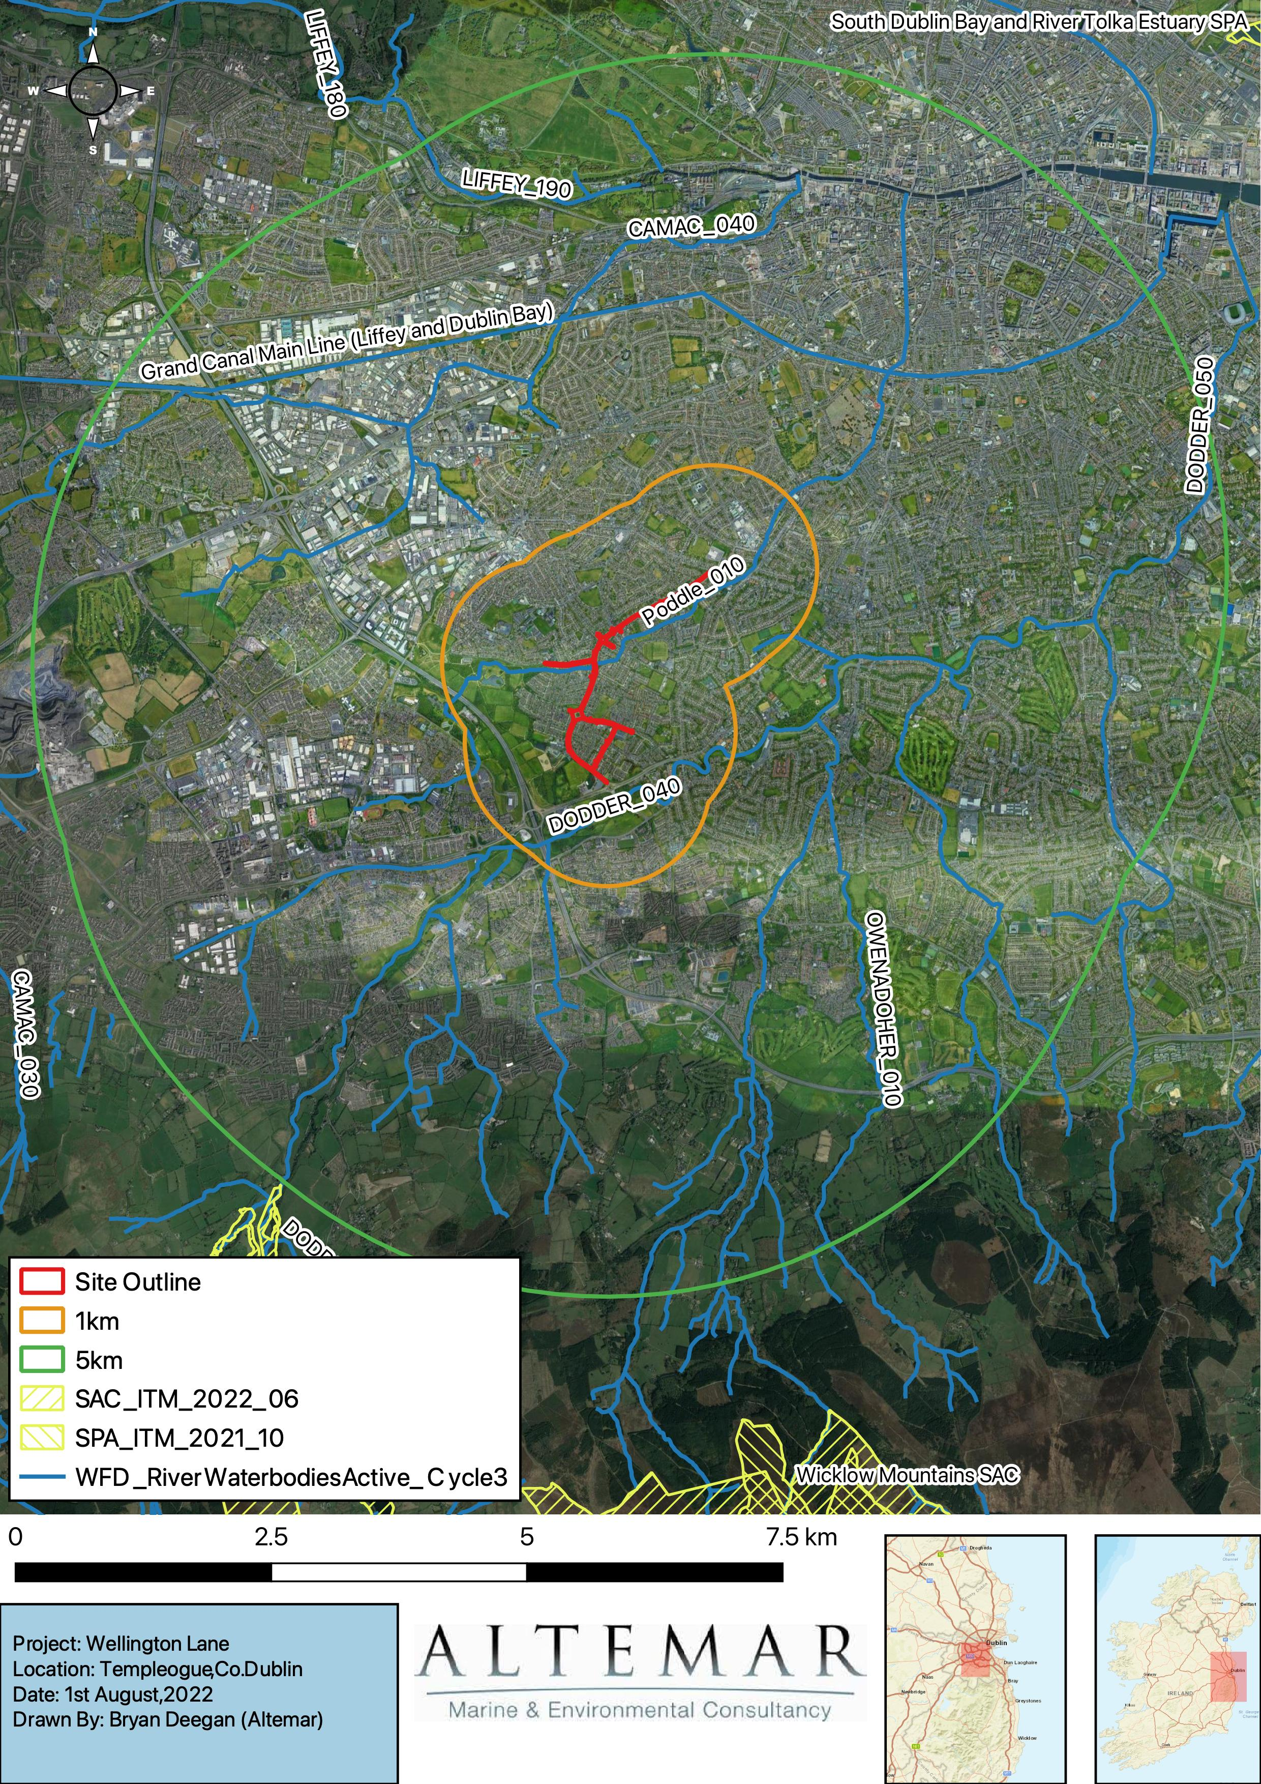
General Waterflow Direction
Figure 10. SPA’s, SAC’s and Watercourses Within 5km of the Site.

In-Combination Effects
A review of the online planning system (www.myplan.ie) was carried out. There are several development proposals located in the area immediately surrounding the subject site that have been granted permission. These are primarily small developments relating to changes to houses.
No significant projects are proposed or currently under construction that could potentially cause in combination effects on Natura 2000 sites.
Given this, it is considered that in combination effects with other existing and proposed developments in proximity to the application area would be unlikely, neutral, not significant and localised. It is concluded that no significant effects on Natura 2000 sites will be seen as a result of the proposed development alone or combination with other projects.
Ref. No. | Address | Proposal
SD21B/0583 | 36, Wellington Park, Templeogue, Dublin 6W | Single storey rear extension and conversion of existing garage; all associated site works.
SD21B/0315 | 51, Wellington Road, Templeogue, Dublin 6W
  Attic conversion to bedroom with ensuite and storage room including front dormer window and internal alterations.
SD21B/0163 | 38, Whitehall Road, Dublin 12 | Erection of alterations and extensions to an existing dwelling house consisting of a single storey extension to the rear and a two storey extension (over existing garage to side) together with associated and auxiliary accommodation and site works.
SD20A/0331 | Faughs GAA Clubhouse, Wellington Lane, Templeogue, Dublin 6w. | Change of use of the existing upstairs Club Hall for the operation of a Creche/Montessori for up to 20 children between the hours of 8am to 2pm, Monday to Friday. The facility will meet Tusla requirements for the businesses of this nature, with the operator of the facility offering the ECCWE scheme & the National Childcare Scheme.
SD20B/0516 | 38, Orwell Park Rise, Dublin 6w | Alterations & extensions to include new roof structure with 'Velux' roof lights to accommodate a bedroom; first floor extension to front bedroom; new bay window and open covered porch to front ground floor; single storey kitchen/dining/living extension to the rear and side; formation of new door and window openings and all ancillary and external works.
No significant effects are likely from in combination effects.

Conclusions
The proposed redevelopment project is located in an urban environment 5km from the nearest Natura 2000 site. Watercourses and surface runoff are seen as the main potential pathway for impacts on Natura 2000 sites. However, the site is not close to and does not have a direct pathway to watercourses that could act as potential vectors for impact on Natura 2000 sites. There is no direct hydrological pathway from the proposed development site to a Natura 2000 site. All drainage from the site goes to a public surface water network sewers where it undergoes dilution, mixing and settlement. All watercourses in the catchment enter the estuarine element of River Liffey where further mixing and dilution take place with the River Liffey and estuarine waters of Dublin Bay. It should also be noted that additional settlement will take place through flocculation in the estuarine environment. No specific mitigation is required to prevent significant effects on Natura 2000 sites.
No Natura 2000 sites are within the zone of influence of this development. Having taking into consideration the surface water discharge from the proposed development works, the distance between the proposed development site to designated conservation sites, lack of direct hydrological pathway to conservation sites and the dilution, missing and settlement effect with other surface runoff and fresh and estuarine waters, prior to reaching designated sites, it is concluded that this development would not give rise to any significant effects to designated sites. The construction and operation of the proposed development will not impact on the conservation objectives of features of interest of Natura 2000 sites.
This report presents a Stage 1 Appropriate Assessment Screening for the Proposed Development, outlining the information required for the competent authority to screen for appropriate assessment and to determine whether or not the Proposed Development, either alone or in combination with other plans and projects, in view of best scientific knowledge, is likely to have a significant effect on any European or Natura 2000 site.
On the basis of the content of this report, the competent authority is enabled to conduct a Stage 1 Screening for Appropriate Assessment and consider whether, in view of best scientific knowledge and in view of the conservation objectives of the relevant European sites, the Proposed Development, individually or in combination with other plans or projects is likely to have a significant effect on any European site.

Findings of No Significant Effects Report
Details of Project | Appropriate Assessment Screening for proposed improvements on cycle and pedestrian facilities around Wellington Lane, Templeogue, Co. Dublin.
Name and Location of NATURA 2000 Sites Within 15km | Glenasmole Valley SAC  Wicklow Mountains SAC  South Dublin Bay SAC  Rye Water Valley/ Carton SAC  North Dublin Bay SAC  Knocksink Wood SAC  Ballyman Glen SAC  Rockabill to Dalkey Island SAC  Wicklow Mountains SPA  South Dublin Bay and River Tolka Estuary SPA  North Bull Island SPA  Dalkey Islands SPA
Project Description | The main scheme route, which aims to provide improved cycle and pedestrian facilities, extends from west of the Spawell Roundabout and runs along Wellington Lane, Wellington Road and Whitehall Road, terminating at the Whitehall Road / Kimmage Road West signalised junction. The main scheme route has also been extended to include Rossmore Road, Orwell Road, Templeogue Wood and Limekiln Road. These routes have been included within the scheme in order to provide key links for pedestrians and cyclists to the primary schools located along Rossmore Road (Bishop Galvin & Bishop Shanahan National School) and Limekiln Road (Riverview Educate Together National School). The scheme, over its majority, provides off road protected cycle track facilities. Pedestrian footpaths and crossings are proposed to be upgraded with crossings located on desire lines. Bus stops are proposed to be upgraded along the scheme route where feasible. A landscaping plan has been proposed over the main routes within the scheme that proposes improved urban realm and additional trees along the route.
Is the Project directly connected with the management of the NATURA 2000 site? | No
Details of any other projects or plans that together with this project could affect the NATURA 2000 site | None
The assessment of significant effects
Describe how the project is likely to affect the NATURA 2000 site | No Impact Predicted
Response to consultation | N/A
Data collected to carry out the assessment | Site Visit and Supporting NPWS data.
Who carried out the assessment | Altemar Ltd.
Sources of data | NPWS website, standard data form, conservation objectives data of the site and references outlined in the AA Screening Report.
Explain why the effects are not considered significant | No Natura 2000 sites are within the zone of influence of this development. Having taking into consideration the surface water discharge from the proposed development works, the distance between the proposed development site to designated conservation sites, lack of direct hydrological pathway to conservation sites and the dilution, missing and settlement effect with other surface runoff and fresh and estuarine waters, prior to reaching designated sites, it is concluded that this development would not give rise to any significant effects to designated sites. The construction and operation of the proposed development will not impact on the conservation objectives of features of interest of Natura 2000 sites.
Level of assessment completed | Stage 1 Screening
Overall conclusions | On the basis of the content of this report, the competent authority is enabled to conduct a Stage 1 Screening for Appropriate Assessment and consider whether, in view of best scientific knowledge and in view of the conservation objectives of the relevant European sites, the Proposed Development, individually or in combination with other plans or projects is likely to have a significant effect on any European site.

References
The following references were used in the preparation of this AA screening report.
- Department of Environment Heritage and Local Government Circular NPW 1/10 and PSSP 2/10 on Appropriate Assessment under Article 6 of the Habitats Directive – Guidance for Planning Authorities March 2010.
- Appropriate Assessment of Plans and Projects in Ireland: Guidance for Planning Authorities, Department of the Environment, Heritage and Local Government 2009; http://www.npws.ie/publications/archive/NPWS_2009_AA_Guidance.pdf
- Managing NATURA 2000 Sites: the provisions of Article 6 of the Habitats Directive 92/43/EEC, European Commission 2000; http://ec.europa.eu/environment/nature/Natura2000/management/docs/art6/provision_of_art6_en.pdf
- Assessment of Plans and Projects Significantly Affecting NATURA 2000 Sites: Methodological guidance on the provisions of Article 6(3) and (4) of the Habitats Directive 92/43/EEC; http://ec.europa.eu/environment/nature/Natura2000management/docs/art6/Natura_2000_assess_en.pdf
- Guidance document on Article 6(4) of the 'Habitats Directive' 92/43/EEC – Clarification of the concepts of: alternative solutions, imperative reasons of overriding public interest, compensatory measures, overall coherence, opinion of the commission; http://ec.europa.eu/environment/nature/Natura2000/management/docs/art6/guidance_art6_4_en.pdf
- Guidance document on the implementation of the birds and habitats directive in estuaries and coastal zones with particular attention to port development and dredging; http://ec.europa.eu/environment/nature/Natura2000/management/docs/guidance_doc.pdf
- The Status of EU Protected Habitats and Species in Ireland. http://www.npws.ie/publications/euconservationstatus/NPWS_2007_Conservation_Status_Report.pdf
- NPWS (2021) Conservation Objectives: Glenasmole Valley SAC 001209. Version 1.0. National Parks and Wildlife Service, Department of Arts, Heritage and the Gaeltacht.
- NPWS (2017) Conservation Objectives: Wicklow Mountains SAC 002122. Version 1.0. National Parks and Wildlife Service, Department of Arts, Heritage and the Gaeltacht.
- NPWS (2013) Conservation Objectives: South Dublin Bay SAC 000210. Version 1.0. National Parks and Wildlife Service, Department of Arts, Heritage and the Gaeltacht.
- NPWS (2021) Conservation Objectives: Rye Water Valley/ Carton SAC 001398 . Version 1.0. National Parks and Wildlife Service, Department of Arts, Heritage and the Gaeltacht.
- NPWS (2013) Conservation Objectives: North Dublin Bay SAC 000206. Version 1.0. National Parks and Wildlife Service, Department of Arts, Heritage and the Gaeltacht.
- NPWS (2021) Conservation Objectives: Knocksink Wood SAC 000725. Version 1.0. National Parks and Wildlife Service, Department of Arts, Heritage and the Gaeltacht.
- NPWS (2019) Conservation Objectives: Ballyman Glen SAC 000713. Version 1.0. National Parks and Wildlife Service, Department of Arts, Heritage and the Gaeltacht.
- NPWS (2013) Conservation Objectives: Rockabill to Dalkey Island SAC 003000. Version 1.0. National Parks and Wildlife Service, Department of Arts, Heritage and the Gaeltacht.
- NPWS (2022) Conservation Objectives: Wicklow Mountains SPA 004040. Version 1.0. National Parks and Wildlife Service, Department of Arts, Heritage and the Gaeltacht.
- NPWS (2015) Conservation Objectives: South Dublin Bay and River Tolka Estuary SPA 004024. Version 1.0. National Parks and Wildlife Service, Department of Arts, Heritage and the Gaeltacht.
- NPWS (2015) Conservation Objectives: North Bull Island SPA 004006. Version 1.0. National Parks and Wildlife Service, Department of Arts, Heritage and the Gaeltacht.
- NPWS (2022) Conservation Objectives: Dalkey Islands SPA 004172. Version 1.0. National Parks and Wildlife Service, Department of Arts, Heritage and the Gaeltacht.

European Commission. (2007).Guidance document on Article 6(4) of the 'Habitats Directive' 92/43/EEC – Clarification of the concepts of: alternative solutions, imperative reasons of overriding public interest, compensatory measures, overall coherence, opinion of the commission.

