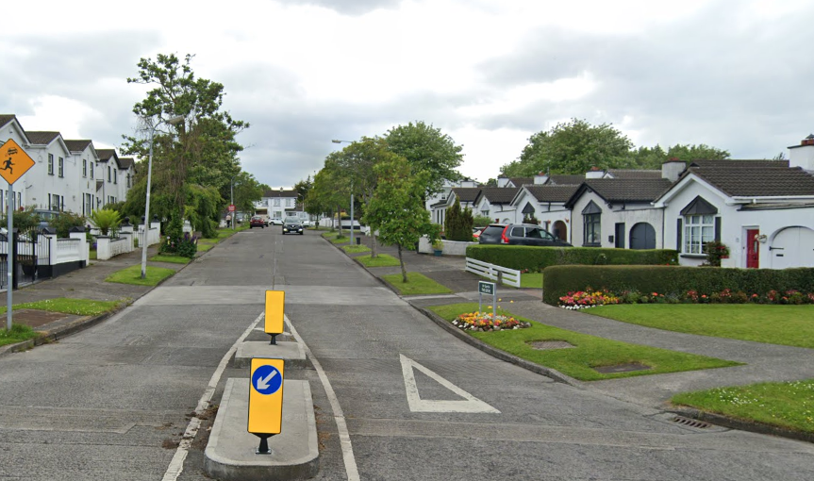
Figure 1 Traffic Calming Island Picture

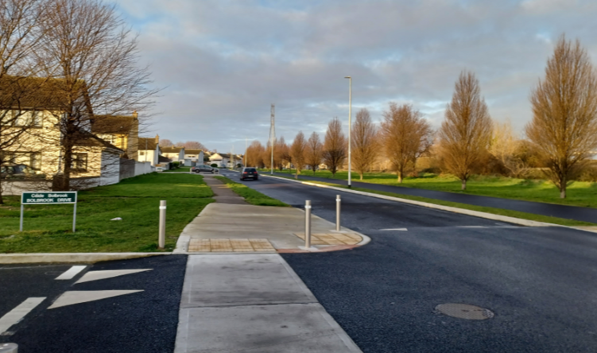
Figure 2 Junction tightening picture

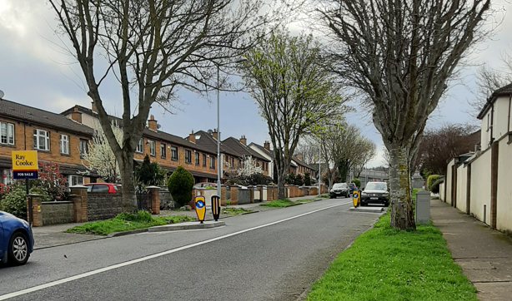
Figure 3 Chicane Picture

