Castletymon Road South, Dublin 24
Active Travel Scheme

Part 8 Report
Febuary 2023
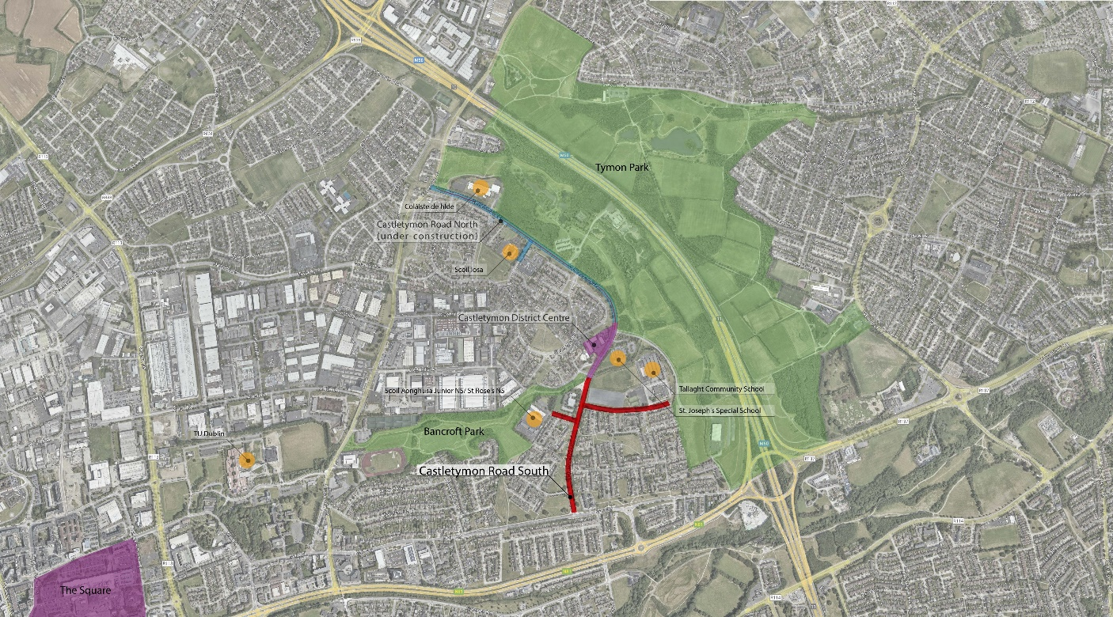

Contents
1. PROJECT OVERVIEW ...................................................................................................... 3
1.1 Site Location........................................................................................................................... 3
2. CASTLETYMON ROAD SOUTH AND DIVISION OF THE PROJECT INTO TWO SECTIONS ... 4
3. NATURE AND EXTENT OF THE PROPOSED DEVELOPMENT ...................................................... 5
3.1 Description of Proposed Development................................................................................... 6
3.2 Works Include............................................................................................................ 7
3.3 Summary of the Key Feature/Changes ............................................................................. 7
3.4 The Objectives of the Overall Scheme....................................................... 10
3.5 The Requirement for the scheme at this location............................................................ 10
4. PLANNING CONTEXT AND ASSESSMENT................................................................................ 4
4.1 National Policy.................................................................................................................. 4
4.2 Regional Policy ....................................................................................................................... 4
4.3 Local Policy ............................................................................................................................ 4
5. OVERVIEW OF ENVIRONMENTAL IMPACTS.................................................................. 11
5.1 Appropriate Assessment (AA). ..................................................................................... 11
5.2 Environmental Impact Assessment (EIA) .................................................................... 11
5.3 Ecological Impact Assessment...................................................................................... 11
6. Conclusion ..................................................................................................................... 12

Project Overview
In accordance with Part 8 of the Planning and Development Regulations 2001 (as amended), South Dublin County Council (SDCC) proposes an active travel scheme at Castletymon Road, Tallaght, Dublin 24. The scheme extends from the southern end of Castletymon Road, moving north past the Castle Park intersection on the west and Balrothery Estate on the east to St. Aengus Church northwest and Castle Lawns to the east, enhancing the entrance to Tallaght Community School further east.
The proposed scheme aims to create an environment where all travel models can move safely and efficiently in the Castletymon area and access all local amenities. Within the active travel proposal is a 1km walking and cycling facilities and traffic calming measures along Castletymon Road, from Main Street to Castletymon Road Library, in the Tymon area, Junction amendments to provide safer movement of pedestrians and cyclists, and General/Landscaping/Public Realm works.
This project is part of the Pathfinder Programme, which forms a key part of the implementation of the National Sustainable Mobility Policy, which sets out the government's plan to meet Ireland's requirement to achieve a 50% reduction in greenhouse gas emissions by 2030 in the transport sector. The cycle path also aligns with the National Transport Authority's new Cycle Design Manual, which replaces the old manual published in 2011.

1.1 Site location
The subject Part 8 proposal is located along Castletymon Road, south of Tymon Park and east of Bancroft Park. The majority of this route is to be constructed on existing Castletymon roadways. The project is split into two sections, located north and south of the Tallaght Community School. Castletymon Road is the connection between an existing and proposed cycle scheme with several schools and amenities along it, including the new Castletymon Library and Bancroft and Tymon Park. The existing road is 9-9.37m with a painted medium in the centre and approximately 2m footpaths on each side, separated from the road by a 2m verge with trees and public lighting. There are no existing cycle facilities on or near the alignment of Castletymon Road, with the closest ones located in Tymon Park. Castletymon Road is the only vehicular access point for the communities within and, therefore, a key link road. The junctions T-ing onto Castletymon Road are wide estate junctions with a radius of +6-8m.
Castletymon Road is tree-lined on both sides for the majority of its length, and Bancroft and Tymon Parks running perpendicular and along the road, creating substantial tree coverage in the area. The area taken in charge includes the road, the verges, the footpaths, and several meters of open space on both sides of the footpath. This open space is a sloped grass lawn draining towards the roadway. It is potentially an underground utility corridor, reducing the likelihood of utilities in the carriageway. No Protected structures or Monuments and Heritage sites within the alignment.
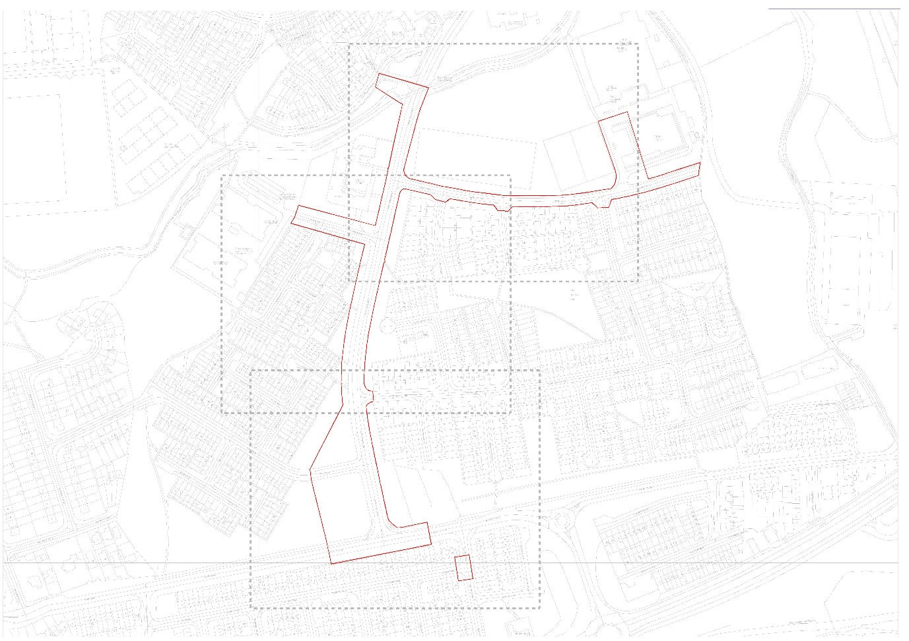
Figure 1-1: Site location of Castletymon Road South, Dublin 24, Active Travel Scheme (© OpenStreetMap contributors, 2023)

Consultation & Castletymon Road South and Division of the overall project into two sections.
This project is located along Castletymon Road, south of Tymon Park and east of Bancroft Park. The majority of this route is to be constructed on existing Castletymon roadways. The overall project is split into two sections, located north and south of the Tallaght Community School.
An informal consultation was held for the overall Castletymon Road Active Travel scheme from May 26th to June 30th, 2023. The feedback received during this process required a change in the scope of work to the southern section; it was determined necessary to divide the project into two sections. The two sections are
- Castletymon Road North and
- Castletymon Road South, with the Castletymon Shopping Centre as the dividing point.
While it was the intention to carry out the entire project under Section 38 of the Road Traffic Act 1994, the change of scope in the southern section of the Castletymon Road Active Travel Scheme, including the required changes to the boundary and open spaces, determined a Part 8 process would be advisable.
Castletymon Road North will continue to progress following Chief Executive approval for the project under Section 38 of the Road Traffic Act 1994; construction began in October 2023.
This statutory public consultation under Part 8 of the Planning and Development Regulations 2001 (as amended) is for the Castletymon Road South section.
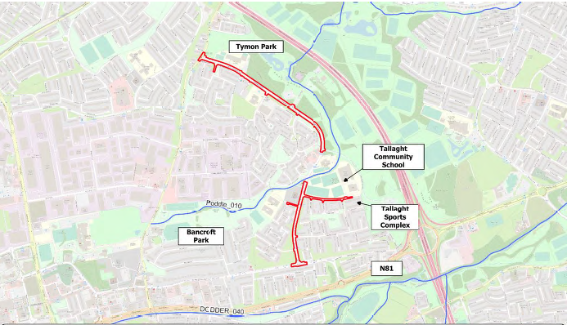
Figure 1-2: The project is split into two sections, Castletymon Road North and Castletymon Road South.

Nature and Extent of the Proposed Development

3.1 Description of Proposed Development:
The purpose of the proposed scheme, as set out by SDCC and the NTA, is to provide an active travel link from the southern end of Castletymon Road from Main Road, moving north including the junctions of Castle Park intersection on the west and Balrothery Estate on the east, connecting to St. Aengus Church and Castletymon Road Library. The development also includes the junction and roads of Castle Lawns to the east enhancing the entrance to Tallaght Community School and of Castle Park to St Rose’s National School and Scoil Aonghusa Junior National School.
The proposed route no. 27a of the Cycle South Dublin will connect to the existing and planned network in South Dublin. It will provide cycle connectivity from Greenhills’s Road to Tallaght Main Street and has a length of 1.8m. Under this scheme, South Dublin County Council proposed to construct a 1km length of cycleway from Main Street to Castletymon Road Library
The proposed equitable distribution of the road will allow the delivery of 2-way traffic and for raised cycle tracks to be added to the edges of the road/in verge. The proposed improvement to junctions joining Castletymon Road will provide safe crossings and connections for walkers, cyclists, and motorists.
Public transport users will benefit from upgraded bus stops along Castletymon Road and the improvements in connectivity through upgraded walking and cycling links to public transport services.

3.2 Works include:
Construction of 1 km walking and cycle facilities and traffic calming measures along Castletymon Road and the Tymon area.
- Junction amendments to provide safer movement of pedestrians and cyclists.
- Traffic Calming measures
- Associated services/works
- Landscaping and Public Realm works
Along with the improvements to pedestrian and cycle facilities, adjustments will be made to existing junctions along the main route and secondary links. Ultimately, when the route is delivered, it will help to improve safety, including a reduction in vehicle speeds, and it is envisaged that it will contribute towards an increased number of trips in the area by pedestrians and cyclists. The proposed works will tie into the existing site limits, private and commercial accesses, and junctions along the route.

3.3 Summary of the Key Features/Changes:
- Equitable road distribution will allow 2-way traffic and for segregated cycle infrastructure from Main Street to the Castletymon District Centre.
- Where side roads meet Castletymon Road, the junction will be improved to prioritise vulnerable road users (pedestrians and cyclists)
- To preserve the existing on-street parking, the cycle track will be located on the verge between Main Road and Castle Park near St. Aengus' Church. The existing on-street parking in this location will be realigned into nine parallel parking spaces.
- The scheme will tie into the District Enhancement Scheme, requiring the relocation of 8 parking spaces outside the Castletymon Library.
- In Castletymon Road South, the proposed designs will have minimal impact on the existing trees. Six trees will be removed, and 18 trees will be proposed.
- School Improvements: There are proposed improvements at Scoil Aonghusa Junior and St Rose's National School campus and Tallaght Community School Entrance. These improvements include widening footpaths, entrances, and other traffic calming and safe routes to school-style improvements.
- Bus Stops on Castletymon Road will be aligned and upgraded to accommodate the new cycle tracks.
- Proposed upgrades to the Main Road and Castletymon Road junction to prioritise the safety of pedestrians' and cyclists' movements.
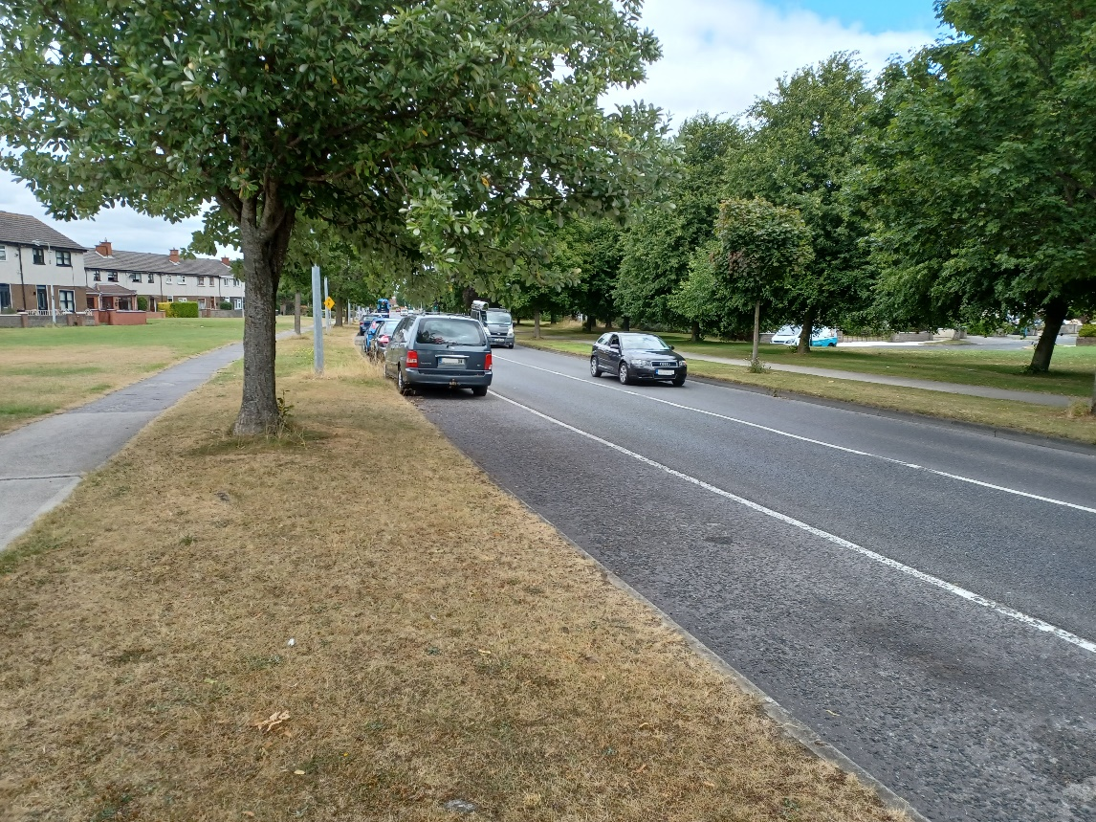
Figure 1-3: Existing Castletymon Road South
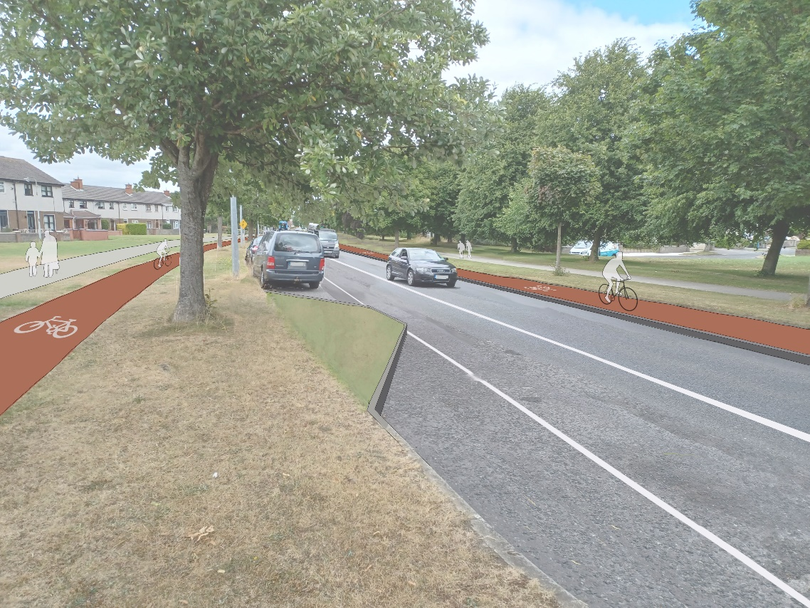
Figure 1-4: Proposed Castletymon Road South

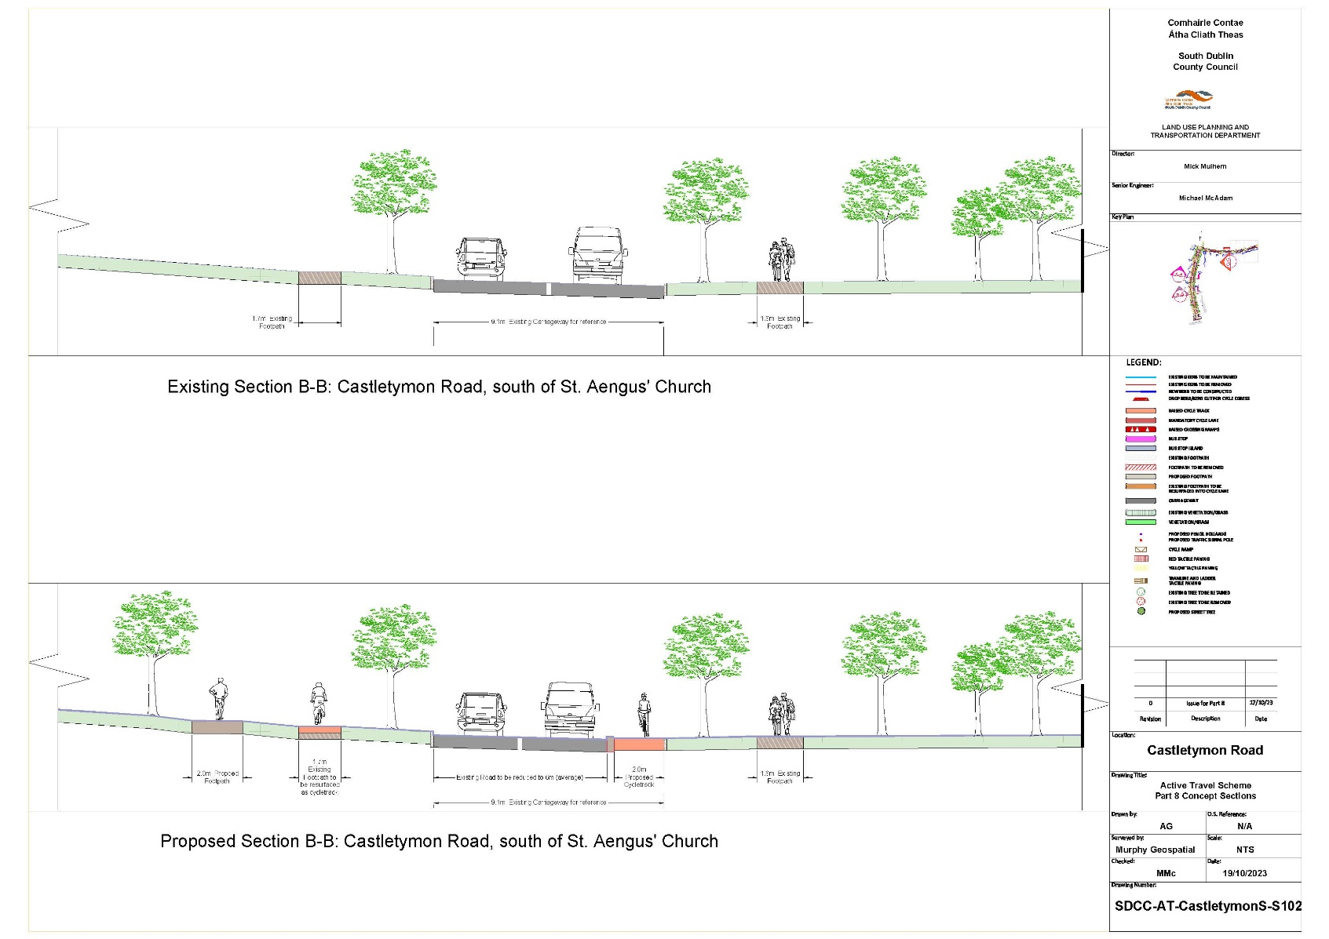

3.3 The objectives of the overall scheme are as follows:
Castletymon Road is the main link for the Tymon area, connecting the Tymon neighbourhoods to the wider area. The existing road has no cycling facilities and minimal walking facilities for the community to access Bancroft Park and Tymon Park, Castletymon Road Library, Castletymon District Centre, and Local Area Schools. The proposed scheme aims to remedy this by creating an environment where all travel models can move safely and efficiently in the Castletymon area and access all local amenities.
- Provide improved cycle and pedestrian facilities along the scheme route to enhance the overall safety of vulnerable road users;
- Enhance connectivity for the surrounding residential developments to key trip attractors within the area, such as the local parks, schools, playing pitches and local shops;
- Improve modal shift for walking and cycling within the area for all users. Improving the modal shift towards sustainable modes of travel will help contribute towards Ireland’s Climate Action Plan for 2030, which aims to reduce greenhouse gas emissions by 51%.

Planning Context and Assessment

4.1 National Policy
The active travel proposals have been developed in the context of and having regard to:
• Project Ireland 2040: National Planning Framework.

4.2 Regional Policy
The active travel proposals have been developed in the context of and having regard to:
• Regional Spatial and Economic Strategy – Eastern Midland Regional Assembly

4.3 Local Policy

South Dublin County Development Plan (2022-2028)
The South Dublin County Development Plan 2022 – 2028 aims to increase the model share for walking and cycling for local trips to work, schools, retail, and leisure. The Plan also aims to enhance safety for all modes of transport in the county and to improve connectivity for pedestrians and cyclists within existing communities to maximise access to local shops, schools, public transport services and other amenities, creating a comprehensive and legible County-wide network of cycling and walking routes that link communities to key destinations, amenities and leisure activities, and; to ensure that all streets and street networks are designed to prioritise walking and cycling movements within a safe and comfortable environment for a wide range of ages, abilities and journey types.
The proposed active travel measures are in accordance with Objective SM1 Objective 1, SM2 Objective 2, SM5 Objective 1 and SM6 Objective 3 of the County Development Plan that aims to achieve a transition to more sustainable travel modes and align with the policies and objectives of (i) Safe cycling routes through the implementation of the Greater Dublin Cycle Network Plan, NTA (2011) and the Cycle South Dublin project; (ii) Walking routes that link communities to key destinations, amenities and leisure activities.
The proposal will contribute to climate action and the area's network of quality walking and cycling facilities. The proposal will link open spaces to one another to increase their amenity value, encourage active travel, and facilitate the green infrastructure network. The provision of parks, open space and social, community and recreational facilities within walking and cycling distances of communities and on public transport routes will encourage active travel and a shift away from car-based transport. Together, these measures will assist South Dublin County in achieving its climate action targets, will enhance residential amenities in the area, provide improved active travel infrastructure and is in accordance with the County Development Plan and the proper planning and sustainable development of the area.

Cycle South Dublin Network
South Dublin County Council aims to make the county one of Ireland's most liveable, equitable, and sustainable. A pillar of this new mobility vision is Cycle South Dublin (an ambitious programme to deliver a connected network of high-quality walking and cycling improvements linking the places where people live to where they want to go. There are 45 routes in the programme, and the goal is to deliver over 250 km of safe walking and cycling improvements. Castletymon Road is Route 27a on the Cycle South Dublin Plan and will tie into the Castletymon District Enhancement (DE) scheme, completed in October 2023. The Castletymon Road Active Travel Scheme is part of the Pathfinder Project, an initiative by the Department of Transport, which aims to deliver active travel schemes which are innovative and ambitious quickly.

National Transport Authority Greater Dublin Area Cycle Network Plan (2022)
In 2022, the NTA updated the Greater Dublin Area Cycle Network Plan, consisting network for each of the seven Local Authority areas comprising the Greater Dublin Area. The plan sets out to create an integrated, comprehensive, high-quality cycling network that is safe, coherent, direct, attractive and comfortable. The Castletymon Road is listed as a feeder route of the National Transport Authority Greater Dublin Area Cycle Network Plan.

Overview of Environmental Impacts

5.1 Screening for Appropriate Assessment
The proposal has undergone Appropriate Assessment Screening under the Habitats Directive (92/43/EEC)
Based on the screening report prepared by JBA Consulting, SDCC determined that the possibility of any significant adverse impacts on the Natura 2000 sites, whether arising from the project itself or in combination with other plans and projects, can be excluded beyond a reasonable scientific doubt based on the best scientific knowledge available. A Stage 2: Appropriate Assessment is not required for the proposed Active Travel Scheme.

5.2 Screening for Environmental Impact Assessment
Screening for an EIAR for the proposed Castletymon Active Travel Scheme was carried out.
The project was not found to fall under Parts 1 or 2 of Schedule 5 of the Act and therefore an EIAR has not been automatically triggered.
South Dublin County Council as the Competent Authority having considered the EIA Screening Report prepared by JBA Consulting made a determination that an Environmental Impact Assessment Report will not be required for the proposed Castletymon Road Active Travel Scheme. This determination is based on an objective review of the proposed development, including its characteristics, location and the likelihood of it causing significant environmental effects. The screening has followed the relevant legislation and has had regard to the relevant guidance.

5.3 Ecological Impact Assessment
While the proposed development project could potentially impact a number of different habitats with high local importance, the specific proposals ensure that these impacts will not arise. The habitat with high local importance (treelines/amenity grassland) and faunal groups (ground-dwelling mammals; bats; breeding birds; wintering birds and terrestrial invertebrates), whose ecological importance ranges from low to high local level in the context of this proposed site.
Based upon the information supplied, and provided that the development is constructed in accordance with the mitigation measures outlined above, there will be no significant impacts alone or in-combination with other projects and plans, as result of the development and associated works on the ecology and local species of the area and on any designated conservation sites.
Given the scale of this development and its suitable landscape plan, the local ecology, including mammals, bats, birds, and terrestrial invertebrates will benefit from the maintained ecological function of the site (remedial planting and sowing) associated with the operational phase of this project.

Conclusion
In conclusion, this Part 8 proposal aims to enhance safety and improve connectivity for pedestrians and cyclists within the Castletymon Active Travel Scheme. This will be achieved through improvements made to existing junctions along the main route and secondary links as part of these improvements. Ultimately, when the route is delivered, it will help to improve safety, including a reduction in vehicle speeds, and it is envisaged that it will contribute towards an increased number of trips in the area by pedestrians and cyclists. The proposed works will tie into the existing site limits, private and commercial accesses, and junctions along the route.
The proposal's design has been informed by understanding the site context and the requirement to comply with planning and environmental legislation and policy. The scheme fully supports all relevant Policy Objectives of the South Dublin County Development Plan 2022-2028. The proposed active travel measures are in accordance with Objective SM1 Objective 1, SM2 Objective 2, SM5 Objective 1 and SM6 Objective 3 of the County Development Plan that aims to achieve a transition to more sustainable travel modes and align with the policies and objectives of (i) Safe cycling routes through the implementation of the Greater Dublin Cycle Network Plan, NTA (2011) and the Cycle South Dublin project; (ii) Walking routes that link communities to key destinations, amenities and leisure activities.
The proposed active travel measures will assist South Dublin County in achieving its climate action targets, will enhance residential amenities in the area, provide improved active travel infrastructure and is in accordance with the County Development Plan and the proper planning and sustainable development of the area.

