Ecological Impact Assessment
Proposed Part 8 Residential Development, Kishoge, Lucan
21 May 2024



NM Ecology Ltd - Consultant Ecologists
38 Maywood Avenue, Raheny, Dublin 5
Website: www.nmecology.com
Email: info@nmecology.com
Tel: 087-6839771

Executive Summary
This Ecological Impact Assessment has been prepared by NM Ecology Ltd on behalf of South Dublin County Council regarding a proposed residential development at Kishogue, Lucan, Dublin 22. The proposed development will involve the construction of 118 dwellings (a mixture of apartments and terraced houses) and associated works. The aim of this report is to identify and evaluate the impacts of the proposed development on ecosystems and their components, including designated sites, habitats, flora and fauna.
Designated sites
There are no designated sites in the vicinity of the proposed development site (hereafter referred to as ‘the Site’). Four designated sites were identified in the surrounding area, but there are no surface water (or other) pathways connecting them to the Site, so impacts can be ruled out.
A Screening for Appropriate Assessment report accompanies the application. It was concluded that the proposed development will not be likely to have a significant effect on any European sites.
Habitats and flora
Habitats within the Site include scrub, broadleaved woodland / treeline, hedgerow, neutral grassland and recolonising bare ground. The woodland / treeline / hedgerow is a mature feature of considerable age that is considered to be of Local ecological importance. The woodland / treeline / hedgerow will be removed as part of the development, but it will be compensated by tree planting elsewhere in the development, resulting in an overall neutral effect on these habitats.
Large areas of scrub and neutral grassland will be cleared in the centre of the Site. These habitats are of Negligible ecological importance because they consist of plant species that are common and widespread, and because they have formed in the last 15 years due to the cessation of management at the Site. The removal of habitats of Negligible ecological importance is not considered to be a significant impact in the context of an Ecological Impact Assessment. However, the removal of these habitats will inevitably result in a net loss of biodiversity from the Site.
The landscaping scheme for the proposed development will include detention basins, trees, shrubs and orchards. These measures will partly compensate for the loss of baseline vegetation, and will introduce some features that are not currently present at the site, e.g. wetlands.
A small patch of Spanish bluebell was recorded within the Site; under the EC (Birds and Natural Habitats) Regulations 2011 (as amended) it is a legal offence to cause this species to spread. It will be treated using herbicide for an initial three-year period, and it is expected to be eradicated before the construction of the proposed development commences.
Fauna
No field signs of otters, badgers or other large terrestrial mammals were identified at the site. A bat survey was carried out, and bat foraging / commuting activity was relatively low. The hedgerow and scrub habitat are considered to be of Local importance for small mammals such as hedgehog, pygmy shrew and stoat. Some common and widespread bird species were recorded at the Site, but no species of conservation importance. To avoid impacts on small mammals and nesting birds it is recommended that site clearance works take place outside the nesting / breeding season, or that a pre-clearance survey is carried out.
Conclusion
Subject to the successful implementation of these measures, we conclude that the proposed development will not cause any significant negative impacts on designated sites, habitats, legally protected species, or any other features of ecological importance.
Table of Contents
1 Introduction 5
1.1 Assessment brief 5
1.2 Statement of authority 5
2 Methods 6
2.1 Scoping 6
2.2 Data collection and walkover survey 6
2.3 Valuation of ecological features 7
2.4 Ecological Impact Assessment 8
3 Development proposals 8
3.1 Description of the proposed development 8
3.2 Other nearby developments (potential in-combination effects) 8
4 The Receiving Environment 9
4.1 Environmental setting 9
4.2 Designated sites 10
4.3 Habitats and flora 12
4.4 Protected fauna 15
4.5 Potential limitations and information gaps 17
4.6 Identification of important ecological features 17
5 Predicted Impacts of the Proposed Development 19
5.1 Landscaping and biodiversity change 19
5.2 Spread of Spanish bluebell 19
5.3 Disturbance of breeding birds and mammals 20
5.4 Potential cumulative / in-combination impacts 20
6 Proposed mitigation measures 20
6.1 Protection of birds during site clearance works 20
6.2 Eradication of Spanish bluebell 20
7 Residual Impacts 21
8 References 22

Introduction

Assessment brief
The aim of this Ecological Impact Assessment (EcIA) is to identify, quantify and evaluate the impacts of the proposed development on ecosystems and their components. This includes designated sites, habitats, flora and fauna. It has been prepared in accordance with the Guidelines for Ecological Impact Assessment in the UK and Ireland (2018), which is the primary resource used by members of the Chartered Institute of Ecology and Environmental Management (CIEEM). The purpose of this document is to:
- Provide an objective and transparent assessment of the potential ecological impacts of the proposed development for all interested parties, including planning authorities and the general public,
- Facilitate objective and transparent determination of the consequences of the development in terms of national, regional and local policies relevant to ecology, and,
- Propose the steps that will be taken to adhere to legal requirements relating to designated sites and legally protected species (CIEEM 2018).
Although the above guidelines provide a framework for EcIA, many processes rely on the professional judgement of an ecologist, including survey design, the valuation of ecological features, and the characterisation of impacts. An outline of the author’s experience, training and accreditation is provided in the following section, which support his competency to make such judgements.

Statement of authority
All surveying and reporting was carried out by Nick Marchant, the principal ecologist of NM Ecology Ltd. He has sixteen years of professional experience, including thirteen years as an ecological consultant, one year as a local authority biodiversity officer, and two years managing an NGO in Indonesia. He provides ecological assessments for developments throughout Ireland and Northern Ireland, including wind farms, infrastructural projects (roads, water pipelines, greenways, etc.), and a range of residential and commercial developments.
He has an MSc in Ecosystem Conservation and Landscape Management from NUI Galway and a BSc in Environmental Science from Queens University Belfast. He is a member of the Chartered Institute of Ecology and Environmental Management, and operates in accordance with their code of professional conduct.

Methods

Scoping
An Ecological Impact Assessment involves the following steps:
- Identification of designated sites within an appropriate zone of influence
- A walkover survey incorporating the following elements:
  - Classification and mapping of habitats
  - A search for rare / protected flora, and for invasive plant species
  - A search for field signs of rare or protected fauna (e.g. badgers), and habitat suitability assessments for species that are secretive, nocturnal or seasonal
  - Specialist surveys (e.g. bats, breeding birds) where appropriate
- Valuation of ecological features, review of legal considerations, and identification of important ecological features
- Assessment of impacts on important ecological features and development of appropriate mitigation strategies

Data collection and walkover survey
A desk-based scoping study was carried out using data from the following sources:
- Plans and specifications for the proposed development
- Bedrock, soil, subsoil, ground water and surface water maps from the Geological Survey of Ireland webmapping service, the National Biodiversity Data Centre, and the Environmental Protection Agency web viewer
- Maps and details of designated sites from www.npws.ie
- Biological records from the National Biodiversity Data Centre online mapping service
- The South Dublin County Development Plan 2022-2028, and details of permitted or proposed developments from their online planning records
The following resources were used for the walkover surveys:
- Habitat surveys were carried out in accordance with the Best Practice Guidance for Habitat Survey and Mapping (Smith et al 2011), and using the classification system of A Guide to the Habitats of Ireland (Fossitt 2000)
- Flora were identified using Webb’s An Irish Flora (Parnell & Curtis 2012) and The Vegetation Key to the British Flora (Poland & Clement 2009). Nomenclature follows the plant crib of the Botanical Society of the British Isles (BSBI 2007). The abundance and extent of species is described using the DAFOR scale (Dominant, Abundant, Frequent, Occasional, Rare)
- Fauna surveys followed the methods outlined in the Ecological Surveying Techniques for Protected Flora and Fauna during the Planning of National Road Schemes (NRA 2006), with reference to other species-specific methods as appropriate.
Desktop data from internet resources was accessed in January 2024, a multi-disciplinary survey was carried out on 15 June 2023, and a bat survey from 23 – 27 October 2023.

Bat survey
A bat activity survey was carried out between 23 and 27 October 2023 using static detectors. Survey methods were developed using Bat Surveys for Professional Ecologists: Good Practice Guidelines (Bat Conservation Trust, 3rd edition, 2016). Weather conditions were suitable for a bat survey, with sunset temperatures of approx. 10 ºC no rain and light winds.

Valuation of ecological features
Based on the information collected during desktop and walkover surveys, the ecologist assigns an ecological importance to each feature based on its conservation status at different geographical scales (Table 1). For example, a site may be of National importance for a given species if it supports a significant proportion (e.g. 5%) of the total national population of that species.
Table 1: The six-level ecological valuation scheme used in the CIEEM guidelines (2018)
Ecological value | Geographical scale of importance
International | International or European scale
National | The Republic of Ireland or the island of Ireland
Regional | Leinster, and/or the east midlands of Ireland
County | County Dublin
Local | Suburban / rural areas in Lucan
Negligible | None, the feature is common and widespread
It is accepted that any development will have an impact on the receiving environment, but the significance of the impact will depend on the importance of the ecological features that would be affected. The following is outlined in the CIEEM guidelines: “one of the key challenges in an EcIA is to decide which ecological features (habitats, species, ecosystems and their functions/processes) are important and should be subject to detailed assessment. Such ecological features will be those that are considered to be important and potentially affected by the project. It is not necessary to carry out detailed assessment of features that are sufficiently widespread, unthreatened and resilient to impacts from the development, and that will remain viable and sustainable.”
For this report we have only assessed impacts on ecological features of Local importance or higher (refer to Table 1), or those that receive legal protection. These features are termed ‘important ecological features’ and are listed in Section 4.6. Impacts on features of Negligible ecological importance (e.g. amenity grasslands) that do not receive legal protection are not considered to be significant, so they are not included in the impact assessment.

Ecological Impact Assessment
Potential direct, indirect or cumulative impacts on ecological features can be described in relation to their magnitude, extent, duration, reversibility and timing/frequency, as outlined in the CIEEM (2018) guidelines. Depending on the type of impact and the sensitivities of the important ecological feature, the ecologist may determine that the impact would have a ‘significant effect’. The following definitions are provided in the CIEEM guidelines: “A significant effect is simply an effect that is sufficiently important to require assessment and reporting so that the decision maker is adequately informed of the environmental consequences of permitting a project”. “For the purpose of EcIA, a ‘significant negative effect’ is an effect that undermines biodiversity conservation objectives for ‘important ecological features’, or for biodiversity in general.”. Where significant impacts are identified, measures will be taken to avoid, minimise or compensate for impacts (where possible). Subject to these measures, the EcIA concludes with a summary of residual impacts.

Development proposals

Description of the proposed development
The proposed development will involve the construction of 118 no. residential units in a range of designs. Road access will be from the northern boundary of the Site, and internal roads and parking areas will be provided. Public open space will be created, and houses will have private gardens.
Foul water will be pumped to a local authority foul sewer to the north of the Site and conveyed to the Ringsend Waste Water Treatment Plant. The Ringsend WWTP is currently exceeding its organic capacity, but a major upgrade is in progress that will provide sufficient capacity by 2025. The WWTP upgrade will be completed before the proposed development is operational / occupied, so there will be capacity to accept the effluent.
Rainwater runoff from roofs and other impermeable surfaces will be channelled to detention basins in the south and centre of the Site, and discharged at a controlled rate to a local authority storm drain in the north of the Site. The system will include an oil and hydrocarbon interceptor.

Other nearby developments (potential in-combination effects)
The surrounding area is part of the Clonburris Strategic Development Zone, which will involve substantial development of housing, infrastructure, community facilities, etc in the short to medium term. Details are provided in the planning report that accompanies this application.
Live and recently-approved planning applications in the vicinity of the Site were reviewed on the online planning records of South Dublin County Council, but none were found. Therefore, no potential in-combination effects were identified.

The Receiving Environment

Environmental setting

Site location and surroundings
The proposed development site (hereafter referred to as ‘the Site’) is located in a suburban / rural area in the townland of Kishoge. Based on a review of aerial photography it appears that the Site was formerly used as allotments / horticultural land in the 1990s and early 2000s, but in the late 2000s it was cleared and disturbed during the construction of the adjacent Lynch’s Park development, the removal of a halting site to the north-west of the Site, and the widening of the railway line. As part of this process, a large mound of spoil was deposited in the north-east of the Site. There has been no activity on the Site since approx. 2010, and it has recolonised with scrub. The only activity on the Site during this period has been low-intensity grazing by horses.
The southern boundary of the Site is formed by a major railway connecting Dublin with the south-west of Ireland. The eastern boundary is formed by the Lynch’s Yard residential development, and the northern boundary by an associated road. Land to the west and north-west of the Site was formerly used as a halting site, and has some remaining walls and concrete-surfaced yards, but the remainder of the area consists of scrub.
The broader surroundings are characterised by abandoned agricultural land, all of which is zoned for future development as part of the Clonburris Strategic Development Zone.

Geology and soils
The underlying bedrock is dark limestone & shale, which is a locally-important aquifer. Subsoils are limestone till. Soils are made ground: most of the Site was disturbed during the construction of the adjacent Lynch’s Yard development, which involved the deposition of building spoil on the Site, the mixing of existing subsoil and soil, and compaction of soils by heavy vehicles.
The topography of the Site is broadly level. The mound of building spoil in the north-east of the Site is the only topographical feature of note.

Hydrology
The EPA database of rivers and streams does not show any watercourses within or adjacent to the Site. None were observed during surveys.
The Grand Canal is located approx. 500 m south of the Site. Canals are self-contained hydrological features that do not interact with surrounding surface water or groundwater features, so there could be no connection between the Site and the canal.
The closest natural watercourse is the Grifeen River, which is a tributary of the River Liffey. It is located approx. 1.3 km west of the Site at the closest point. Due to its distance from the Site and the absence of any intervening surface water features, it can be concluded that the Site has no connection to the Grifeen River.
In summary, the Site has no connection to any watercourses.

Designated sites
A map of designated sites in the surrounding area is provided in Figure 1, and details of the designated sites shown in the image are provided in Table 2.
Table 2: Designated sites shown in Figure 1
Site Name | Distance | Reasons for designation
Grand Canal pNHA (site code 2104) | 0.5 km south | Diversity of habitats, ecological connectivity, and protected aquatic plant species (Opposite-leaved Pondweed Groenlandia densa)
Liffey Valley pNHA (128) | 3.0 km north-west | Deciduous woodland, wetlands and rare plant species
Royal Canal pNHA (2103) | 4.5 km north | Diversity of habitats, ecological connectivity, and protected aquatic plant species (Opposite-leaved Pondweed Groenlandia densa)
Rye Water Valley/Carton SAC (1398) | 5.2 km north-west | Annex I habitats: Petrifying springs with tufa formation  Annex II species: Narrow-mouthed Whorl Snail Vertigo angustior, Desmoulin's Whorl Snail Vertigo moulinsiana

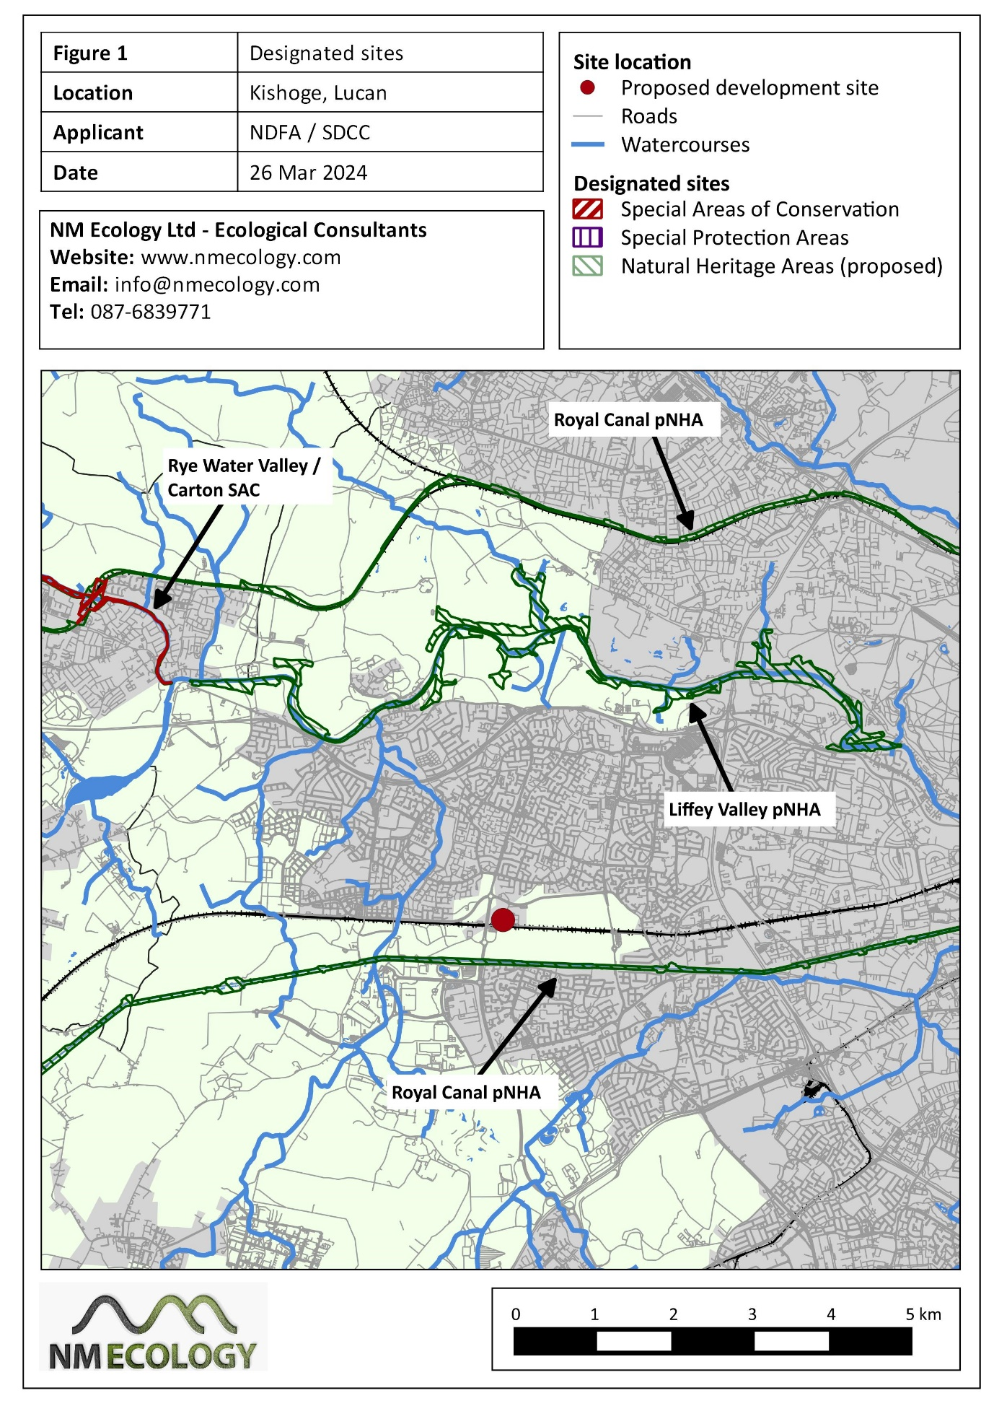

The Site is not within or adjacent to any designated sites, so there is no possibility of direct effects. It has been established in Section 4.1 that the Site does not have a connection to the Grand Canal, Grifeen River, River Liffey or any other watercourses, so there are no surface water pathways to any of these designated sites. Due to the distances involved there is no risk of a pathway via groundwater, land or air.
In summary, the proposed development will not have significant effects on any designated sites. A Screening for Appropriate Assessment report accompanies the application, in which it was concluded that the proposed development will not be likely to have a significant effect on any European sites.

Habitats and flora
Habitats recorded within the Site are discussed below, using the habitat classification system of A Guide to Habitats in Ireland (Fossitt 2000). A map of habitats is provided in Figure 2.

Phase 1 habitat survey

Scrub (WS1)
Scrub has established over the majority of the Site since approx. 2010. All areas are dominated by bramble Rubus fruticosa ag., with some thickets up to approx. 2 m in height. Frequent species include nettle Urtica dioica, false oat-grass Arrhenatherum elatius, dog-rose Rosa canina and rosebay willowherb Chamerion angustifolium. Occasional species include common hogweed Heracleum sphondylium, wild teasel Dipsacus fullonum, hawk’s-beard Crepis sp. and creeping thistle Cirsium arvense. Saplings of grey willow Salix cinerea and pedunculate oak Quercus robur emerge from the scrub in places.
All of the above species are common and widespread on abandoned / neglected land in suburban areas. Bramble scrub is particularly widespread in the Lucan area, as the area is no longer in agricultural use pending its development as part of the Clonburris Strategic Development Zone. On this basis, the scrub within the Site is considered to be of Negligible botanical importance. However, it may have secondary value for nesting birds and other fauna; this is addressed in Section 4.4.

Broadleaved woodland (WD1) / Treeline (WL2)
There is a small patch of semi-mature black poplar Populus nigra in the north-west of the Site. The largest of the trees is approx. 20 – 25 m in height, with a trunk diameter of 0.6 – 0.7 m. These trees are not visible on aerial photography from the 1990s, so they appear to have self seeded within the last 20 years.
These trees are part of a treeline that extends to the north-east and south-west. Sycamore Acer pseudoplatanus and ash Fraxinus excelsior are frequent, with an understorey of bramble, hawthorn Crataegus monogyna, elder Sambucus nigra and dog-rose. Butterfly-bush Buddleja davidii and hazel Corylus avellana are also occasional.
One notable feature of this habitat is its historical value. The lane on the north-western boundary of the Site is visible on First Edition Ordnance Survey maps, which were produced over 180 years ago (between 1829 and 1841). The lane connects Ronanstown and the Grand Canal, as well as some large residential properties (no longer present). Some of the vegetation on the south-eastern side of the road is visible on the Ordnance Survey map, suggesting that it may be original.
All of the tree and shrub species listed above are common and widespread, and some of the larger species are not native to Ireland. However, due to the historical value of the feature it is considered to be of Local importance. It also has secondary value for nesting birds and other fauna; this is addressed in Section 4.4.

Hedgerow (WL1)
A hedgerow of approx. 5 m breadth is located just outside the southern boundary of the Site along the northern boundary of the railway. It consists primarily of hawthorn, blackthorn Prunus spinosa and dog-rose Rosa canina, with occasional grey willow. It is a relatively modern feature, which appears to have been planted in approx. 2010 following the widening of the railway.
This habitat is common and widespread in agricultural areas, and is considered to be of Negligible importance. However, it may have secondary value for nesting birds and other fauna; this is addressed in Section 4.4.

Neutral grassland (GS1)
There are some patches of grassland between the scrub that are grazed at a low intensity by horses. They have not been fertilised or reseeded, so they are considered to be neutral grassland rather than an improved agricultural grassland.
Yorskhire-fog Holcus lanatus is the dominant grass, but at the time of survey in June 2023 it had been grazed to a low level. Abundant species included creeping cinquefoil Potentilla reptans, white clover Trifolium repens and creeping buttercup Ranunculus repens. Common bent Agrostis capillaris and creeping thistle are frequent, and occasional species include burnet rose Rosa spinosissima, cut-leaved crane's-bill Geranium dissectum and broad-leaved dock Rumex obtusifolius.
All of the above species are common and widespread on abandoned / neglected land in suburban areas. The habitat has developed at the Site over the last ~ 15 years due to the cessation of management. It is considered to be of Negligible importance.
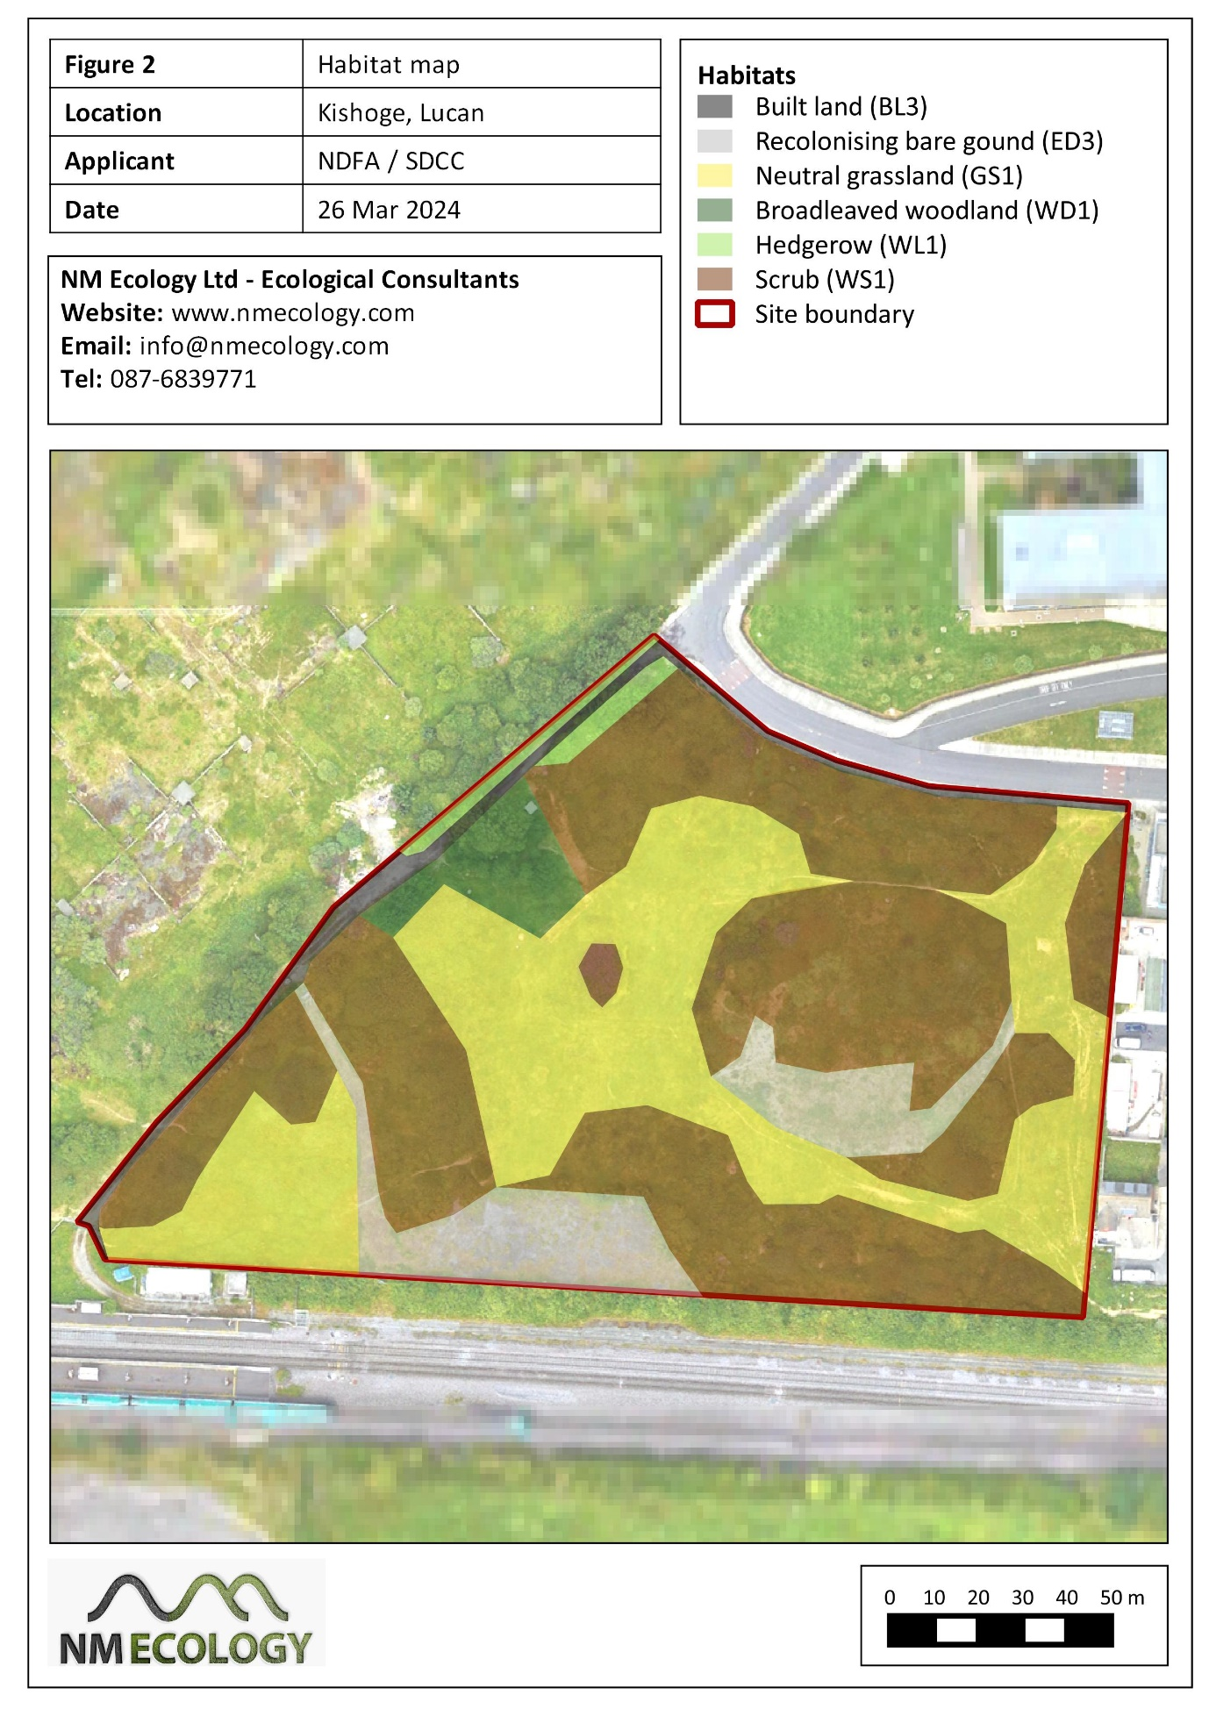

Recolonising bare ground (ED3)
An area in the south of the Site was surfaced with gravel / cut stone in 2010, possibly associated with the widening of the railway. It has now been recolonised by vegetation, with an overall coverage of approx. 50%.
Frequent species include great willowherb Epilobium hirsutum, perforate st john's-wort Hypericum perforatum, dog-rose and creeping cinquefoil. Occasional species include teasel, weld Reseda luteola, burnet rose and bramble.
All of the above species are common and widespread on abandoned / neglected land in suburban areas. In another 5 – 10 years the habitat would develop into bramble scrub. For these reasons, the habitat is considered to be of Negligible importance

Rare or protected flora
No rare or protected plants were encountered.

Invasive plant species
A small patch of Spanish Bluebell Hyacinthoides hispanica (or potentially a hydrid bluebell species) was recorded within the Site. This species is listed on the third schedule of the European Communities (Birds and Natural Habitats) Regulations 2011), which makes it an offence to cause it to spread. It was formerly a popular garden plant throughout Ireland, but is no longer permitted for sale. It remains widespread throughout the country.
No Japanese knotweed or any other Schedule 3 invasive species were recorded within the Site.

Protected fauna

Terrestrial mammals
No field signs of any mammals were observed during the site inspection. There are no waterbodies suitable for otters. The hedgerows around the boundary of the Site were searched for badger setts, mammal paths, latrines, etc, but none were found. The Site does not contain woodland habitat suitable for deer, red squirrels or pine martens. Therefore, the Site is of no importance for these species.
However, the scrub and hedgerows could potentially be suitable for small mammals such as hedgehog, pygmy shrew and / or stoat. These species are shy and secretive, and they do not leave distinctive field signs, so it is very difficult to confirm their presence or absence during walkover surveys. Therefore, based solely on the suitability of habitats within the Site, we consider it likely to be of Local importance for at least one of the species listed above. All three species are protected under the Wildlife Act 1976 (as amended).

Bats
Bats are common and widespread in Ireland. During the day they roost in buildings, bridges and mature trees. At night they forage around wetlands (lakes, rivers, swamps), woodland and hedgerows. They typically avoid urban areas with artificial lighting or open areas such as grasslands.

Potential roost features
There are no buildings, bridges or other built structures within the Site. Buildings around the margins of the Site are modern and illuminated by streetlights, so they are unsuitable for roosting bats. No cavities, crevices or other potential roost features were identified on any of the mature trees. Therefore, the Site and its immediate surroundings are of Negligible importance for roosting bats.

Foraging / commuting habitat
The woodland / treeline / hedgerow and scrub within the Site were considered suitable foraging habitat for bats, so a bat activity survey was carried out. Due to access restrictions and security considerations the survey was carried out using static detectors (3 x Anabat Express units) installed for four consecutive nights from 23 – 27 October 2023. Weather conditions were suitable for a bat survey: sunset temperatures of approx. 10 ºC, dry, and with light winds.
Bats were recorded on two of the survey nights, with moderate activity by soprano pipistrelles and low activity by common pipistrelles. There was no temporal pattern to the results: bats were recorded at dusk, the middle of the night and at dawn. This suggests that bats were feeding within the Site rather than commuting to / from a nearby roost. No other species of bat were recorded.
Soprano pipistrelle and common pipistrelle are the most common bat species in Ireland, and would be expected to occur in habitat of this type. There is similar foraging habitat in the surrounding area, much of which will be lost in the future as the Clonburris SDZ is implemented. Therefore, the Site is considered to be of Negligible importance for foraging / commuting bats.

Birds
There are no Special Protection Areas in the surrounding area, so there is no risk that any associated species could the Site.
Some common countryside birds were observed during the surveys, including woodpigeon, jackdaw, blackbird and wren. No species of conservation importance were recorded. Abandoned agricultural land is rarely of importance for any birds of conservation importance. Therefore, the Site is of Negligible importance for bird species.
However, it is noted that birds and their nests are protected under the Wildlife Act 1976 (as amended). The hedgerow and scrub habitats would be suitable for nesting birds.

Fish and aquatic fauna
There are no waterbodies in the vicinity of the Site, so it is of no importance for fish or other aquatic fauna.

Reptiles and amphibians
No reptiles or amphibians were observed during the survey, nor any ponds or other permanent wetland features suitable for breeding. Therefore, the Site is of Negligible importance for these taxa.

Terrestrial invertebrates
The habitats within the Site are common in rural / suburban landscapes in Ireland, so it is considered to be of Negligible importance for invertebrates.

Potential limitations and information gaps
Habitat and fauna surveys were carried out in June and October 2023, which are ideal months for ecological surveys.
The bat survey was undertaken in late October 2023. In the BCT 2016 guidance it is stated that bat activity surveys in October are “weather or location dependent, i.e. may not be suitable due to spring and autumn conditions in any one year, or in more northerly latitudes.” It is also stated that optimal conditions for bat surveys are “sunset temperature 10 ºC or above, no rain or strong wind”. Air temperatures in October 2023 were relatively mild, and the sunset temperature on the nights of survey was 10 ºC. Winds were low and conditions were dry. Therefore, the timing of the bat survey is not considered to be a limitation.
Bat activity surveys are typically carried out at dusk using handheld detectors. However, due to concerns about antisocial behaviour at the Site the surveyor elected to carry out the survey using static detectors, as this allowed the detectors to be deployed and collected during daylight. Static detectors provide a lower level of spatial accuracy than handheld detectors, but allow a substantially longer survey period (three full nights rather than a 1.5 hour dusk survey). For this reason, the use of static detectors is not considered to be a limitation of the assessment.

Identification of important ecological features
Table 3 provides a summary of all ecological features identified on the Site, including their importance and legal status. For the purposes of this impact assessment, any features that are of Local ecological importance, or that receive legal protection, are considered to be ‘important ecological features’, and will be addressed in the impact assessment.
Table 3: Important ecological features within the Site
Ecological feature | Importance | Legal status | Important feature?
Designated sites | N.A. | HR, WA | No
Scrub (WS1) | Negligible | - | No
Woodland (WS1) / Treeline (WL2) / Hedgerow (WL1) | Local | - | Yes
Neutral grassland (GS1) | Negligible | - | No
Recolonising bare ground (ED3) | Negligible | - | No
Rare / protected flora | Negligible | - | No
Spanish bluebell | N.A. | HR | Yes
Other invasive plant species | N.A. | - | No
Small mammals (hedgehog, stoat, pygmy shrew) | Local | WA | Yes
All other terrestrial mammals | Negligible | HR, WA | No
Bats | Negligible | HR, WA | No
Birds (including nesting habitat) | Negligible | WA | Yes
Fish and aquatic fauna | N.A. | WA | No
Reptiles and amphibians | Negligible | - | No
Invertebrates | Negligible | - | No
* HR – European Communities (Birds and Natural Habitats) Regulations 2011 (as amended); WA - protected under Section 19 or 20 of the Wildlife Act 1976 (as amended)
The Important Ecological Features identified in this assessment are the woodland / treeline / hedgerow, Spanish bluebell, small mammals and nesting birds. Potential impacts are considered in Section 5, and mitigation measures are presented in Section 6.
All other ecological features discussed in Section 3 are considered to be of Negligible ecological importance, so they are not listed as Important Ecological Features. This does not mean that that they will not be affected by the proposed development: the proposal will require the clearance of large areas of scrub and neutral grassland. It simply means that the features are sufficiently common and widespread that their loss would not be considered significant in the context of an Ecological Impact Assessment.

Predicted Impacts of the Proposed Development

Landscaping and biodiversity change
The cessation of management since approx. 2000 – 2005 has led to the establishment of scrub and neutral grassland. The development of the Site will require the clearance of these habitats.
The broadleaved woodland / treeline / hedgerow in the north-west of the Site will need to be removed to accommodate the proposed development. However, the landscaping scheme for the proposed development will incorporate a large number of native trees and shrubs, which will be greater in number than the number removed. Therefore, the proposed development will have a neutral impact on woodland / treeline / hedgerow habitat.
The Landscape and Biodiversity Plan for the proposed development (prepared by Mitchell & Associates, 2024) includes some biodiversity-enhancment measures that will be implemented as part of the landscaping scheme, including:
- Detention basins will be constructed in the centre and south of the Site, which will temporarily hold water during periods of high rainfall. These features are expected to develop some wetland vegetation
- Native trees will be planted throughout the Site, including crabapple, elder, hawthorn, hazel, birch and alder. Trees will be planted surrounding the southern detention basin, creating an ideal habitat for birds and small mammals
- Provision of small openings (13 x 13 cm) in boundary fences to provide access for small mammals
- Swift nest boxes will be installed on the apartment building in the south-west of the Site. Nest boxes for other species (e.g. tits, finches) will be provided on trees in the south of the Site.
These measures will partly compensate for removal of existing habitats (hedgerow, scrub and dry meadow). They will also introduce some habitats that are not currently present at the Site, notably the detention basin with wetland vegetation.

Spread of Spanish bluebell
Construction works within the Site could potentially cause localised spread of Spanish bluebell or its seeds, which would constitute an offence under the EC (Birds and Natural Habitats) Regulations 2011 (as amended).

Disturbance of breeding birds and mammals
It is possible that birds and / or small mammals (e.g. hedgehog) could breed in some of the scrub and woodland / treeline / hedgerow habitats proposed for removal. If trees and shrubs were cut during the bird nesting season (usually between March and August, inclusive), it is possible that active nests could be destroyed. The breeding season for small mammals is approximately the same. The killing of any birds or small mammals, or the disturbance of their breeding / resting places, would constitute an offence under the Wildlife Act 1976 (as amended).

Potential cumulative / in-combination impacts
No developments were identified in Section 3.2 that could potentially lead to in-combination effects.

Proposed mitigation measures

Protection of birds during site clearance works
Under Sections 22 and 23 of the Wildlife Act 1976 (as amended), it is an offence to kill or injure a protected bird or mammal, or to disturb their breeding / resting places. Most birds nest between March and August (inclusive), and the breeding season for most small mammals is similar. Therefore, it is strongly recommended that site clearance works are carried out between September and February (inclusive), i.e. outside the nesting season. If this is not possible, an ecologist will survey the affected areas in advance in order to assess whether any breeding birds or mammals are present. If any are encountered, vegetation clearance will be delayed until the breeding attempt has been completed, i.e. after chicks have fledged and a nest has been abandoned.

Eradication of Spanish bluebell
Individual plants can be killed by herbicide application, and it is recommended that this is carried out in the next growing season, approx. March / April 2025. It is possible that seeds are present in the surrounding soil and may germinate in the future, so it is recommended that treatment is also carried out in 2026 / 2027 to treat any new growth.
It is recommended that this is undertaken by South Dublin County Council prior to tendering for the construction of the proposed development, as it should be possible to eradicate the plant before construction commences.

Residual Impacts
The proposed development will involve the removal of large areas of scrub and neutral grassland in the centre of the Site. These habitats are considered to be of Negligible ecological importance because they consist of plant species that are common and widespread, and because they have formed in the last 15 years due to the cessation of management at the Site. The removal of habitats of Negligible ecological importance is not considered to be a significant impact in the context of an Ecological Impact Assessment. However, when the baseline habitats are compared with the development layout there will inevitably be a net loss of biodiversity at the Site.
It will also be necessary to clear a small area of woodland / treeline / hedgerow in the north-west of the Site. However, this will be compensated by tree planting elsewhere in the Site, resulting in a neutral impact on this habitat.
The loss of these habitats will be partly compensated by the landscaping scheme for the proposed development, which will include detention basins, native trees / shrubs, access points for small mammals, and bird nest boxes.
Spanish bluebell will be treated using herbicide for at least three years: 2025 – 2027. It is expected that it can eradicated before the construction of the proposed development commences.
Site clearance works will take place outside the season of peak breeding activity in birds and mammals, or the area will be surveyed by an ecologist to confirm that no protected fauna are present. This will avoid any direct impacts on breeding birds or small mammals, and prevent a legal offence under the Wildlife Act 1976 (as amended).
Subject to the successful implementation of these measures, it can be concluded that the proposed development will not cause any significant negative impacts on designated sites, habitats, legally protected species, or any other features of ecological importance.

References
Bat Conservation Trust (ed. Collins, J.) 2016. Bat Surveys for Professional Ecologists: Good Practice Guidelines (3rd edition). Available online
Botanical Society of the British Isles, 2007. Plant species nomenclature checklist. Botanical Society of the British Isles, Southampton.
Chartered Institute of Ecology and Environmental Management, 2018. Guidelines for Ecological Impact Assessment in the U.K and Ireland: Terrestrial, Freshwater and Coastal (2nd Edition). C.I.E.E.M., Hampshire, England.
Marnell, F., Kingston, N., Looney, D., 2009. Ireland Red List No. 3 – Terrestrial Mammals. National Parks and Wildlife Service, Department of Environment, Heritage and Local Government, Dublin, Ireland.
Parnell, J. & Curtis, T., 2012. Webb’s An Irish Flora, Eighth Edition. Cork University Press.
Poland, J., Clement, E., 2009. The Vegetation Key to the British Flora. John Poland and the Botanical Society of the British Isles, Southampton.

