Screening for Appropriate Assessment
Proposed Residential Development at
Kishoge, Lucan
26 March 2024


NM Ecology Ltd - Consultant Ecologists
38 Maywood Avenue, Raheny, Dublin 5
Website: www.nmecology.com
Email: info@nmecology.com
Tel: 087-6839771

Executive Summary
This Screening for Appropriate Assessment report has been prepared by NM Ecology Ltd on behalf of South Dublin County Council regarding a proposed residential development at Kishogue, Lucan, Dublin 22. The proposed development will involve the construction of 118 dwellings (a mixture of apartments and terraced houses) and associated works.
In accordance with their obligations under the European Communities (Birds and Natural Habitats) Regulations 2011 (SI 477/2011), the competent authority must assess whether the proposed development could have ‘likely significant effects’ on any European sites. This document provides information to support an Appropriate Assessment screening exercise, including: a description of the proposed development, a map and list of European sites in the surrounding area, a review of potential source-pathway-receptor links, an appraisal of the suitability of the habitats for birds associated with nearby SPAs, and a screening conclusion.
There is no risk of direct impacts on European sites. Potential pathways for indirect impacts were considered, but none were found to be feasible. Habitats within the site are unsuitable for any of the species associated with nearby SPAs. Therefore, with regard to Article 42 (7) of the European Communities (Birds and Natural Habitats) Regulations 2011, it can be concluded that the proposed development will not be likely to have a significant effect on any European sites. The assessment can conclude at Stage 1 of the Appropriate Assessment process, and it is not necessary to proceed to Stage 2.

Introduction

Background to Appropriate Assessment
Approximately 14% of the land area of Ireland is included in the European Network of Natura 2000 sites (hereafter referred to as European sites), which includes Special Protection Areas (SPAs) to protect important areas for birds, and Special Areas of Conservation (SACs) to protect a range of habitats and species. Legislative protection for these sites is provided by the European Council Birds Directive (79/409/EEC) and E.C. Habitats Directive (92/43/EEC, as amended), which are jointly transposed into Irish law by the European Communities (Birds and Natural Habitats) Regulations 2011 (SI 477/2011, as amended).
Regulation 42 (1) states that: “Screening for Appropriate Assessment of a plan or project for which an application for consent is received […] shall be carried out by the public authority to assess, in view of best scientific knowledge and in view of the conservation objectives of the site, if that plan or project, individually or in combination with other plans or projects is likely to have a significant effect on [any European sites].” To ensure compliance with this regulation, planning authorities must screen all planning applications for potential impacts on European sites. Supporting information may be requested from the applicant to assist with this process.
This document provides information to support the competent authority’s Screening for Appropriate Assessment exercise for the proposed development. It includes a description of the proposed development, a map and list of European sites in the surrounding area, a review of potential source-pathway-receptor links, and an appraisal of the suitability of the habitats for birds associated with nearby SPAs.

Statement of authority
This report was written by Nick Marchant, the principal ecologist of NM Ecology Ltd. He has sixteen years of professional experience, including thirteen years as an ecological consultant, one year as a local authority biodiversity officer, and two years managing an NGO in Indonesia. He provides ecological assessments for developments throughout Ireland and Northern Ireland, including wind farms, infrastructural projects (roads, water pipelines, greenways, etc.), and a range of residential and commercial developments.
He has an MSc in Ecosystem Conservation and Landscape Management from NUI Galway and a BSc in Environmental Science from Queens University Belfast. He is a member of the Chartered Institute of Ecology and Environmental Management, and operates in accordance with their code of professional conduct.

Methods
This report has been prepared with reference to the following guidelines:
- OPR Practice Note PN01: Appropriate Assessment Screening for Development Management (Office of the Planning Regulator 2021)
- Assessment of plans and projects significantly affecting Natura 2000 sites: Methodological guidance on the provisions of Article 6(3) and (4), (E.C., 2021)
- Appropriate Assessment of Plans and Projects in Ireland (Department of the Environment, Heritage and Local Government, 2009)
- Guidelines for Ecological Impact Assessment in the UK and Ireland: Terrestrial, Freshwater and Coastal (Chartered Institute of Ecology and Environmental Management, 2018)
A desk-based study was carried out using data from the following sources:
- Plans and specifications for the proposed development
- Qualifying interests / conservation objectives of European sites from www.npws.ie
- Bedrock, soil, subsoil, surface water and ground water maps from the Geological Survey of Ireland webmapping service (dcenr.maps.arcgis.com), the National Biodiversity Data Centre (http://maps.biodiversityireland.ie/), and the Environmental Protection Agency web viewer (gis.epa.ie/EPAMaps/)
- The South Dublin County Development Plan 2022 – 2028, and details of permitted or proposed developments from the local authority’s online planning records
Desktop data from internet resources was accessed in January 2024, and a multi-disciplinary ecology survey was carried out on 15 June 2023.

Description of the Project

Environmental setting

Site location and surroundings
The proposed development site (hereafter referred to as ‘the Site’) is located in a suburban / rural area in the townland of Kishoge. Based on a review of aerial photography it appears that the Site was formerly used as allotments / horticultural land in the 1990s and early 2000s, but in the late 2000s it was cleared and disturbed during the construction of the adjacent Lynch’s Park development, the removal of a halting site to the north-west of the Site, and the widening of the railway line. As part of this process, a large mound of spoil was deposited in the north-east of the Site. There has been no activity on the Site since approx. 2010, and it has recolonised with scrub. The only activity on the Site during this period has been low-intensity grazing by horses.
The southern boundary of the Site is formed by a major railway connecting Dublin with the south-west of Ireland. The eastern boundary is formed by the Lynch’s Yard residential development, and the northern boundary by an associated road. Land to the west and north-west of the Site was formerly used as a halting site, and has some remaining walls and concrete-surfaced yards, but the remainder of the area consists of scrub.
The broader surroundings are characterised by abandoned agricultural land, all of which is zoned for future development as part of the Clonburris Strategic Development Zone.

Geology and soils
The underlying bedrock is dark limestone & shale, which is a locally-important aquifer. Subsoils are limestone till. Soils are made ground: most of the Site was disturbed during the construction of the adjacent Lynch’s Yard development, which involved the deposition of building spoil on the Site, the mixing of existing subsoil and soil, and compaction of soils by heavy vehicles.
The topography of the Site is broadly level. The mound of building spoil in the north-east of the Site is the only topographical feature of note.

Hydrology
The EPA database of rivers and streams does not show any watercourses within or adjacent to the Site. None were observed during surveys.
The Grand Canal is located approx. 500 m south of the Site. Canals are self-contained hydrological features that do not interact with surrounding surface water or groundwater features, so there could be no connection between the Site and the canal.
The closest natural watercourse is the Grifeen River, which is a tributary of the River Liffey. It is located approx. 1.3 km west of the Site at the closest point. Due to its distance from the Site and the absence of any intervening surface water features, it can be concluded that the Site has no connection to the Grifeen River.
In summary, the Site has no connection to any watercourses.

Description of the proposed development
The proposed development will involve the construction of 118 no. residential units in a range of designs. Road access will be from the northern boundary of the Site, and internal roads and parking areas will be provided. Public open space will be created, and houses will have private gardens.
Foul water will be pumped to a local authority foul sewer to the north of the Site and conveyed to the Ringsend Waste Water Treatment Plant. The Ringsend WWTP is currently exceeding its organic capacity, but a major upgrade is in progress that will provide sufficient capacity by 2025. The WWTP upgrade will be completed before the proposed development is operational / occupied, so there will be capacity to accept the effluent.
Rainwater runoff from roofs and other impermeable surfaces will be channelled to detention basins in the south and centre of the Site, and discharged at a controlled rate to a local authority storm drain in the north of the Site. The system will include an oil and hydrocarbon interceptor.

Review of relevant European sites
In this section we identify European sites that could potentially be affected by the proposed development. The primary consideration is whether the proposed development is within the boundaries of any European sites, because this could lead to direct effects. This is discussed in Section 3.1.
It is also possible that the proposed development could cause indirect effects on European sites located outside the boundary. This is considered using the source-pathway-receptor model, which identifies potential pathways (e.g. surface water) between the source (the Site) and the receptor (a European site). This is discussed in Section 3.2.
Some of the bird species associated with SPAs can use secondary habitats outside the SPA boundaries, e.g. brent geese feeding on urban grasslands. The suitability of habitats within the Site for SPA bird species is discussed in Section 3.3.
To support the above assessments, a map of European sites in the surrounding area is shown in Figure 1, and details of relevant European sites are provided in Table 1. For the avoidance of doubt, an arbitrary zone of influence (e.g. 15 km) has not been used for this assessment, as it is no longer considered to be best practice (OPR 2021).
Table 1: European site shown in Figure 1
Site Name | Distance | Qualifying Interests
Rye Water Valley / Carton SAC (1398) | 5.2 km north-west | Annex I habitats: Petrifying springs with tufa formation  Annex II species: Narrow-mouthed Whorl Snail Vertigo angustior, Desmoulin's Whorl Snail Vertigo moulinsiana
The Conservation Objectives of all European sites discussed in this report are available at https://www.npws.ie/protected-sites. They are lengthy and repetitive documents, so in the interests of brevity they are not reproduced here.
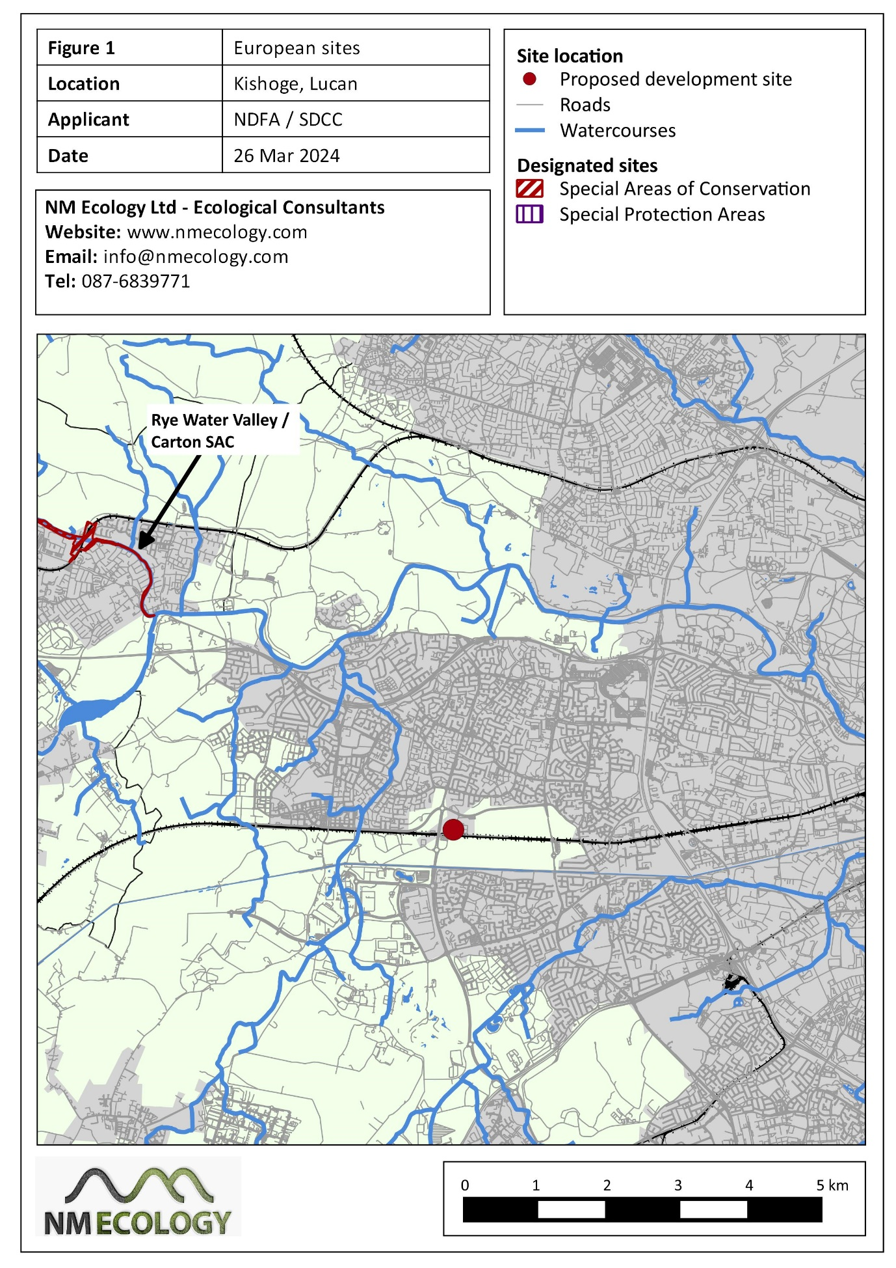

European sites within the Site boundary (potential direct effects)
The Site is not within or adjacent to any European sites (Figure 1). Therefore, the proposed development poses no risk of direct impacts on any European sites.

European sites outside the Site boundary (potential indirect effects)
In this section we identify potential pathways (e.g. surface water) between the source (the Site) and the receptor (a European site). The most common pathway is surface water, which typically occurs when a pollutant is washed into a river and carried downstream into a European site. Other potential pathways are groundwater, air (e.g. airborne dust or sound waves), or land (e.g. flow of liquids, vibration). The zone of effect for hydrological effects can be several kilometres, but for air and land it is rarely more than one hundred metres.

Surface water
There are no rivers or streams within or adjacent to the Site (refer to Section 2.1 and Figure 1), so surface water can be ruled out as a pathway to any European sites.

Groundwater
If any pollutants soaked to ground within the Site, they would have to pass through 5.2 km of intervening subsoils / bedrock before reaching the Rye Water Valley / Carton SAC. This would reduce any pollutants to negligible concentrations before reaching the SAC, in which case they would pose no risk of impacts. Therefore, groundwater can be ruled out as a feasible pathway.

Land
There is no risk that any pollutants could flow 5.2 km over land to reach the SAC.

Air
The only potential airborne pollutant generated at the Site would be dust. There is no risk that any perceptible quantity of dust could be carried 5.2 km to the SAC.

Summary
In summary, no feasible pathways were identified between the Site and any European sites.

Habitat suitability for SPA birds
There are no SPAs in the vicinity of the Site. The closest is the Wicklow Mountains SPA, which is located approx. 14 km south of the Site, and was designated to protect peregrine and merlin. Habitats within the Site are unsuitable for either of these species. Therefore, the Site is of no importance for any SPA bird species.

Screening Statement
In Section 3 of the OPR guidance (OPR 2021), it is stated that the first stage of the AA process can have two possible conclusions:
- No likelihood of significant effects
Appropriate assessment is not required and the planning application can proceed as normal. Documentation of the screening process including conclusions reached and the basis on which decisions were made must be kept on the planning file.
- Significant effects cannot be excluded
Appropriate assessment is required before permission can be granted. A Natura Impact Statement (NIS) will be required in order for the project to proceed.
Having considered the particulars of the proposed development, we conclude that this application meets the first conclusion, because there is no likelihood of significant impacts on any European sites. This is based on three key conclusions:
- The Site is not within or adjacent to any European sites, so there is no risk of direct effects
- There are no surface water (or other) pathways linking the Site to any European sites, so there is no risk of indirect effects
- There are no SPAs in the vicinity of the Site
Appropriate Assessment Screening must consider the potential implications of a project both in isolation and in combination with other plans and projects in the surrounding area. An ‘in-combination effect’ can occur when a project will have a perceptible but non-significant residual effect on a European site (when considered in isolation), that subsequently becomes significant when the additive effects of other plans and projects are considered. However, as the proposed development poses no risk of impacts on European sites in isolation, the risk of in-combination effects can also be ruled out.
Therefore, with regard to Article 42 (7) of the European Communities (Birds and Natural Habitats) Regulations 2011, it can be concluded that the proposed development will not be likely to have a significant effect on any European sites. On this basis, the assessment can conclude at Stage 1 of the Appropriate Assessment process, and it is not necessary to proceed to Stage 2.
In accordance with the OPR 2021 guidance, we note that no mitigation measures have been considered when reaching this conclusion.

References
Chartered Institute of Ecology and Environmental Management, 2018. Guidelines for Ecological Impact Assessment in the U.K and Ireland: Terrestrial, Freshwater, Coastal and Marine (2nd Edition). C.I.E.E.M., Hampshire, England.
Department of the Environment, Heritage and Local Government, 2009. Appropriate Assessment of Plans and Projects in Ireland. National Parks and Wildlife Service, DAHG, Dublin, Ireland.
European Commission. 2020. Assessment of plans and projects significantly affecting Natura 2000 sites: Methodological guidance on the provisions of Article 6(3) and (4) of the Habitats Directive 92/43/EEC. Office for Official Publications of the European Communities, Luxembourg.
Office of the Planning Regulator 2021. Practice Note PN01: Appropriate Assessment Screening for Development Management. Available online at opr.ie

