COUNTY ARCHITECT’S REPORT  Proposed Extension and alterations to a Day-House at 19 Kishogue Park, Clondalkin, Dublin 22  Part 8 Process, carried out under Part 8 of the Planning and Development Regulations 2001, Part 8.  Consultation Process stage.  This is an advisory report. The full report will be issued following the conclusion of the Consultation Process.  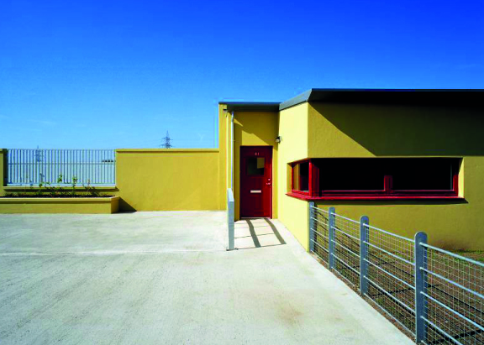  A typical Day-House in Kishogue Park, as existing  19 Kishogue Park, as proposed  Issued September 2019 |  |  | 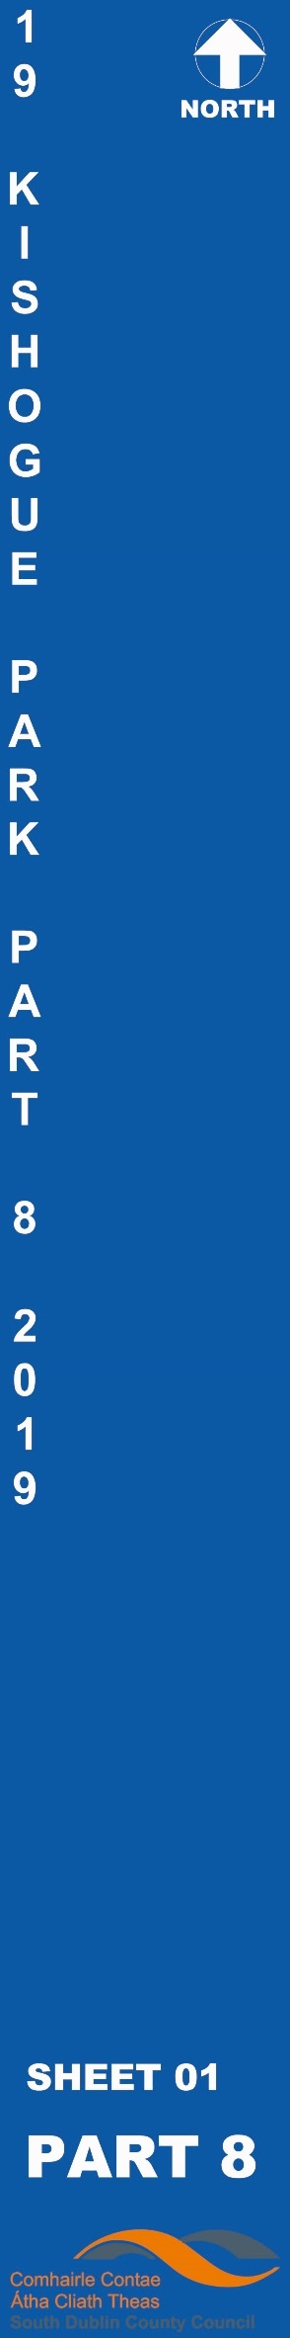
 |  | COUNTY ARCHITECT’S REPORT – Part 8 – display / consultation
 | Project Title: | Proposed Extension and alterations to a Day-House at 19 Kishogue Park, Lynch’s Lane, Lucan, Co. Dublin
 | County Architect:  Senior Architect:  Architects: | Eddie Conroy FRIAI  Anne Lynch FRIAI  Architectural Services Department, South Dublin County Council
 | Brief explanation of Part 8 Process carried out under Part 8 of the Planning and Development Regulations 2001 | Part 8 (Public Consultation Schemes)  Developments by a local authority are subject to a public consultation process as set out in the Planning & Development Regulations, 2001 - 2012. This procedure requires that notice of the proposed development be given in the public press and that a site notice be erected. If any submissions or observations are received, a report is presented to the members of the Council. This report contains a list of the objector's names along with a summary of the points made by them and the Local Authority' response.  Arising from consideration of the representations, the report sets out whether or not it is proposed to proceed as originally planned or to proceed with a modified proposal.  Development by a Local Authority: 'Part 8'  From time to time the Local Authority may carry out development within its administrative area, such as the construction of houses, roads, swimming pools, public toilets etc.  Development carried out by a Local Authority is often referred to as a 'Part 8':- this is reference to Part 8 of the Planning and Development Regulations 2001 which sets out the procedure for carrying out such developments.  Public consultation is an intrinsic part of the 'Part 8' process. This is achieved by public notices, public display of the proposal, observations by members of the public, reportage on observations received and a recommendation that considers all internal and public observations. The consultation may extend to advisory consultation meetings with local community and interest groups dependant on the particular circumstances and impact of the proposal, though such meetings are not proscribed under the legislation. The primary purpose of the process is to notify the public of the proposal and incorporate any observations validly submitted into a report to inform the Council on its decision to recommend the proposal.  Comments and observations on Proposed Developments by a Local Authority can only be received in writing between certain dates. The public notices should be referred to in this regard to ascertain the final date of receipt for observations.  Part 8 of the Planning and Development Act 2000 – 2007 refers to requirements in respect of specified development by, on behalf of, or in partnership with Local Authorities. Part 8 applications are generally lodged by the proposing department within the Council. Article 80 of the Planning and Development Regulations 2001 sets out a list of the types of development prescribed for the purposes of the act.  The process is as follows:  Public Notices of the proposed development must be placed in an approved newspaper. A site notice (or notices) must be erected on the land on which the proposed development is situated – Article 81(1)(a)(b) of the Planning and Development Regulations 2001 provides guidance on the requirements.  The application, which must be submitted on the same date as the newspaper notice, must include a cover letter / report, a copy of the newspaper notice and site notice and public display of the proposal in a designated public area accessible to the public during normal office hours – normally County Hall. Drawings can be made available to the public on request.  There is no fee payable on a Part 8 application.  The application is referred to internal works Departments in the City Council – (Roads, Water, and Drainage).  In the case of protected structures the application is referred to the Conservation Section, An Taisce, DEHLG and the Heritage Council.  The timeframe for third party Observations/Submissions on the Part 8 application is six weeks from the date of lodgement. This date is specified in the public notices. There is no fee charged for observations/submissions on a Part 8.  The proposing Department completes a report for the attention of the Executive Manager of the Planning Department. The Executive Manager will make a recommendation to the proposing department on foot of this report.  A report will then be compiled for a meeting of the Council. Following consideration of this report by the Council, the proposed development may be recommended, unless the local authority, by resolution, decides to vary or modify the development, otherwise than as recommended in the report, or decides not to proceed with the development’ – as per Section 179(4)(b) of the Planning and Development Act 2000 (as amended). For a part 8 application the period for observations/submissions is 6 weeks.  There are 5 weeks allowed for a normal planning application.  The making of a decision on a Part 8 application is a reserved function of Council, while for a normal planning application this is an executive function.  The above is a summary of the Part 8 requirement for consultation. It is intended for guidance only. The Planning Acts set out the requirements in full.
 | Public Notice: | Proposed New Works  Proposed Extension and alterations to a Day-House at 19 Kishogue Park, Lynch’s Lane, Lucan, Co. Dublin  Planning and Development Act, 2000 (as Amended) Public Consultation Procedure under Part 8 of the Local Government Planning and Development Regulations 2001 (as Amended).  Pursuant to the requirements of the above, notice is hereby given of the proposal to construct the following scheme by South Dublin County Council:  Proposed Extension and alterations to a Day-House at 19 Kishogue Park, Lynch’s Lane, Lucan, Co. Dublin  In accordance with the requirements of the above, notice is hereby given that South Dublin County Council proposes an extension and alterations to be constructed at ground floor level to the existing Day-House at No. 19 Kishogue Park.  Works to the existing day-house include: Extension and reconfiguration of the current building at 19 Kishogue Park, Lynch’s Lane, Lucan, Co. Dublin to create a 4-bedroom, 5-person, single-storey dwelling and all necessary associated ancillary works on the site. Works to the existing Day-house will include: reconfiguration of the kitchen and shower room areas to create a kitchen, utility area and W.C. The living / dining area will also be extended. The works include alterations to the front boundary wall and entrance gates, new hard landscaping works and all necessary associated ancillary works on the site and adjacent areas.  Plans and particulars of the proposed scheme will be available for inspection or purchased at a fee not exceeding the reasonable cost of making a copy for a period of four weeks from Thursday, 5th September 2019 during the public opening hours at the offices of South Dublin County Council, County Hall, Tallaght, Dublin 24.  The proposed Scheme has undergone Appropriate Assessment Screening under the Habitats Directive (92/43/EEC). The proposal has undergone a preliminary examination for Environmental Impact Assessment of the proposal and the Planning Authority has concluded that there will be no real likelihood of significant effects on the environment arising from the proposed development and therefore an Environmental Impact Assessment is not required. Any person may, within 4 weeks from the date of this notice, apply to An Bord Pleanála for a screening determination as to whether the proposed development would be likely to have significant effects on the environment.  The plans and particulars can be viewed on South Dublin County Council’s website – www.sdcc.ie and the Public Consultation Portal http://consult.sdublincoco.ie  Date site notice erected: Wednesday 4th September 2019.
  Submissions:  Submissions or observations in relation to the proposed development, dealing with the proper planning and sustainable development of the area in which the development would be situated, may be made as follows:  Or | Online at https://consult.sdublincoco.ie up to midnight on Friday 18th October 2019.
  Written submissions not later than 4.30pm Friday 18th October 2019.  Please address your submission to: | Senior Executive Officer  Traveller Accommodation Unit, Housing Department  South Dublin County Council  County Hall, Tallaght, Dublin 24, D24 YNN5
  NOTE: Please make your submission by one medium only.  Only submissions received by Friday 18th October 2019 and addressed as set out above, will be considered. | It should be noted that the Freedom of Information Act applies to all records held by South Dublin County Council. South Dublin County Council's Personal Data Privacy Statements can be viewed at www.sdcc.ie and all personal data will be retained in line with statutory requirements.
  Submissions cannot be accepted in any other format or to any other postal address. Submissions and observations should state the name, address, and, where relevant, details of any organisation, community group or company etc. which you represent.
 | Context: | The site is located in an existing residential caravan park. The site is accessed off the R136 at the roundabout to Kishogue Road. The site is a Bay with day-house on an existing Traveller Development.  Concept sketch/ design approach/ constraint  19 Kishogue Park is a single-storey, detached building. It is situated in a residential caravan park, just off the R136 Outer Ring Road. The site is within an existing Traveller Accommodation development and the completed works will not impact on the surrounding dwelling plots.  In construction detail and finishes, number 19 Kishogue Park is similar to the nearby Day-Houses which share the same building line, wall finishes, window opening sizes and arrangements, decorative details and roof covering. Like the other Day-Houses, number 19 has a garden / yard – the ground surface is poured concrete.  The proposed development comprises the following works: an extension to the existing Day-House comprising 4 bedrooms, an accessible bathroom, and modifications and extension to the existing kitchen/living area (to comply with current Department of Planning, Housing and local Government standards) and ancillary works within the confines of number 19 Kishogue Park. These have been designed in accordance with the recommendations of the consultant occupational therapist.  The proposed development will not affect the density of the estate.  The following areas apply to the site and building, as existing:  - Site area: 390 sq.m. / 0.095 acres / 0.038 hectares  - Existing internal floor plan area: 48.4 sq.m.  The following areas apply to the site and building, as proposed:  - Site area: 390 sq.m. / 0.095 acres / 0.038 hectares (remains the same)  - Proposed ground-floor day-house and extension, internal area: 138.0 sq.m.  Following the end of the consultation process, and following the final presentation to the Council Chamber, the layout will be adjusted to reflect the outcomes of the public consultation.  The proposed works were approved at the Local Area Committee Meeting, C/442/18 – (H7) Item ID: 60038. The overall Project Budget is subject to approval by the Department of Housing, Planning and Local Government.  Site Plan  Plan of Proposal  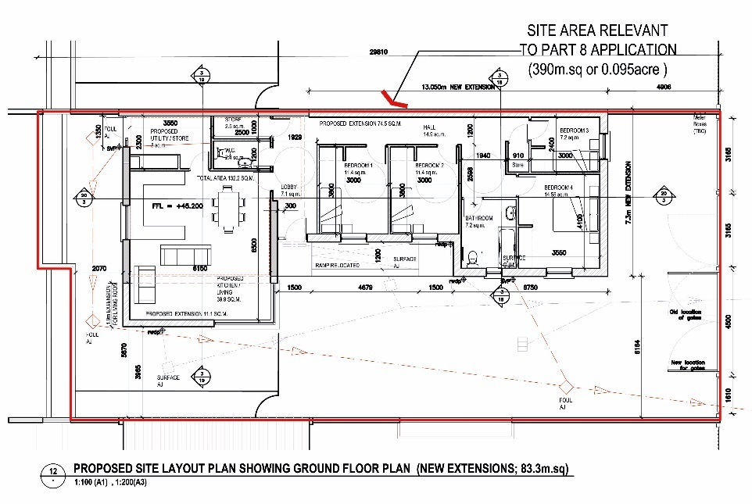
 | Planning / Zoning for the site | Planning / Zoning  The lands are zoned – South Dublin County Council Development Plan 2016-22 – Variation 1  Zoning Objective SDZ – “To provide for strategic development in accordance with approved planning schemes” (SDZ is an abbreviation for “Strategic Development Zone”)  The zoning of the site, coloured brown on the map below, supports an extension to the dwelling on the plot and the criteria as applicable from the Development Plan supports the proposed density. The proposed development complies in principle with the relevant Development plan polices.  Planning Designation: The planning designation is for residential  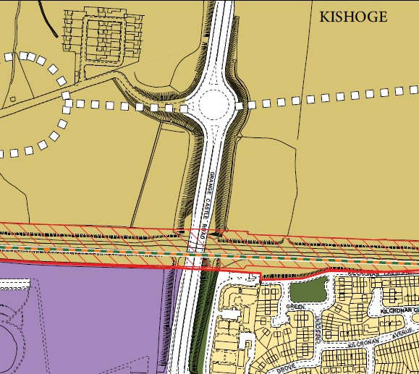  Zoning map for Area (extract from the County Development Plan 2016 – 2022)  Extracts from the County Development Plan 2016 – 2022  The development plan policies that affect the site directly are the following:  2.3.4 INTERNAL RESIDENTIAL ACCOMMODATION  H14 Objective 2:  To support adaptable housing layouts that can accommodate the changing needs of occupants, through extension or remodelling.  2.4.1 RESIDENTIAL EXTENSIONS  Domestic extensions allow for the sustainable adaptation of the County’s existing housing stock. The South Dublin County Council House Extension Design Guide (2010) supplements the policies and guidance of the development plan.  HOUSING (H) Policy 18 Residential Extensions  It is the policy of the Council to support the extension of existing dwellings subject to the protection of residential and visual amenities.  H18 Objective 1:  To favourably consider proposals to extend existing dwellings subject to the protection of residential and visual amenities and compliance with the standards set out in Chapter 11 Implementation and the guidance set out in the South Dublin County Council House Extension Design Guide, 2010 (or any superseding guidelines).  5.6.4 DISTRICT CENTRES  R6 Objective 3:  To support and facilitate the development of new District Centres of an appropriate urban scale at Adamstown and Clonburris in accordance with approved Planning Schemes which should provide a sustainable retail mix including department stores and shopping centres that facilitates walking, cycling and use of public transport and reduces car journeys outside the SDZ for many retail needs.  The zoning of the site supports the proposed development. The proposed development complies in principle with the relevant Development plan polices.  DENSITY  Density will not be affected by the proposed works.  Site Area – Total site area : 0.095 acres, 0.038 hectares, or 390m²  The proposals as submitted for Part 8 Public Consultation are in compliance with the County Development Plan Objectives.
 | Habitats Directive Assessment | Habitats Directive Assessment  Ecological Survey and Screening of a proposed development on site.  A screening assessment is required due the proximity of SAC and SPA site within 15km.  Site in context of nearby Site covered by the Habitats Directive  Screening Assessment Conclusion  The proposed Scheme has undergone Appropriate Assessment Screening under the Habitats Directive (92/43/EEC). The proposal has undergone a preliminary examination for Environmental Impact Assessment of the proposal and the Planning Authority has concluded that there will be no real likelihood of significant effects on the environment arising from the proposed development and therefore an Environmental Impact Assessment is not required. Any person may, within 4 weeks from the date of this notice, apply to An Bord Pleanála for a screening determination as to whether the proposed development would be likely to have significant effects on the environment.  This screening report has evaluated the proposed development by South Dublin County Council at the site, to determine whether or not significant negative impacts on Natura 2000 sites are likely to arise by virtue of its construction and use.  The site does not affect watercourses or developed park land.  Visual Inspection:  There are no trees present on the site that offer potential for roosting bats. The existing building is occupied and does not offer an appropriate habitat due to noise / human activity.  Conclusion:  A bat derogation licence is therefore not required for the proposed development as part of the Part 8 Approval.  Badger Survey:  There was no evidence of badgers using the site – The site is open and offers no cover and has invasive vehicular / pedestrian traffic to the exposed boundaries.  The report finds that the project will not, either individually or in combination with other plans and projects, give rise to significant effects on the integrity of any Natura 2000 site.  The Appropriate Assessment procedure for this proposed Plan is therefore concluded at this Screening Stage and a detailed (Stage 2) Appropriate Assessment is not required.  5.2 Biodiversity Measures  General recommendations for conserving and improving biodiversity within the site are presented below:  - Lighting  No additional public lighting is proposed by this project. if any is required, lighting should be designed and installed with controlled targeting a priority:  It is recommended that lighting should be directional to ensure that it can be restricted to the grounds of the housing development and not overspill onto any of trees and shrubs which form the boundaries of the site and which could be used by foraging bats. This can be achieved in a number of ways including low mounting position, cowls, low intensity, direction of light, etc.  - Planting of native species:  No additional planting is proposed by this project. If any is required, the development will include new landscaping proposals including the planting of trees and shrubs. This should include the use of native and local plant species, such as hawthorn, blackthorn, hazel, Wych elm, mountain ash, alder, willows, oak, ash, broom, elder and gorse – a small selection of one of these. Species used should be native and of local origin.  - Provision of roosting and nesting opportunities:  Nesting and roosting opportunities should be provided for both bats and birds within the site. These can include nest boxes, bat boxes and the incorporation of specialised bricks/pre-constructed opportunities in walls. These should be specified by an ecologist at detailed design stage.
 | Project Description  & Design | Development consisting of an Extension and alterations to a Day-House at 19 Kishogue Park, Lynch's Lane, Lucan, Co. Dublin  The proposed development shall consist of:  An extension to be constructed at ground floor level to the existing Day-House at No. 19 Kishogue Park. The extension will comprise 4-bedroom, 5-person and a bathroom.  Works to the existing day-house will include: reconfiguration of the kitchen & shower room areas to create a kitchen, utility area and W.C. The living/dining area will also be extended.  The works include: Extension and reconfiguration of the current building to create a 4 bedroom dwelling and all necessary associated ancillary works on the dwelling site.  The works include: alterations to the front boundary wall and entrance gates, new landscaping works and all necessary associated ancillary works on the site and adjacent areas.  Following the end of the consultation process, and following the final presentation to the Council Chamber, the layout will be reviewed in the light of observations submitted during the public consultation period. The Overall Project Budget is subject to Department of Housing, Planning and Local Government (DoHPLG) approval.
 | Landscaping | Restoration of the existing yard with supplementary planting to boundaries where existing properties abut with the proposed development site. Removal of undergrowth and weed plants on site. Landscaping of all open space areas and local upgrading of boundaries.
 | Ancillary Works to Project: | Connection to existing local services (drainage, water, gas, electrical, telecoms)  Alteration / Upgrading of existing landscaping and open space.  Minor re-routing of existing services within the dwelling plot
 | Project Partners | Housing Construction department of South Dublin County Council  Department of Housing, Planning and Local Government  ESB Networks
 | Site / Services Contraints: | All major existing services runs have been identified for the design. Local alterations to layout are likely when on site investigations establish precise underground service locations.
 | Internal Comments | Water Supply – water supply is adequate  - Will be reported at final stage of Part 8.  - Other comments to be reviewed during consultation period.
 | Flood | - Ensure floor levels are above 100-year projected floor events.
 | Surface Water | Surface water - available to the existing day-house  Needs to be fully scoped to ensure capacity of existing network. Attenuation provision and method to be agreed.
 | Foul drainage | Foul drainage - available to the existing day-house  Needs to be fully scoped to ensure capacity of existing network. Irish Water application required.
 | Roads  Roads Access | • Roads access and capacity are within acceptable and safe limits.  For Comment
 | Statutory | Ecological Survey and Screening of a proposed housing development on site, prior to any disturbance of the overall site, is required to fulfil legislative obligations under the EU Habitats Directive.  The Screening Assessment conclusions are included above in compliance with the Directive.  Other comments to be reviewed during consultation period.  The proposed Scheme has undergone Appropriate Assessment Screening under the Habitats Directive (92/43/EEC). The proposal has undergone a preliminary examination for Environmental Impact Assessment of the proposal and the Planning Authority has concluded that there will be no real likelihood of significant effects on the environment arising from the proposed development and therefore an Environmental Impact Assessment is not required. Any person may, within 4 weeks from the date of this notice, apply to An Bord Pleanála for a screening determination as to whether the proposed development would be likely to have significant effects on the environment.
 | Irish Water | Application for Foul and Water services to be completed.  No known diversions.
 | Parks | For Comment
 | Circulation to prescribed bodies | None required
 | September 2019 | Anne Lynch FRIAI Senior Architect
 | Part 8 Submissions  & Commentary | All submissions will be recorded by the Housing Department and a commentary will be provided below on the main issues raised during the consultation period.  SPACE RESERVED FOR COMMENT following Consultation Process Review

Unit Types  DoHPLG Unit Types | Dwelling Type | Comment | Number of Units according to type
4 Bed / 5 Person [single-storey ] | Day-House | Medium-sized family unit | 1
Total number of units |  |  | 1

