Airton Road Extension
Cookstown Industrial Estate to Belgard Road

Part 8 Report

South Dublin County Council

Date: December 2021

- Site Location and Description
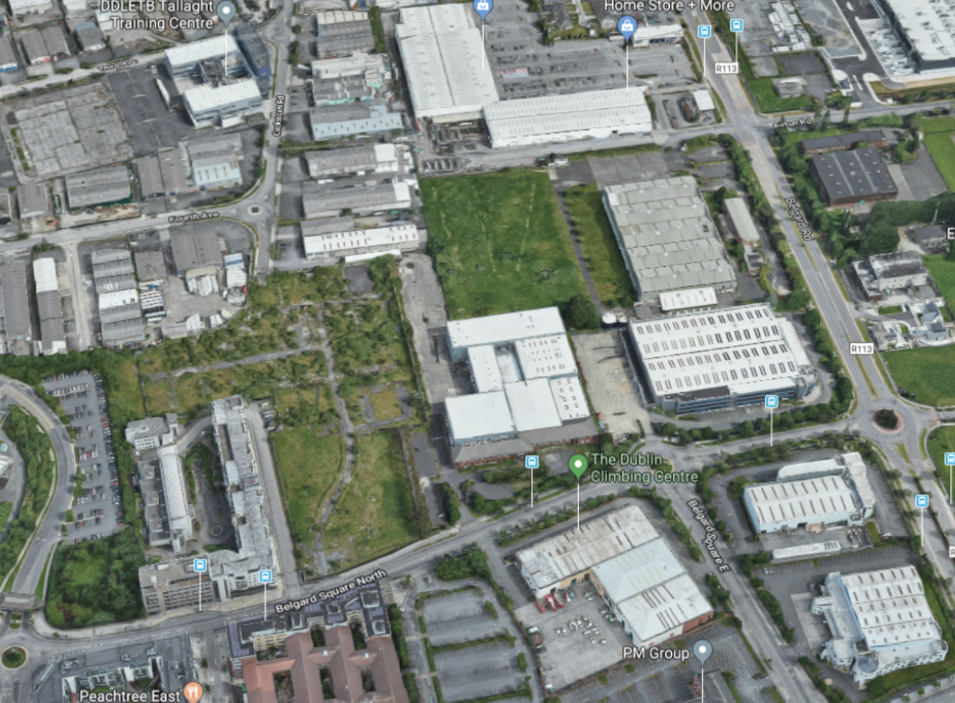
The lands required to deliver the Airton Road extension are located to the west of the existing Airton Road and run through to the Cookstown Road at the junction of the Cookstown Road and Fourth Avenue.

Figure 1.1 – Aerial view of the lands subject to the proposed CPO outlined red

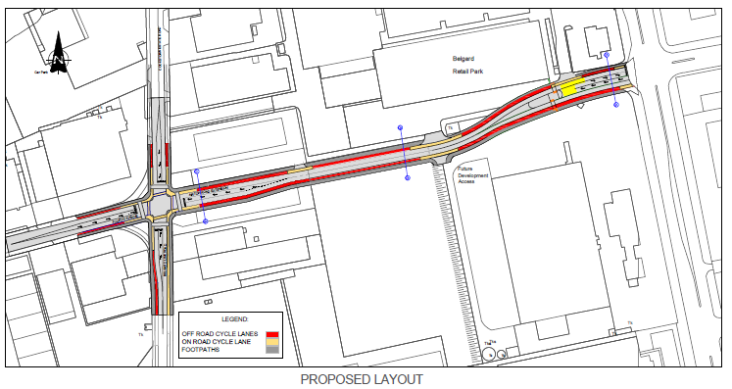

Figure 1.2: Plan showing the lands required to deliver Airton Road extension

Description

- The lands required to deliver the Airton Road extension are located to the west of the existing Airton Road and run through to the Cookstown Road at the junction of the Cookstown Road and Fourth Avenue. The proposed works will form part of a wider integrated road network which will result in the creation of a new permeable street connecting the Airton Road to the Cookstown Road and further south to Tallaght Town Centre via an approved Part 8 development.

- It is South Dublin County Council’s intention to start public consultation in January 2022, subject to finalising landowner agreement.

- The scheme consists of:
- The construction of approximately 328 m. of a two-way single carriageway road connecting Cookstown Industrial Estate Road to Belgard Road. The Cross sections consists of a 6.0 metre carriageway, 2.0 metre raised adjacent off-road cycle lanes and 2.5-metre-wide footpaths.
- The construction of three signal-controlled junctions, Junction of Cookstown Ind. Estate Road with Airton Road Extension, Junction of Airton Road Extension with the entrance into Belgard Retail Park and the Junction of Airton Road Extension and Belgard Road.
- Junctions – Junction layouts are to be as per the NTA’s standard for cycleways, the layout of the proposed junctions will be updated in line with new NTA standards when the latest layouts come available.
- The construction of associated drainage and culverts.
- The provision of associated road markings, traffic signage and public lighting.
- The installation of ducting for statutory service relocations and the diversion of existing statutory services that are affected by the works.
- The construction of boundary walls, fencing and access treatment.
- Associated earthworks and appropriate landscape works.

- Relevant Planning Application History

Appendix 1 includes a full list of all planning decisions related to the land in question.

- Policy Context

National
The National Planning Framework (NPF)
The NPF encourages the consolidation of urban areas and the making of stronger consolidated urban areas. Of relevance to Tallaght is the emphasis placed on strengthening, renewal and consolidation of urban areas. The NPF promotes the creation of high-quality urban places of scale and requires a specific percentage of future growth into existing urban areas. Specifically, National Policy Objective 4 encourages the creation of attractive, liveable, well designed, high quality urban places. National Policy Objective 27 states: “Ensure the integration of safe and convenient alternatives to the car into the design of our communities, by prioritising walking and cycling accessibility to both existing and proposed developments and integrating physical activity facilities for all ages.”

In Dublin, the proportion of new housing to be provided within the built envelope of the existing urban areas is 50%. Locations such as Tallaght Town Centre, where large areas are already zoned for regeneration, including new residential, have a significant role to play in meeting this target.

Smarter Travel-A Sustainable Transport Future 2009-2020
Smarter Travel sets out a transport policy for Ireland, in which sustainable transport modes are strongly promoted. The plan includes actions aimed at ensuring alternatives to the car are more widely available, including investment in cycling and walking.

The National Transport Strategy (NTA) - Transport Strategy for the Greater Dublin Area 2016-2035 sets out a number of objectives of relevance to Tallaght, and which are subsequently reflected in the draft LAP including:

• New public transport interchange at Tallaght town centre (pedestrian, cycle, regional and city bus and Luas);
• Consolidation of existing city and suburban bus services;
• Extension of bus routes in the town centre;
• Improved permeability and walking routes to Luas stops at Cookstown, Belgard and Tallaght Hospital;
• Extensive and connected pedestrian network (all streets, urban spaces and opens spaces);
• Improved cycle network; and
• Balanced consideration of car parking as part of residential development.
Pedestrian and cycle accessibility and movement are key components of the overall Urban Framework as set out in the Draft Tallaght Local Area Plan (LAP). The LAP aims to develop an integrated network of streets and routes with a clear hierarchy that promotes walking and cycling. It is a key objective of the Draft LAP to maximise existing and proposed public transport opportunities, including high quality Luas and bus services, and support these opportunities with an integrated network of streets and routes with a clear hierarchy that promotes walking and cycling.

Regional
Regional Spatial and Economic Strategy for the Eastern and Midland Region (RESE)
The RSES is the strategic plan and investment framework to shape future development and to better manage regional planning and economic development throughout the Region. It identifies regional assets, opportunities and pressures and provides appropriate policy responses in the form of Regional Policy Objectives.

The RSES includes a Metropolitan Area Strategic Plan ‘MASP’ for the Metropolitan Area which provides a 12 to 20-year strategic planning and investment framework for the Dublin metropolitan area.
In order to achieve the vision for the development of the MASP a number of Guiding Principles for the sustainable development of the Dublin Metropolitan Area are set out including:

- Compact sustainable growth and accelerated housing delivery
- Integrated Transport and Land use
- Co-ordination and active land management

Regional Policy Objective 5.3 is of particular note in regard to the subject CPO, where it is an objective within the RSES that future development in the Dublin Metropolitan Area shall be planned and designed in a manner that facilitates sustainable travel patterns, with a particular focus on increasing the share of active modes (walking and cycling) and public transport use and creating a safe attractive street environment for pedestrians and cyclists.
Tallaght is designated as a major town centre within the Metropolitan area with brownfield lands at Cookstown identified as having the potential for regeneration in the form of a mixed-use neighbourhood.

County/Local
South Dublin County Council County Development Plan 2016 – 2022
The South Dublin County Council County Development Plan (CPD) sets out a number of objectives relevant to the proposals for the provision of a new link road connecting the Airton Road to the Cookstown Road. Of particular note are CS2 Objective 4: which promotes and supports the regeneration of underutilised industrial areas within areas designated with Zoning Objective Regeneration ‘REGEN’ (to facilitate enterprise and/or residential led regeneration) and CS2 Objective 6: which promotes higher residential densities at appropriate locations, adjacent to town centres or high capacity public transport nodes (Luas/Rail).

The lands at Cookstown are zoned regeneration with an objective of facilitating enterprise and or residential led regeneration. Section 11.2.4 of the CDP stipulates that development within Regeneration zones will be assessed against the relevant criteria within the Urban Design Manual – A Best Practice Guide (2009), the Design Manual for Urban Roads and Streets (2013) and/or the Retail Design Manual (2012) as appropriate.

A Design Statement (see Section 11.2.1 Design Statements) accompanying development proposals in Regeneration (REGEN) zones should also address the following criteria:

- Demonstrate a clear transition towards a more urban form of development and a traditional street network.
- Address connectivity and linkages in the area and demonstrate that the development of the site would not give rise to isolated piecemeal pockets of residential development that are disconnected from shops, amenities and/or other residences.
- Residential development should not be introduced at ground floor level adjacent to busy roads, and/or roads that are subject to significant movements by Heavy Goods Vehicles (HGVs).
- Given the transitional nature of Regeneration zones, precautions will be taken to ensure that the potential for noise pollution, air pollution or other nuisance from established industrial uses will not exceed acceptable environmental standards. The Planning Authority may seek a report from a suitably qualified person to identify and quantify sources of noise pollution, air pollution, or nuisance, assess the potential impacts on the proposed development and provide a series of recommendations to mitigate the impacts of any pollutants insofar as possible (e.g. orientation and layout of dwellings, positioning of openings and insulation).
- It may be necessary to consider improvements to the surrounding road and street network in conjunction with the Planning Authority, to calm traffic and improve pedestrian and cyclist access.

The following sections/objectives are also noted as being of relevance to the CPO proposal:
Section 6.3.0 Walking and Cycling
Policy TM3 Walking and Cycling
It is the policy of the Council to re-balance movement priorities towards more sustainable modes of transportation by prioritising development of walking and cycling facilities within a safe and traffic calmed street environment.

Section 6.4.3 Road and Street Design
Policy H12
It is the policy of Council to ensure that streets and roads within the County are designed to balance the needs of place and movement, to provide a safe traffic-calmed street environment, particularly in sensitive areas and where vulnerable users are present.
Table 6.5 Six Year Road Programme
Tallaght Town Centre Street Network - Various streets within the Tallaght Town Centre – Function Formation of a strategic street network within the Tallaght Town Centre LAP lands.

Tallaght Town Centre Local Area Plan 2020
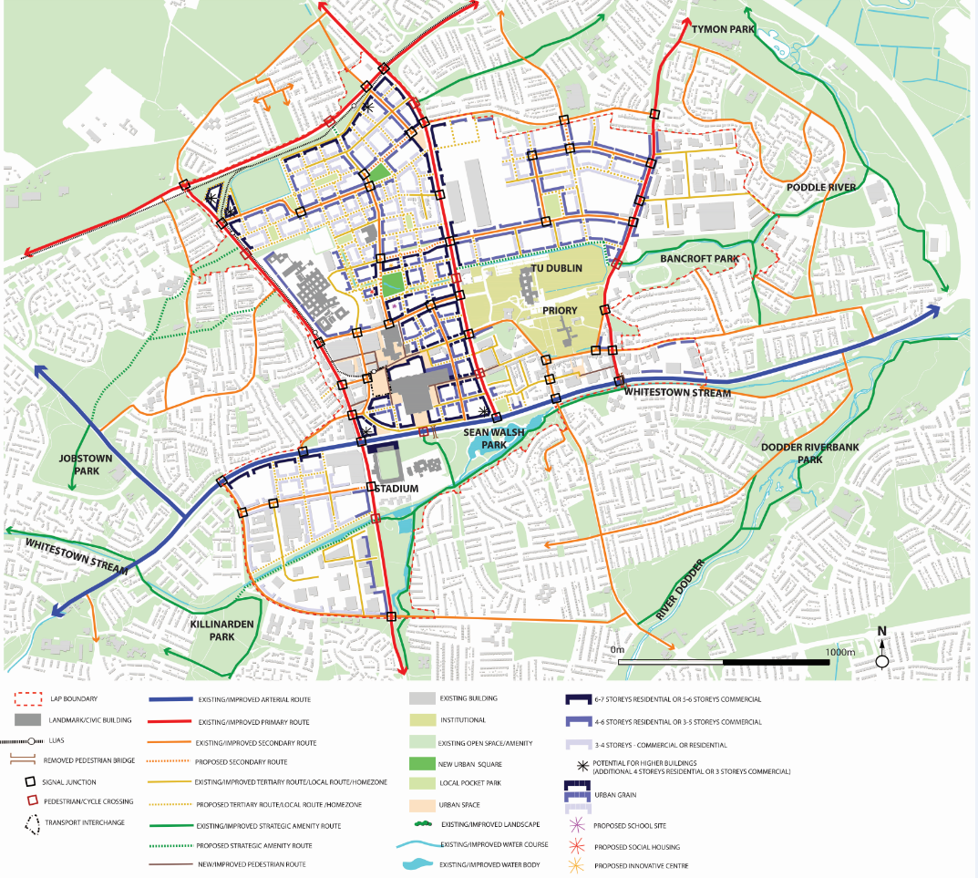
The adopted Tallaght Town Centre Local Area Plan (LAP) 2020-2026 represents a new era of opportunity and the rise of positive and sustainable growth for Tallaght Town Centre following a robust plan led approach and under the guidance and direction of the National Planning Framework, RSES and the South Dublin CDP. The purpose of this Draft Plan is to resume momentum and to build upon the achievements of the past, which have contributed to Tallaght’s important role as the capital of South Dublin. The LAP provides a strategic framework for the sustainable development of Tallaght. The LAP seeks to deliver high quality housing and well-connected neighbourhood areas with a strong sense of community and social cohesion. The LAP promotes a permeable and connected urban structure that integrates movement, through the development of a framework of routes and spaces that promote place-making and movement by different modes of transport, while connecting Tallaght with existing communities.
Figure 1.3 Tallaght LAP (Urban and Route Structure

Section 2.2.1 ‘street network and route structure’ of the LAP sets out an area wide route network across the whole of Tallaght. The network includes existing and improved routes as well as proposals for new routes. This network of streets will facilitate the sequential regeneration of Tallaght and the Cookstown Industrial Estate lands for mixed use development. The key objective for Tallaght is to promote the emergence of a vibrant mixed use residential neighbourhood; the creation of a new urban block structure; improved legibility throughout the area and provision of new streets linking to nearby hubs and The Centre; and the delivery of a variety of building types around Luas stops.

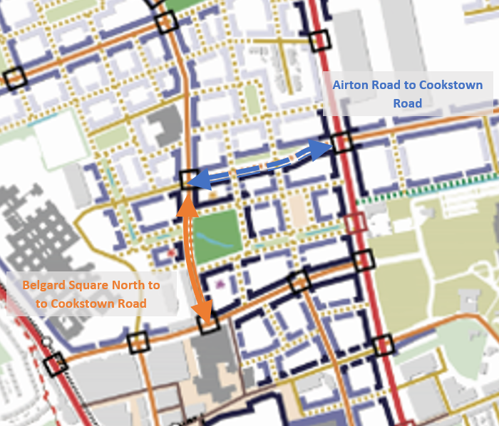
Where the Tallaght Town Centre and Cookestown neighbourhoods meet, the street network included in the LAP promotes provision of a new link street connecting the existing Airton Road to the Cookstown Road (shown in blue on Figure 1.4), which is referred to as the Airton Road extension. The Airton Road extension will significantly open-up currently inaccessible land, by improving access to public and road transport and by creating permeable/accessible places.
Figure 1.4 Airton Road to Cookstown Road and Belgard Square North to Cookstown Road.

In addition, the plan also promotes a new connection from Belgard Road North to Cookestown (shown in orange on Figure 1.4). This new road is located solely on Council owned land and construction of this road has now been completed

Conclusion

In conclusion, the proposed Part 8 planning application to deliver the new Airton Road extension aligns with existing adopted National, Regional and Local Planning policy. It improve transport access into the Cookstown area and will better enable the delivery on new homes and intensified employment space in line with the NPF principles of Compact Growth.

Appendix 1: Planning History
South of the Proposed Link Road

SHD3ABP-303306-18
Junction of Belgard Road and Belgard Square North, Tallaght, Dublin 24
Permission granted for development of 438 apartment units consisting of 158 no. 1 beds, 230 no. 2 beds and 50 no. 3 beds (total apartment units include 8 no. live/work units with a total c. 509 sqm work areas at ground floor) and c. 732 sqm of tenant/resident service amenities all within blocks A1, A2, A3 and B1. Block B2 to comprise a 403 bed space student accommodation scheme and associated student amenity and staff facilities (c.815 sqm); childcare facility (c.380 sq.m) and external playing area (c. 242sq.m); 6 retail/commercial units (c. 632sq.m in total); security room (c.52sq.m); 107 car parking spaces below podium; 22 car parking spaces at surface level; 1227 bicycle parking spaces; 4 semi-private courtyards of c. 5,516sq.m; public plaza; public realm & landscaping (c.7,442sq.m).

SD16A/0270
Site located at Units 60, 66, 67 Fourth Avenue, And Sites 69 & 70 Cookstown Road, As well as vacant lands, Cookstown Industrial Estate, Tallaght, Dublin 24
Permission refused for a mixed residential and commercial development (GFA 38,207.1sq.m) providing a total of 246 apartments in 2 separate buildings, 3 commercial units, 2 community rooms, 2 crèches and 2 ESB substations, along with landscaped courtyards (containing a surface bicycle store to each site), underground car parking, providing an overall total of 233 parking spaces, refuse stores and plant areas. Site A with frontages to Fourth Avenue and Cookstown Road comprises a total of 148 apartments (14 studios, 27 one bed, 95 two bed and 12 three bed), all with private balcony spaces in a building with a maximum height of 7 stories. (Total GFA of 23,483.4m2). 2 commercial units of 333m2 and 197m2, 1 community room of 44.8m2 and 1 crèche of 194.6m2 with dedicated open space, are proposed at ground floor level. An ESB substation is proposed at ground floor level to service site A. The landscaped courtyard contains bicycle store for 44 bicycles. An underground carpark serviced off Fourth Avenue, contains 148 car parking spaces (of which 19 are disabled) and refuse stores. Site B with a frontage to Cookstown Road comprises a total of 98 apartments (10 studios, 26 one bed, 54 two bed and 8 three bed) all with private balcony spaces in a building with a maximum height of 7 stories (total GFA of 14,723.7m2). 1 community room of 29.8m2 and 1 crèche of 147m2 with dedicated open space, are proposed at ground floor level. An ESB substation is proposed at ground floor level to service Site B. The landscaped courtyard contains bicycle store for 94 bicycles. An underground carpark serviced off Cookstown Road contains 85 carparking (of which 13 are disabled) spaces and refuse stores. Proposals also included the provision of a new road linking the existing Cookstown Road to Belgard Square North, a new road to Southern boundary of Unit 69, a new pedestrian walkway to the Southern boundary of Units 66 and 67, (which will also allow for the servicing of the proposed ESB substation for Site A) and the provision of a new public park (0.7175ha). The development also includes the demolition of all existing industrial units and all associated site development works.

SD13A/0041
Unit 69, Cookstown Industrial Estate, Tallaght, Dublin 24.
Permission refused for an additional use of part of premises (area 755 sq.m) as a 'Refuse Transfer Station' for WEEE and associated batteries; this additional use will also require the holding of a Waste Facility Permit.

North of the Proposed Link Road

SD03A/0191
Belgard Road and Cookstown Estate Road, (formerly Windsor Car Auctions), Tallaght, Dublin 24
Permission granted for an amendment to previously approved retail warehouse development (Reg. Ref. S00A/0542 and S01A/0489) consisting of the provision of 92.5sq.m of ancillary accommodation in units 6/7.

SD03A/0190
Belgard Road and Cookstown Estate Road, (formerly Windsor Car Auctions), Tallaght, Dublin 24
Permission granted for an amendment to previously approved retail warehouse development (Reg. Ref. S00A/0542 and S01A/0489) consisting of the omission of dividing wall between units 6 and 7 to create 1 no. single unit of 1826.3sq.m.

SD02A/0727
Belgard Road and Cookstown Estate Road, (Formerly Windsor Car Auctions), Tallaght, Dublin 24
Permission granted for an amendment to previously approved retail warehouse development (Reg. Ref. S00A/0542 and S01A/0489) consisting of the provision of 4.8m high fencing to rear boundaries of Unit 5

SD02A/0672
Belgard Road and Cookstown Estate Road, (Formerly Windsor Car Auctions), Tallaght, Dublin 24
Permission granted for an amendment to previously approved retail warehouse development (Reg. Ref. S00A/0542 and S01A/0489) consisting of: (a) the relocation of substation and switch room and (b) the division of the service yard into two separate areas, allowing for access and egress of delivery vehicles.

SD02A/0668
Belgard Road & Cookstown Estate Road, (Formerly Windsor Car Auctions), Tallaght,
Permission granted for an amendment to previously approved retail warehouse development (Reg. Ref. S00A/0542 and S01A/0489) consisting of the division of Unit 1 into 2 separate units of 908.5sq.m and 703sq.m (to be known as Unit 1 & Unit 1B respectively) to include a new entrance door to North Elevation of Unit 1B and a new service door to South Elevation of Unit 1.

SD02A/0649
Belgard Road and Cookstown Estate Road, (Formerly Windsor Car Auctions), Tallaght, Dublin 24
Permission granted for an amendments to previously approved retail warehouse development (Reg. Ref. S00A/0542 and S01A/0489) consisting of alterations to elevations of Unit 5, to include entrance and exit lobbies totalling 83 sq.m. and a subsequent reduction in area of garden centre of 83 sq.m. and alteration to the line of its enclosure

SD02A/0576
Belgard Road and Cookstown Estate Road, (Formerly Windsor Car Auctions), Tallaght, Dublin 24
84 seat drive-thru restaurant of 233sq.m with ancillary refuse storage area of 4.2sq.m and associated sub-station and switch-room, to include provision of 11 no. designated car-parking spaces (Outline Permission Granted under Reg. Ref. S00A/0542).

SD02A/0369
Belgard Road & Cookstown Estate Road, (formerly Windsor Car Auctions), Tallaght, Dublin 24.
Permission granted for an amendment to previously approved retail warehouse development (Reg. Ref. S01A/0489) consisting of: (a) alterations to car parking; (b) relocation of and alterations to substations; (c) provision of underground water storage tank and associates pump house.

SD02A/0216
Belgard Road and Cookstown Estate Road, (formerly Windsor Car Auctions), Tallaght, Dublin 24.
Permission granted for an amendment to previously approved retail warehouse development (Reg. Ref. S00A/0542) for alterations to car parking layout, relocation of and alterations to substations, alterations to delivery access points and fire exits to units.

SD02A/0215
Belgard Road and Cookstown Estate Road, (formerly Windsor Car Auctions), Tallaght, Dublin 24
Permission granted for an amendment to previously approved retail warehouse development (Reg. Ref. S00A/0542) comprising provision of underground water storage tank and associated pump house

SD02A/0214
Belgard Road and Cookstown Estate Road, (formerly Windsor Car Auctions), Tallaght, Dublin 24.
Permission granted for an amendment to previously approved retail warehouse development (Reg. Ref. S00A/0542) comprising provision of mezzanine storage space of 107 sq.m.

SD02A/0213
Belgard Road & Cookstown Estate Road (Formerly Windsor Car Auctions), Tallaght, Dublin 24.
Permission granted for an amendments to previously approved retail warehouse development (Reg. Ref. S00A/0542) for (a) reduction in floor area of retail warehousing by 875 sq.m. and the provision of a garden centre of 875 sq.m. in lieu; (b) alterations to east elevation of Unit 5 at entrance; (c) provision of service yard to Unit 5.

S01A/0489
Windsor Car Auctions, Belgard Road and rear of Colberts Fort Tallaght, Dublin, 24.
Permission granted for an amendment to part of approved retail warehouse development (Reg. Ref. S00A/0542), consisting of 7,622 sq.m. in 3 retail warehouse units, a garden centre and 602 sq.m. of associated office space at first floor level to replace previously approved retail units totalling 7,516 sq.m. An additional 30 car spaces are proposed (total now 571). Access off existing to Belgard with new service vehicle access off Cookstown Industrial Estate Road.

S00A/0542
Belgard Road, Tallaght
Permission granted for a retail warehouse development of 14,530 sq.m with surface car parking for 541 spaces. Access is off existing to Belgard Road with new service vehicle entrance off Cookstown Estate Road. Permission is also sought for the demolition of all buildings on the site and for a free standing drive-through fast food restaurant, a tyre fitting unit, an A.T.M. unit and ancillary site works (ESB Substations), refuse station, security huts, etc) all on a site formerly used by Windsor Car Auctions. The application is accompanied by an Environmental Impact Statement.

